**Practical -1**

**AIM: Evaluation of Database (File System, DBMS, RDBMS, DDBMS).**

**THEORY:**

1. **File System:**

File system is basically a way of arranging the files in a storage medium like hard disk. File system organizes the files and helps in retrieval of files when they are required. File systems consists of different files which are grouped into directories. The directories further contain other folders and files. File system performs basic operations like management, file naming, giving access rules etc.

**Example:**

NTFS (New Technology File System), EXT(Extended File System).

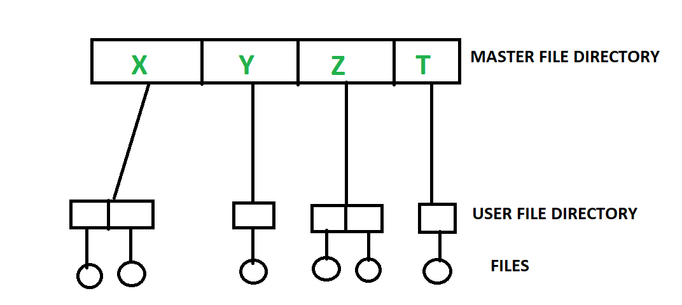

1. **DBMS (Database Management System) :**

Database Management System is basically a software that manages the collection of related data. It is used for storing data and retrieving the data effectively when it is needed. It also provides proper security measures for protecting the data from unauthorized access. In Database Management System the data can be fetched by SQL queries and relational algebra. It also provides mechanisms for data recovery and data backup.

**Example:**

Oracle, MySQL, MS SQL server.

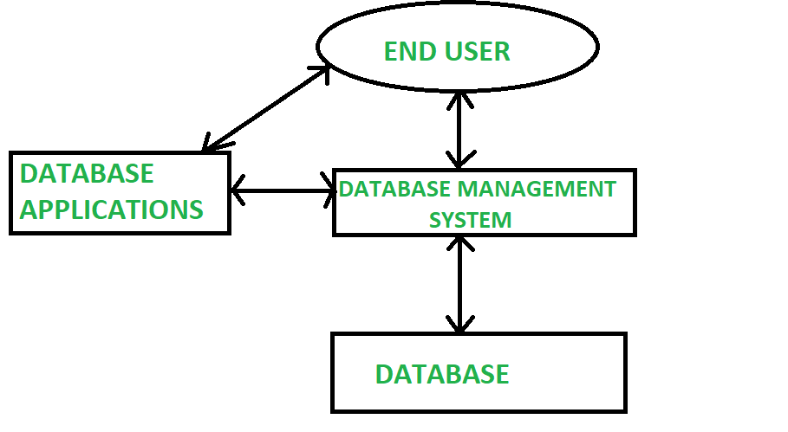

**3. RDBMS:**

RDBMS stands for Relational Database Management System and it implements SQL. In the real-world scenario, people use the Relational Database Management System to collect information and process it, to provide service. E.g. In a ticket processing system, details about us (e.g. age, gender) and our journey (e.g. source, destination), are collected, and the ticket is provided to us.

**RDBMS Architecture:**

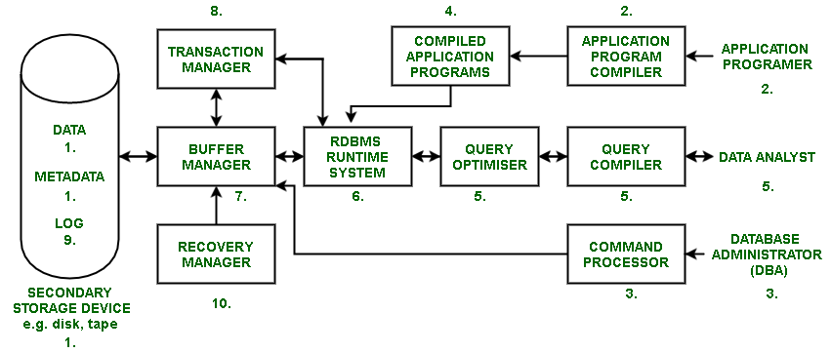

**4. DDBMS**

A distributed database is basically a database that is not limited to one system, it is spread over different sites, i.e, on multiple computers or over a network of computers. A distributed database system is located on various sited that don’t share physical components. This maybe required when a particular database needs to be accessed by various users globally. It needs to be managed such that for the users it looks like one single database.

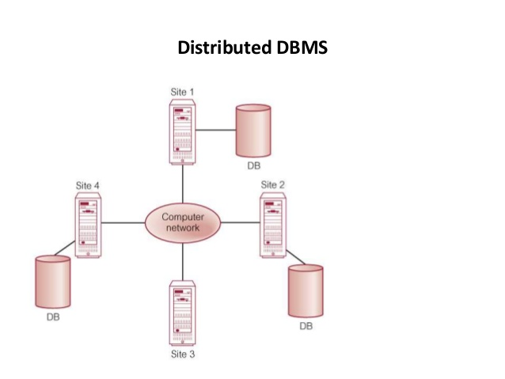

**Practical -2**

|  |
| --- |
| **Aim:**  **Introduction to Oracle (step by step installation, introduction of sql, plsql).** |

**THEORY:**

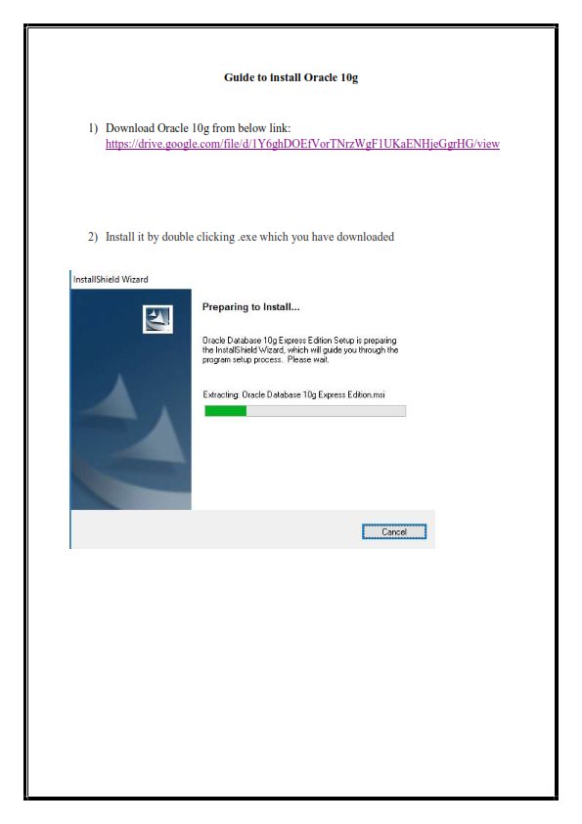

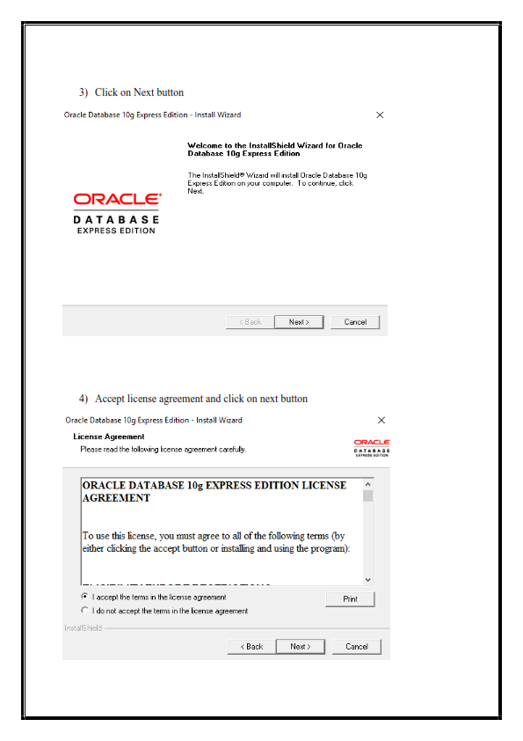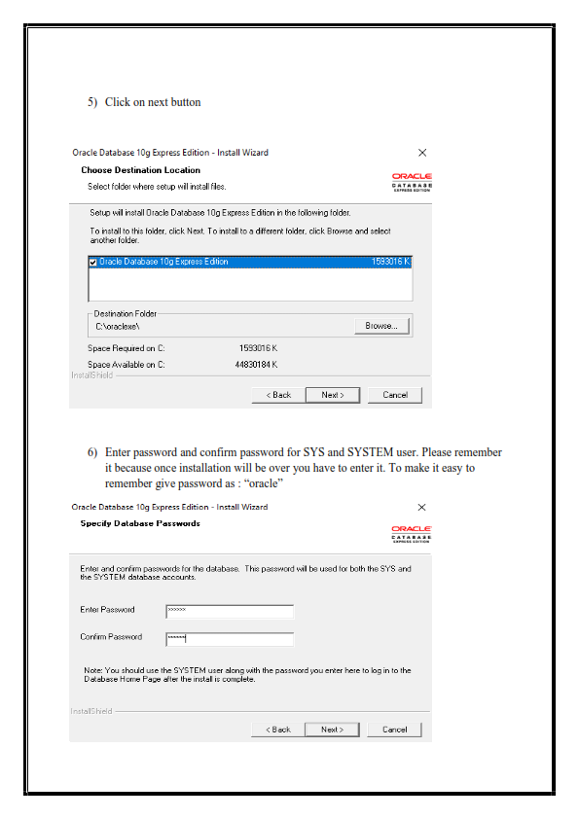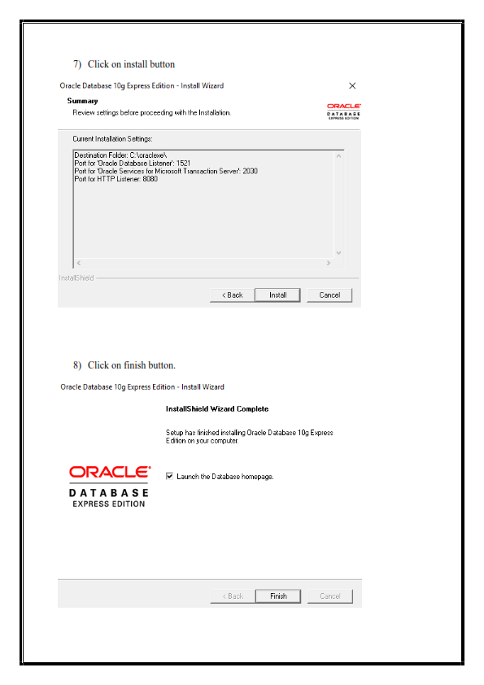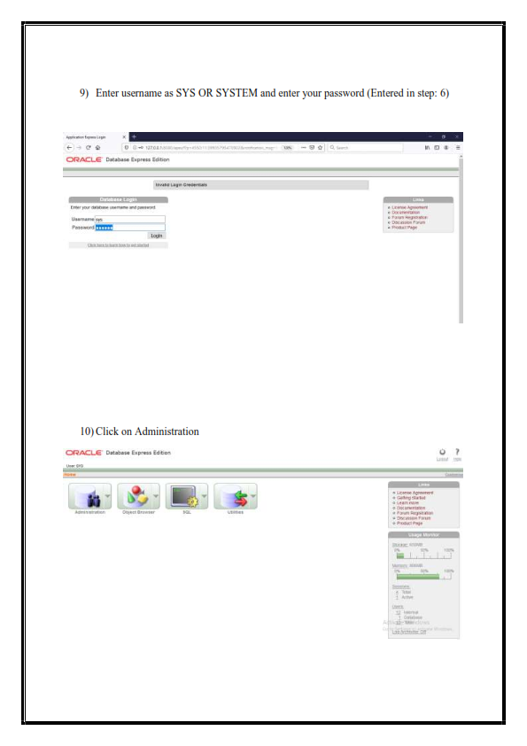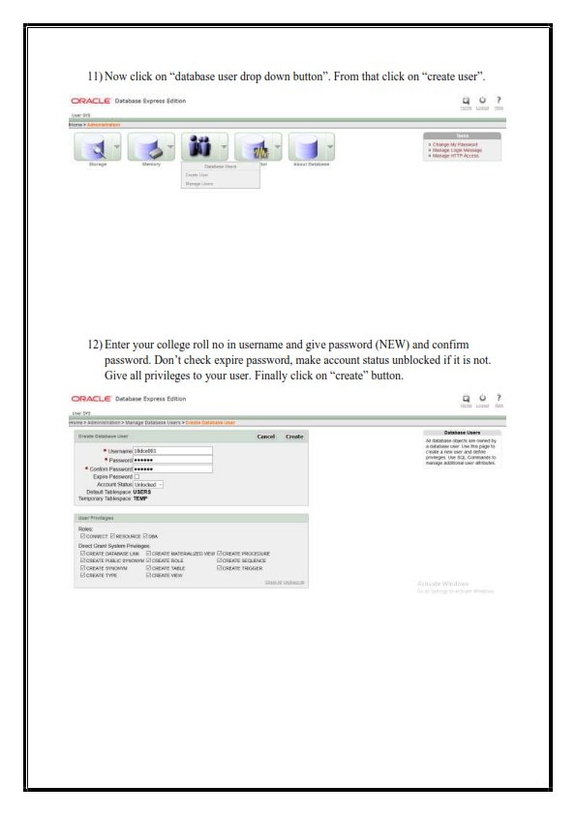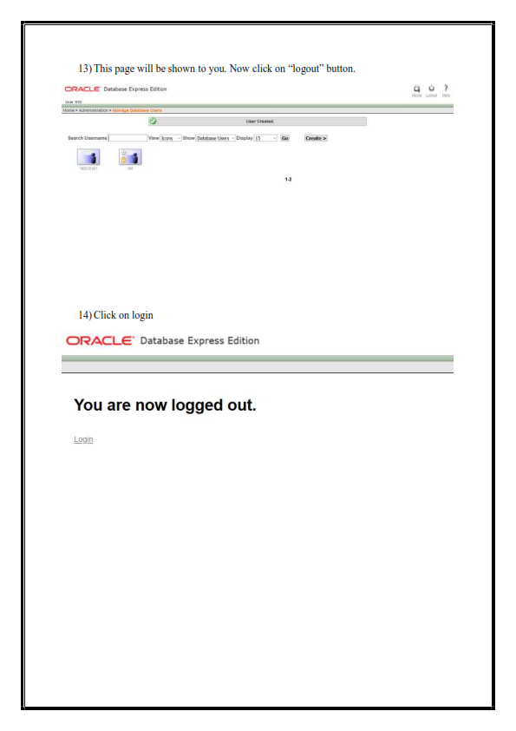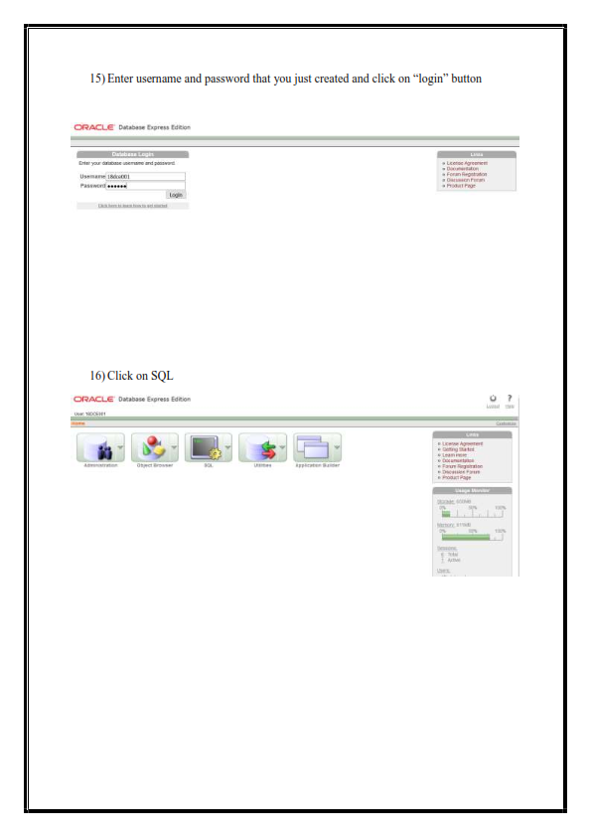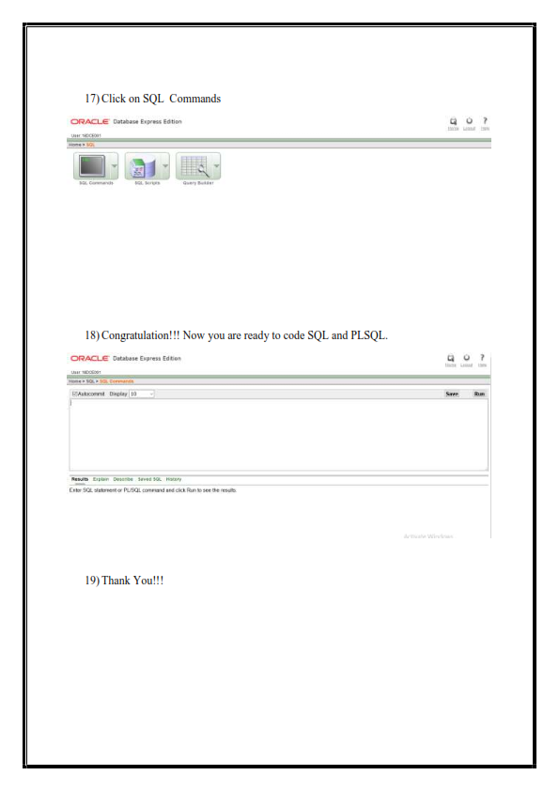

**Introduction**

**SQL:**  
Structured Query Language (SQL) is a standard Database language which is used to create, maintain and retrieve the relational database.

**Introduction to PL/SQL:**

PL/SQL is a block structured language that enables developers to combine the power of SQL with procedural statements. All the statements of a block are passed to oracle engine all at once which increases processing speed and decreases the traffic. PL/SQL stands for “Procedural language extensions to SQL.” PL/SQL is a database-oriented programming language that extends SQL with procedural capabilities. It was developed by Oracle Corporation within the early 90’s to boost the capabilities of SQL.

PL/SQL adds selective (i.e. if…then…else…) and iterative constructs (ie. loops) to SQL. PL/SQL is most helpful to put in writing triggers and keep procedures. Stored procedures square measure units of procedural code keep during a compiled type inside the info.

**Conclusion:** From this practical I learned how to install oracle & learned about sql & pl/sql.

**Practical – 3**

|  |
| --- |
| **Aim: (i) To study DDL-CREATE and DML-INSERT Commands**. |

**CREATE:**

Syntax:

CREATE TABLE <TABLE_NAME> (

FIELD_NAME <DATA_TYPE>,

);

Snapshot:

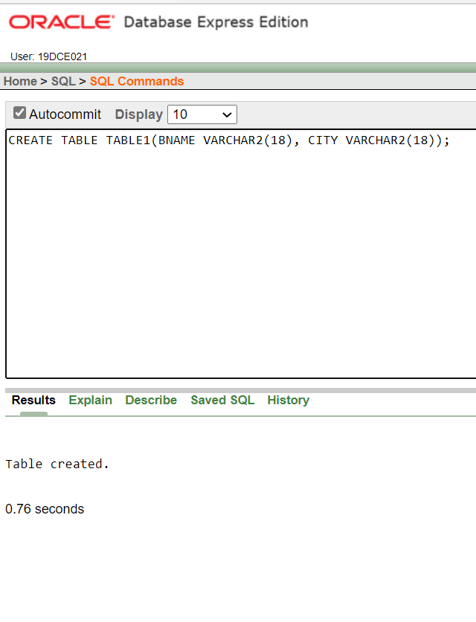

**INSERT:**

Syntax:

INSERT INTO <TABLE_NAME>

VALUES (‘val-1’, ‘val-2’,…. );

Snapshot:

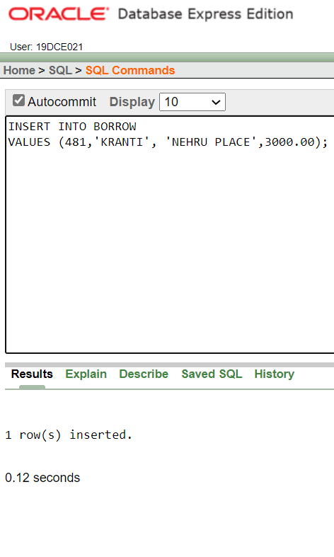

**From the above given tables perform the following queries**:

1. Describe deposit, branch.

Snapshot:

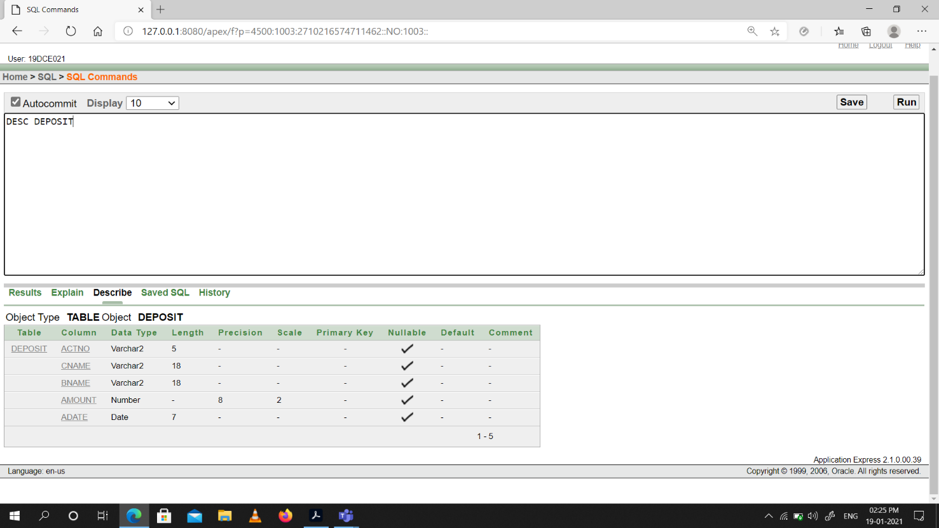

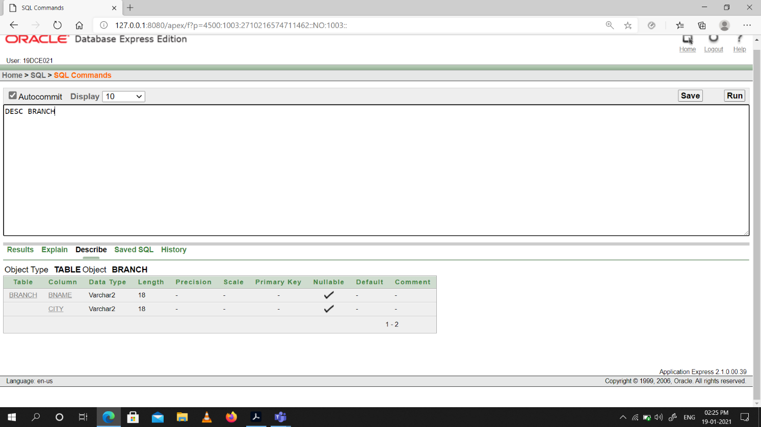

1. Describe borrow, customers.

Snapshot:

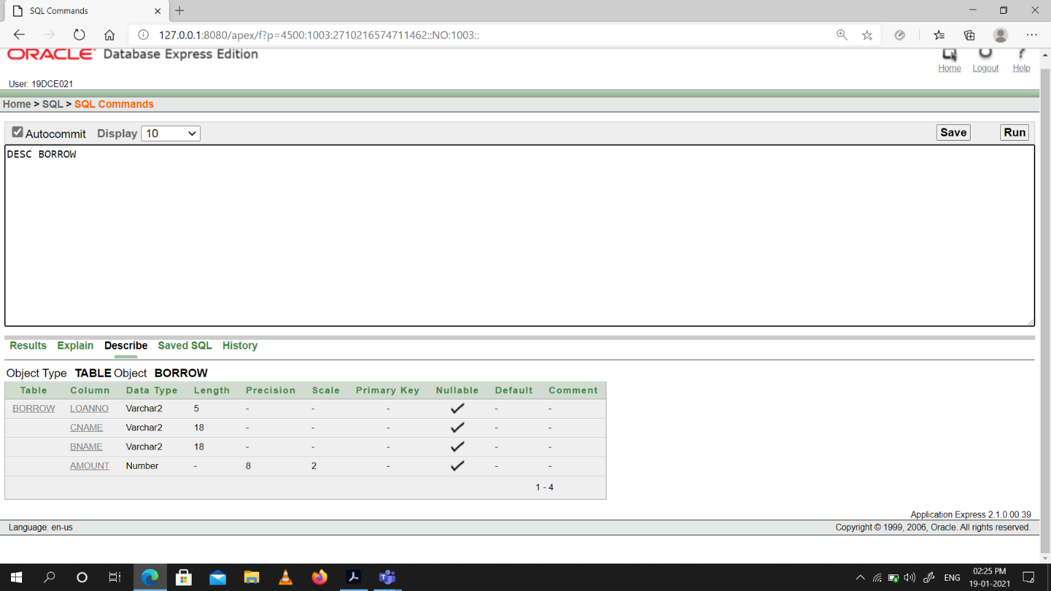

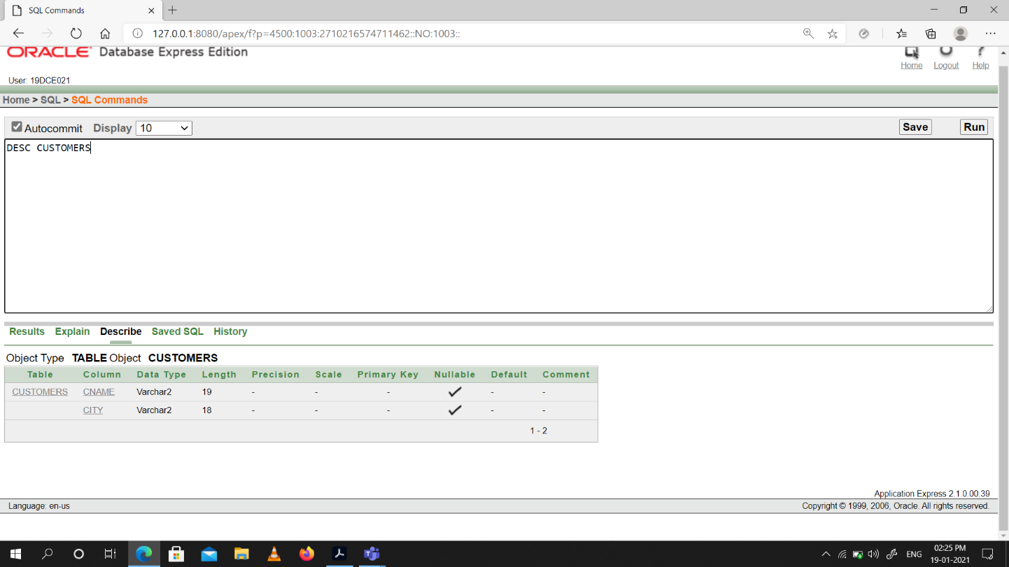

1. List all data from table DEPOSIT.

Snapshot:

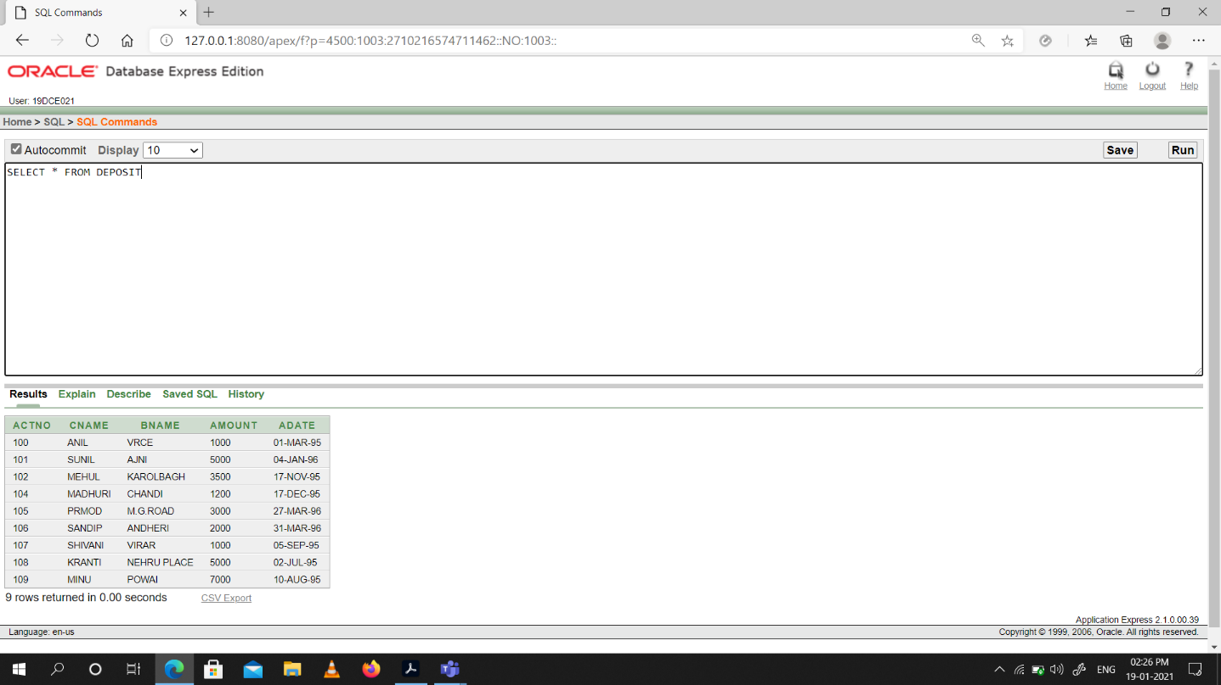

1. List all data from table BORROW.

Snapshot:

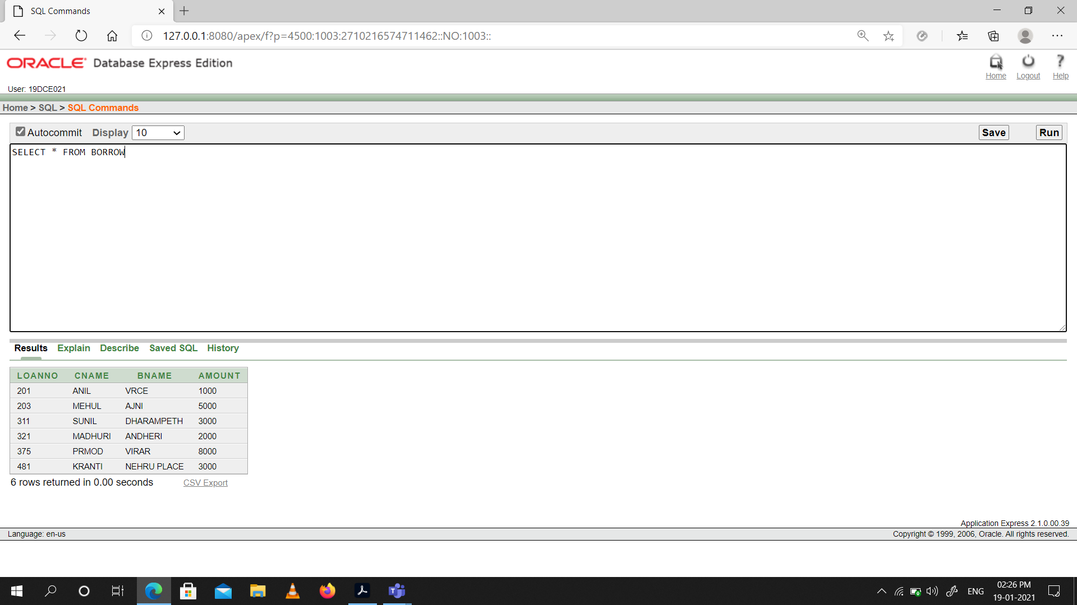

1. List all data from table CUSTOMERS.

Snapshot:

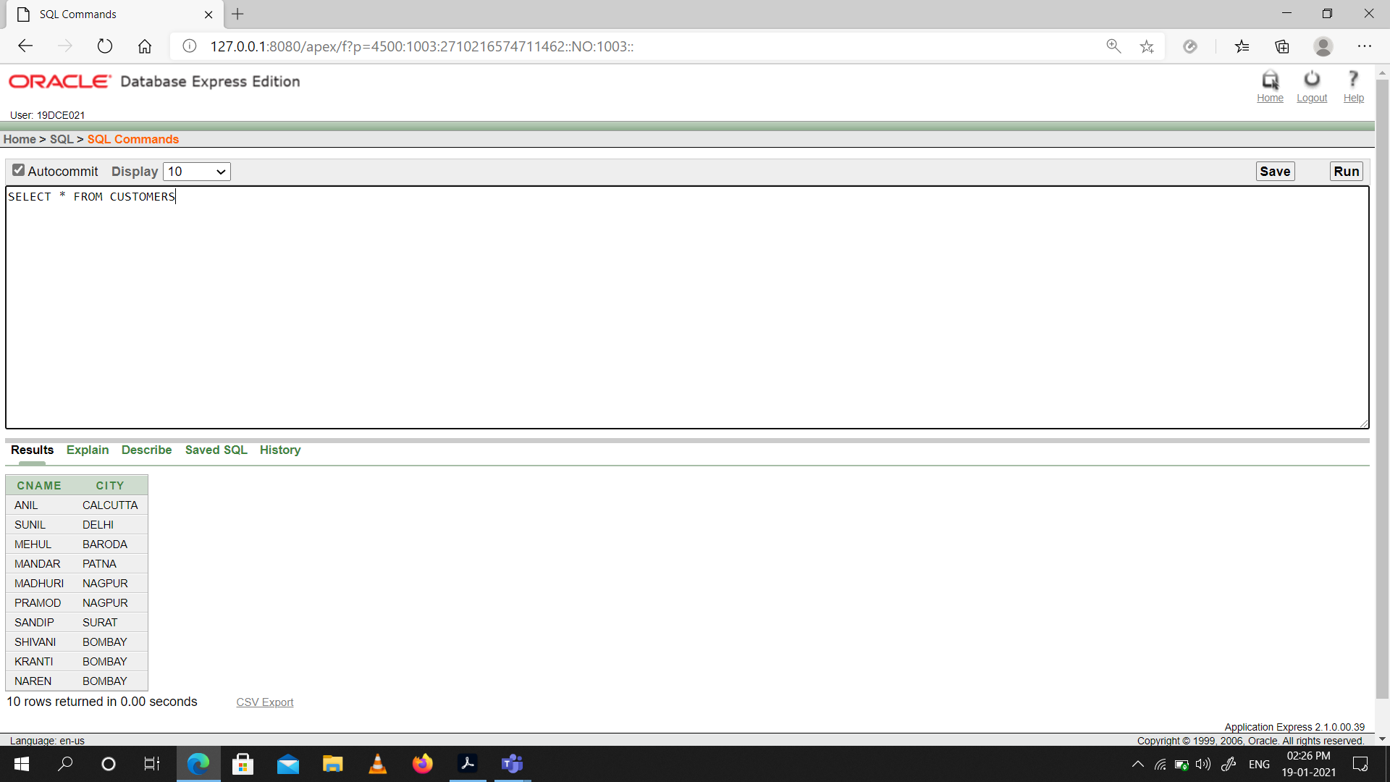

1. List all data from table BRANCH.

Snapshot:

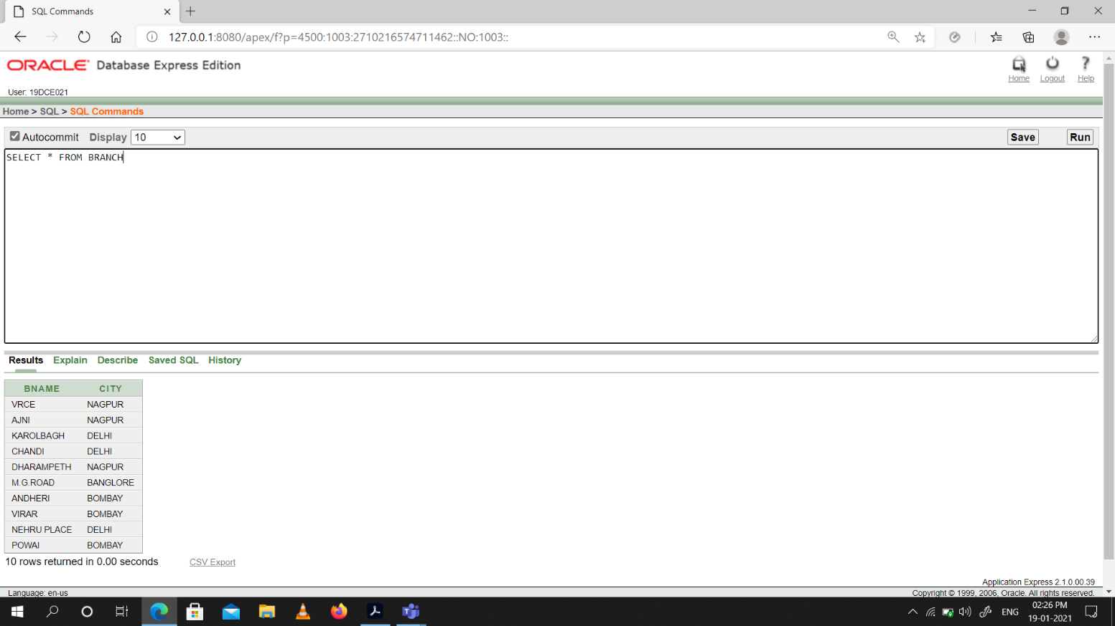

1. Give account no and amount of depositors.

Snapshot:

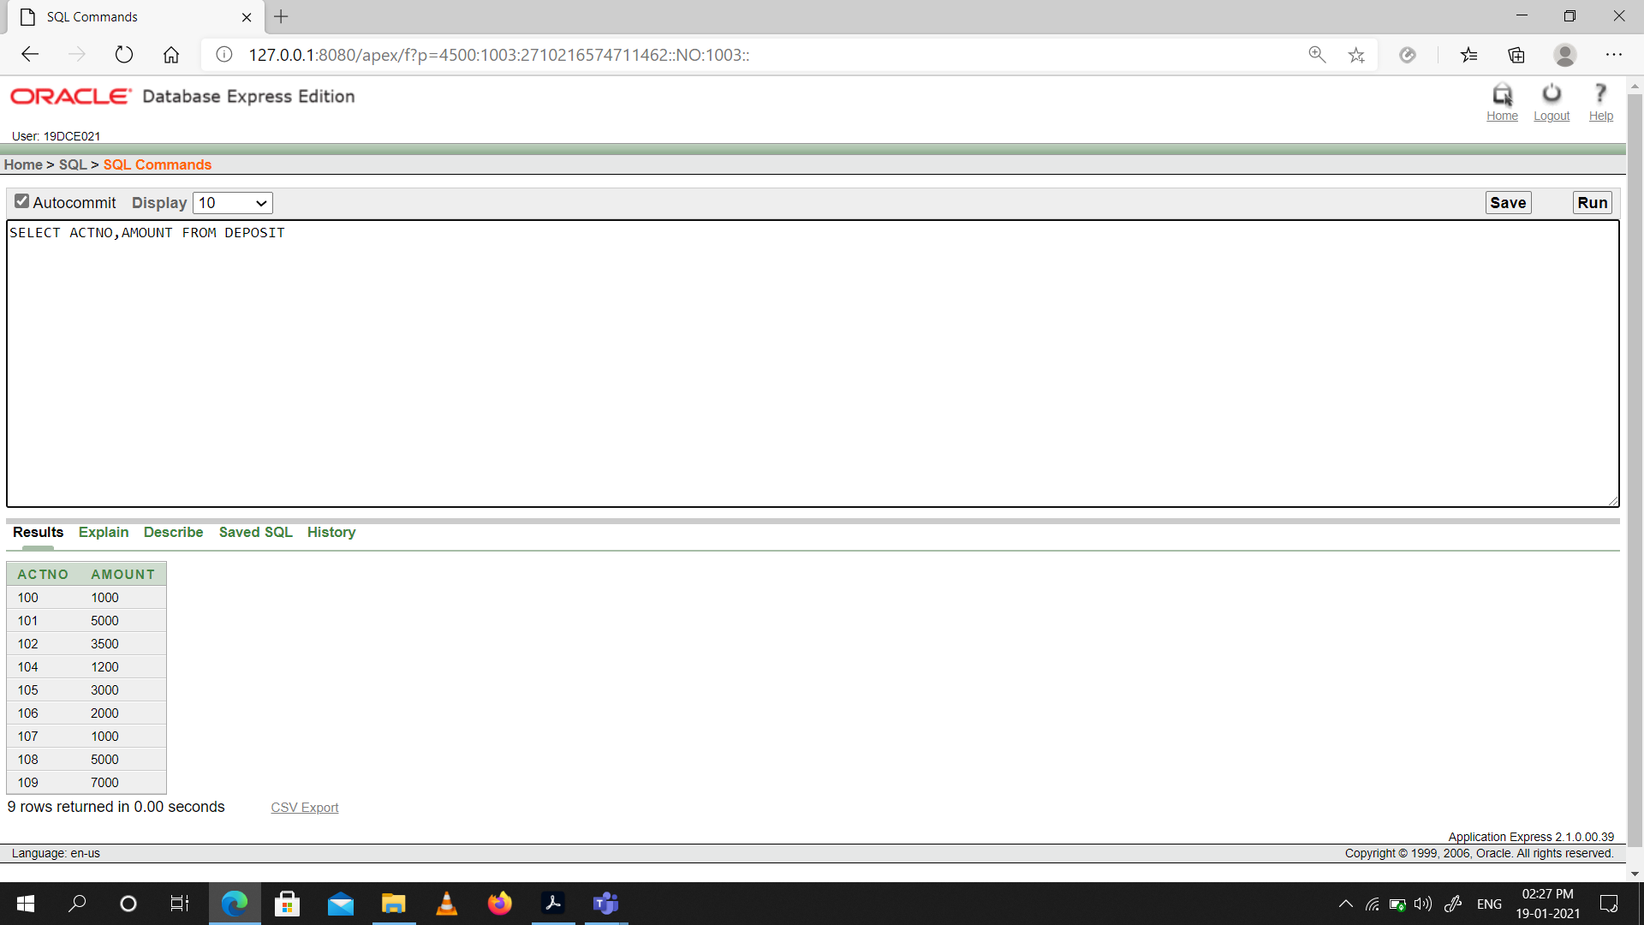

1. Give name of depositors having amount greater than 4000.

Snapshot:

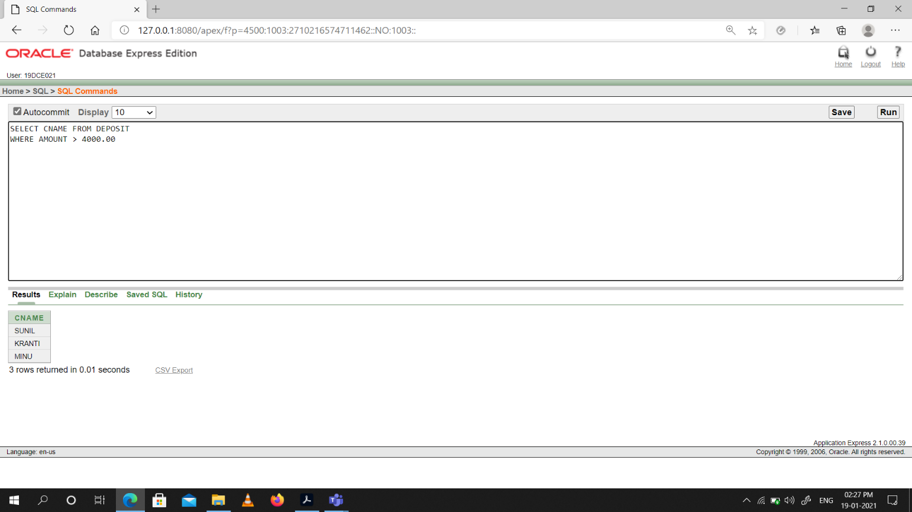

(9) Give name of customers who opened account after date '1-12-96'.

Snapshot:

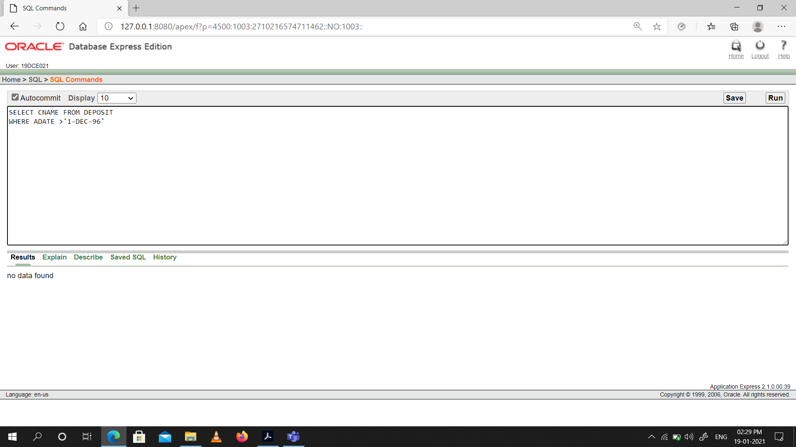

(10) Give name of city where branch karolbagh is located.

Snapshot:

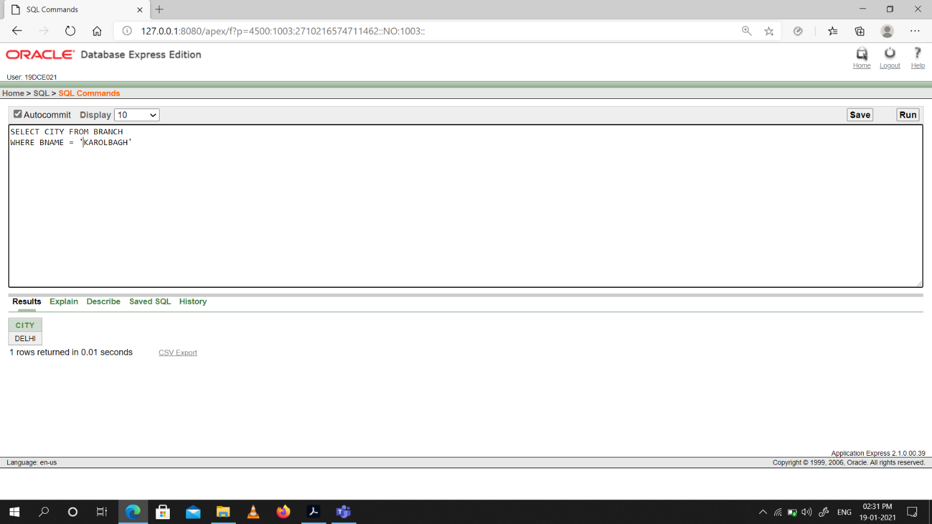

(11) Give account no and amount of customer having account opened between date

1-12-96 and 1-6-96.

Snapshot:

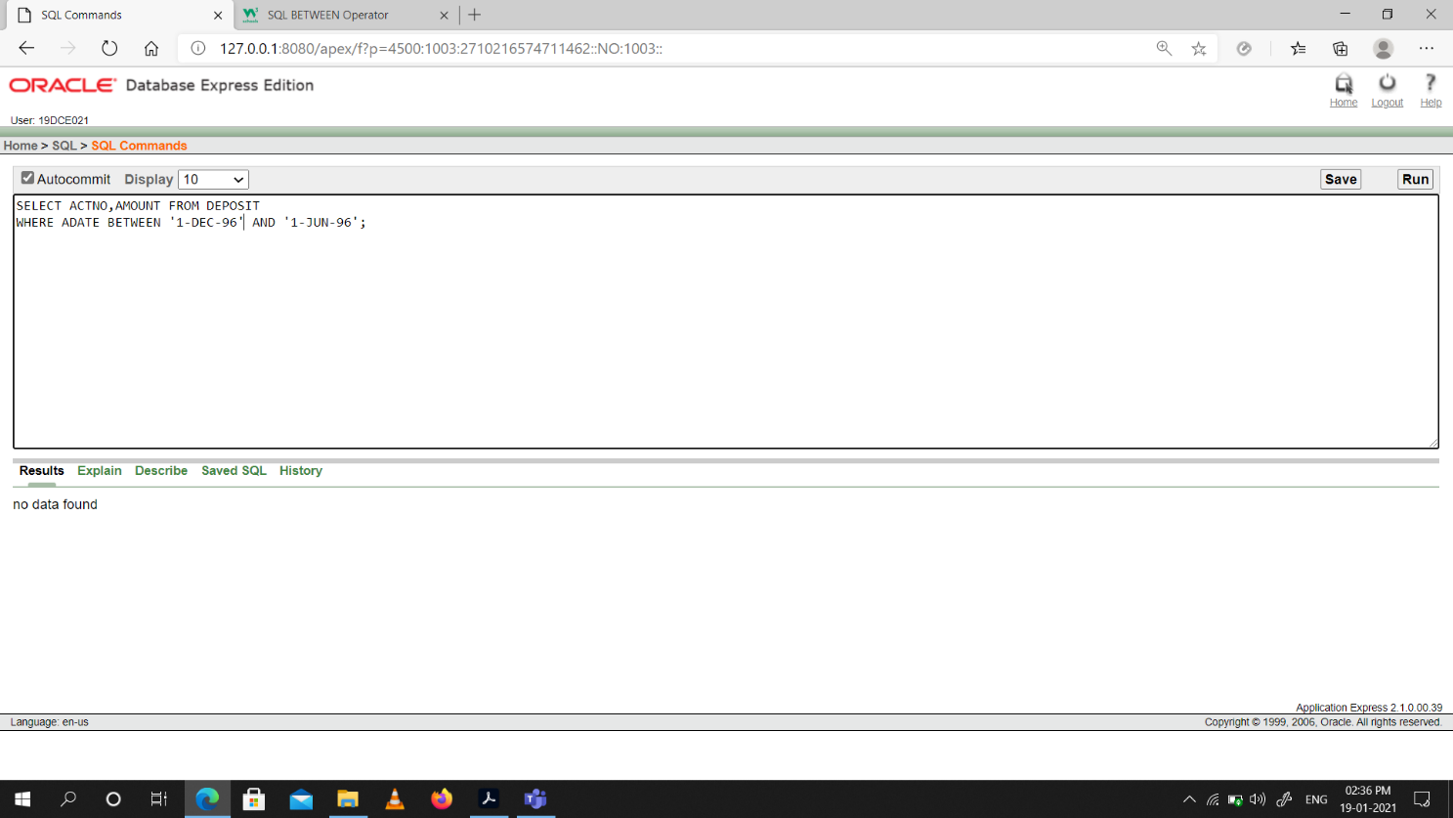

(12) Give names of depositors having account at VRCE.

Snapshot:

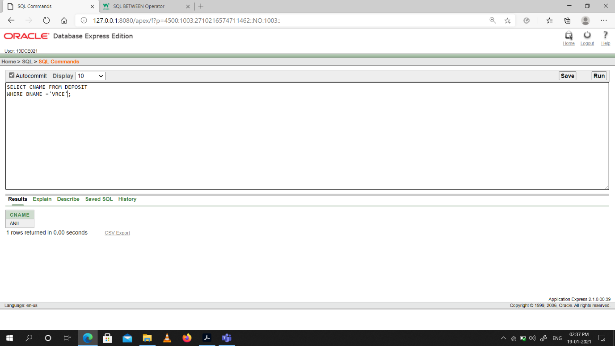

**Conclusion:** We Learned how to create tables, insert data into tables & read from the table as any required query.

**Practical -4**

**Perform following queries**

(1) Retrieve all data from employee, jobs and deposit.

Snap-Shot:

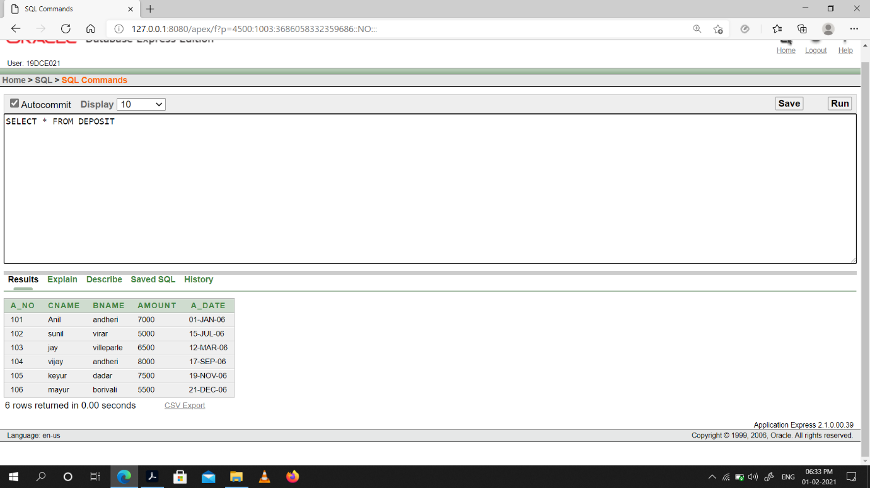

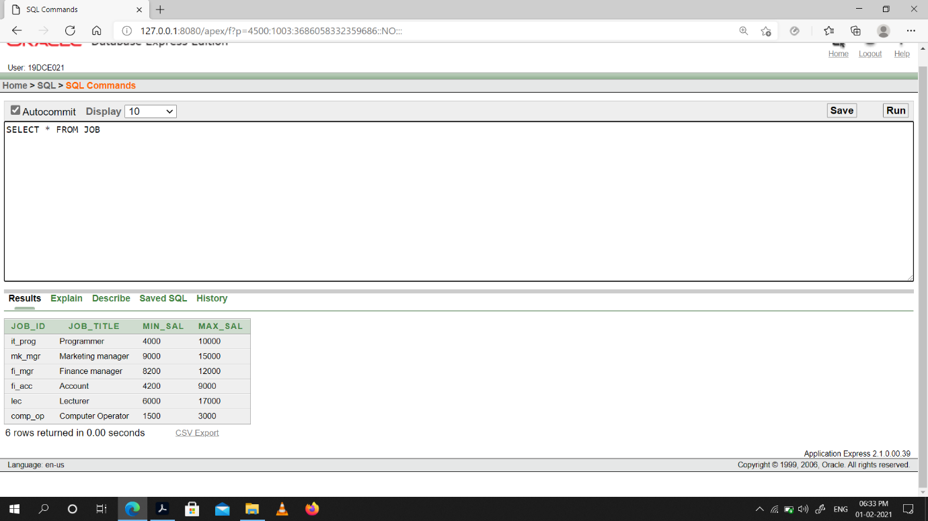

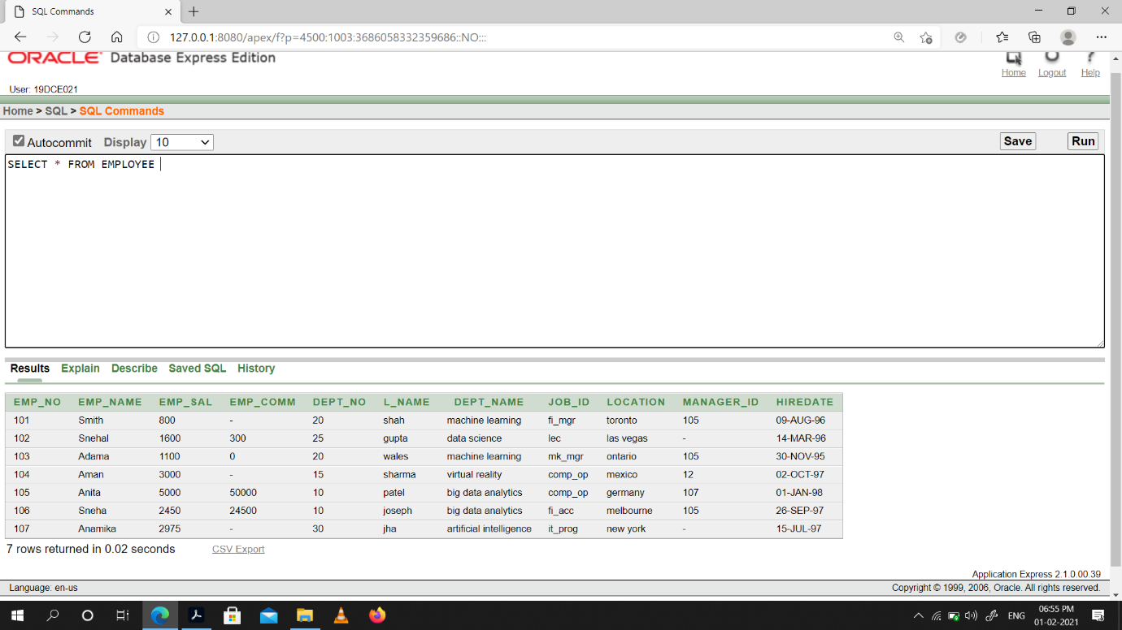

(2) Give details of account no. and deposited rupees of customers having account opened between dates 01-01-06 and 25-07-06.

Snap-Shot:

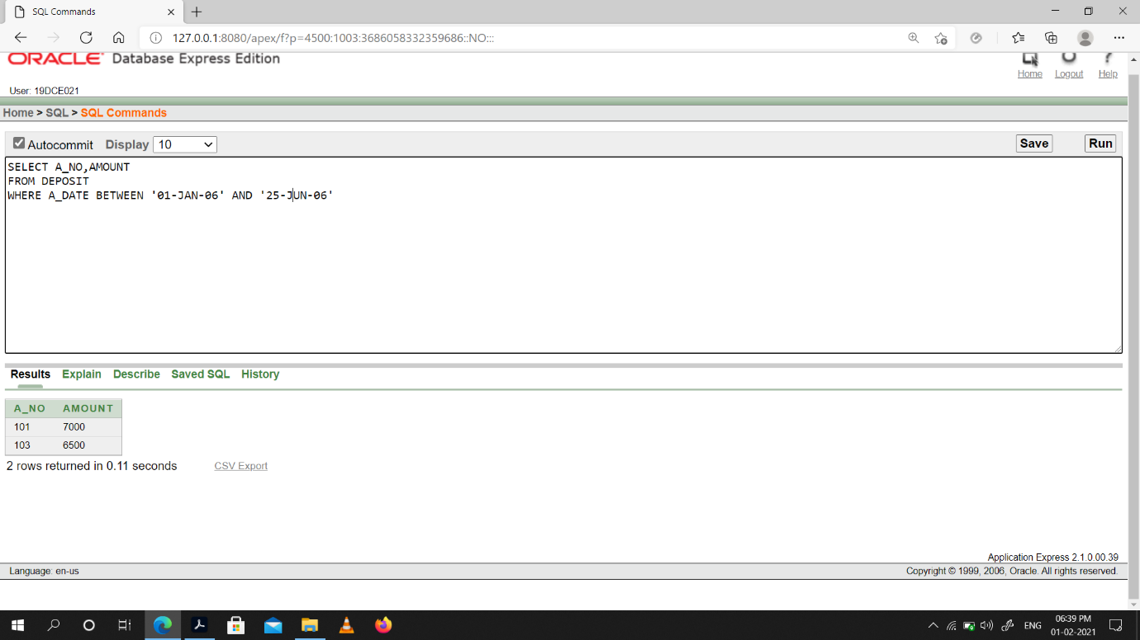

(3) Display all jobs with minimum salary is greater than 4000.

Snap-Shot:

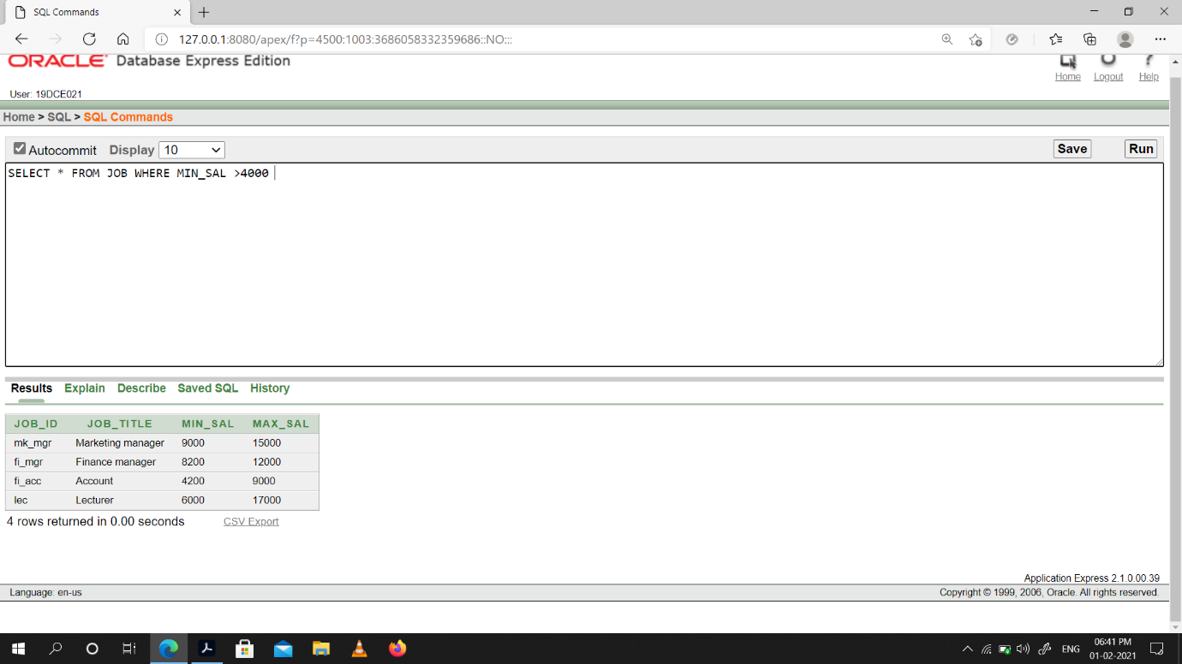

(4) Display name and salary of employee whose department no is 20. Give alias name to

name of employee.

Snap-Shot:

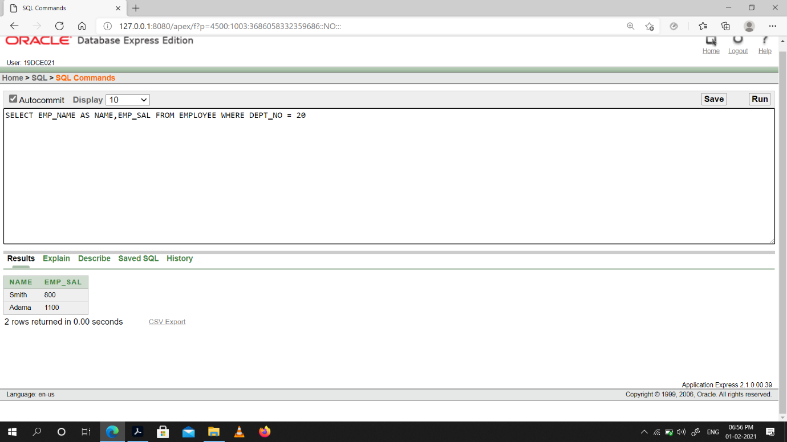

(5) Display employee no, name and department details of those employee whose department lies in (10,20).

Snap-Shot:

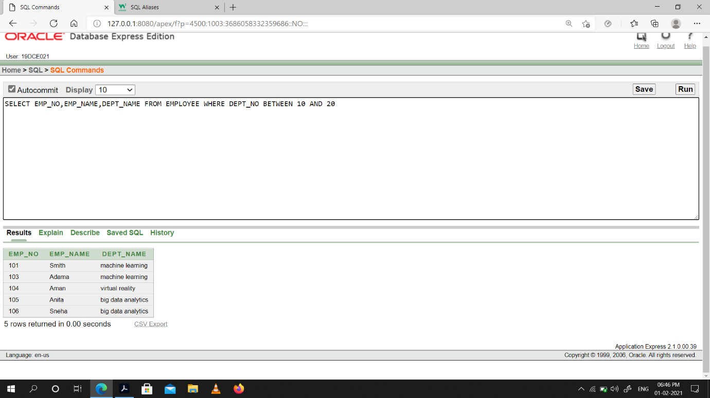

(6) Display the non-null values of employees.

Snap-Shot:

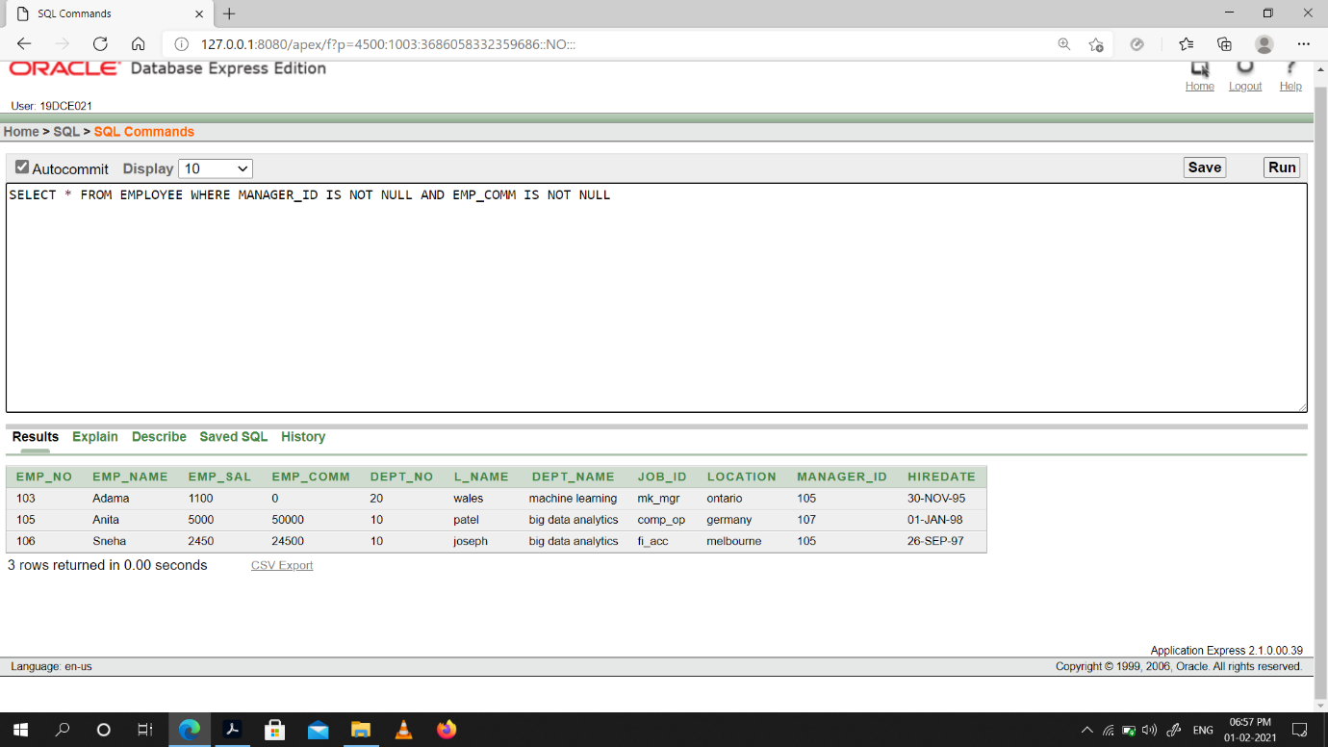

(7) Display name of customer along with its account no (both columns should be displayed as one) whose amount is not equal to 8000 Rs.

Snap-Shot:

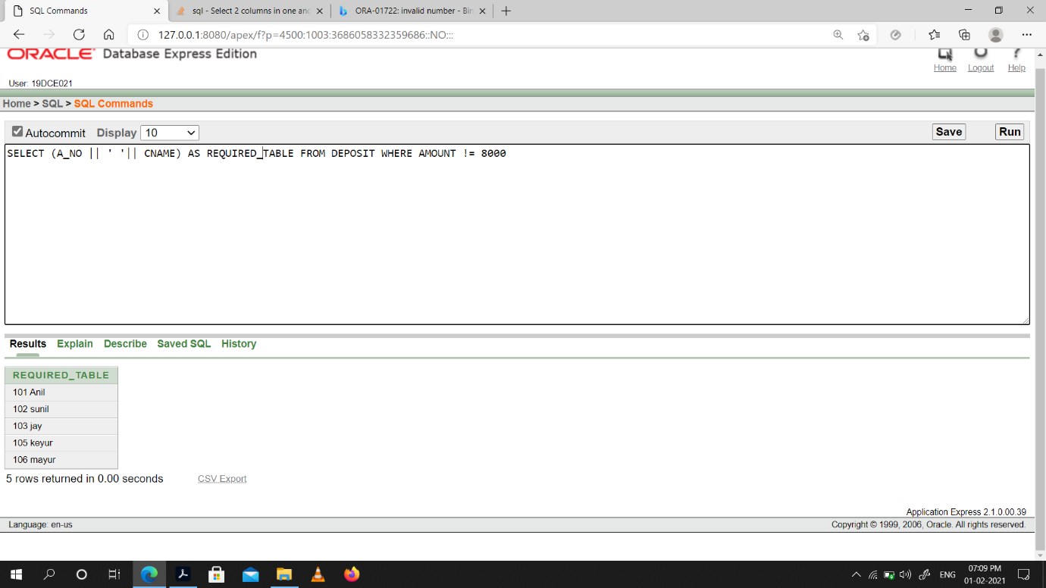

(8) Display the content of job details with minimum salary either 2000 or 4000.

Snap-Shot:

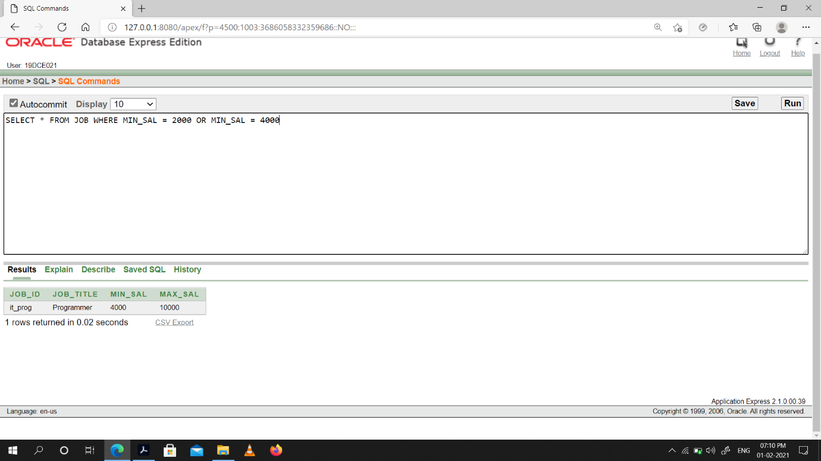

**To study various options of LIKE predicate**

(1) Display all employee whose name start with ‘A’ and third character is ‘‘a’.

Snap-Shot:

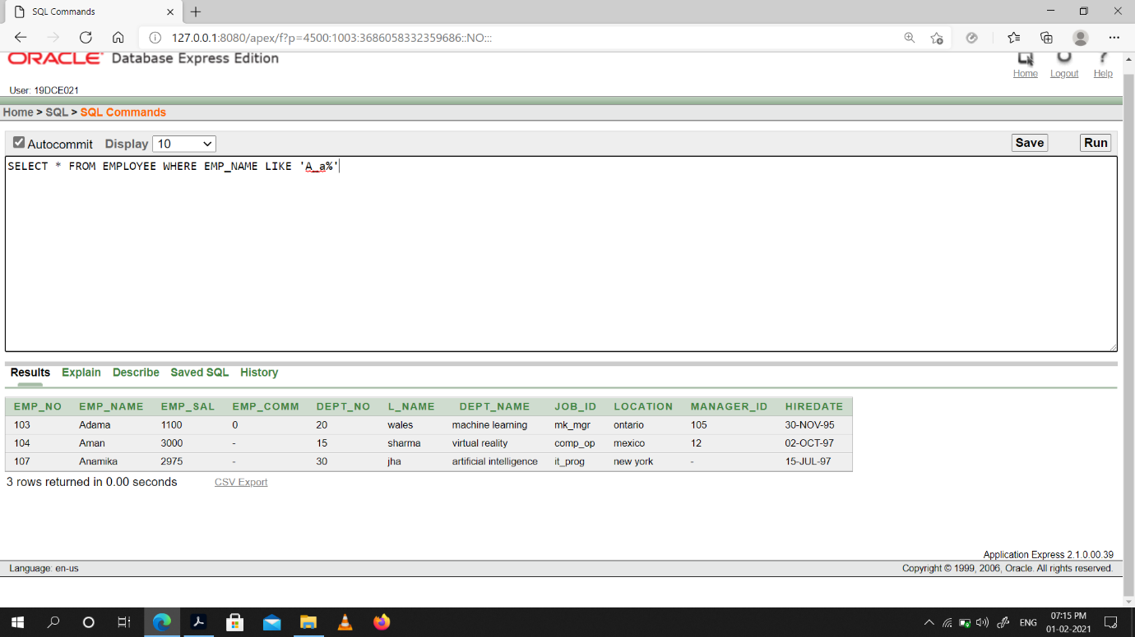

(2) Display name, number and salary of those employees whose name is 5 characters long and first three characters are ‘Ani’.

Snap-Shot:

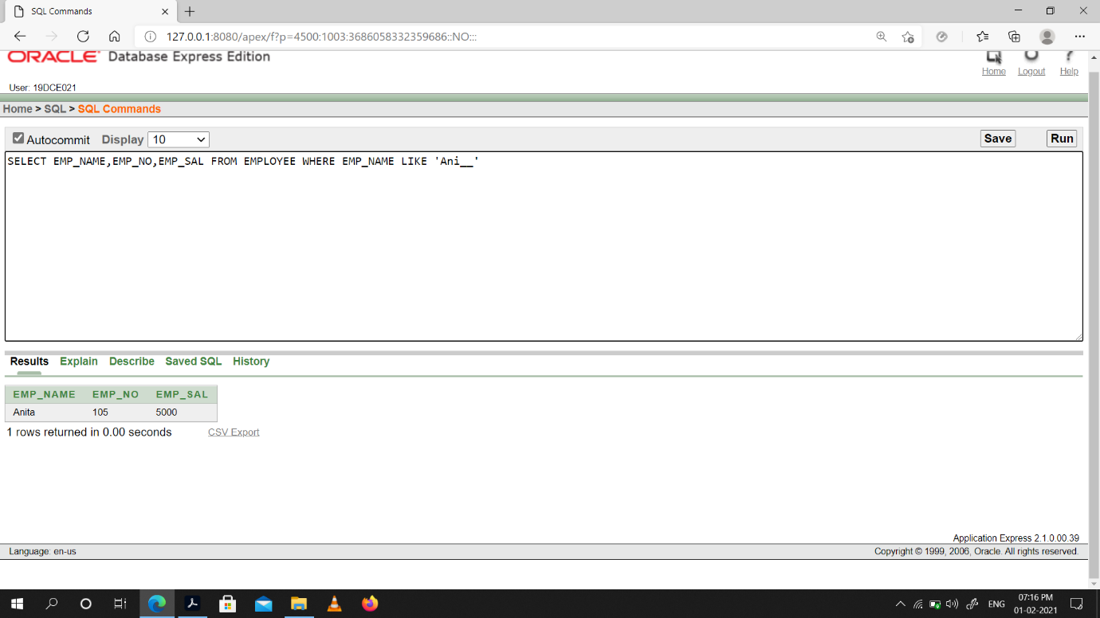

(3) Display all information of employee whose second character of name is either ‘M’ or ‘N’.

Snap-Shot:

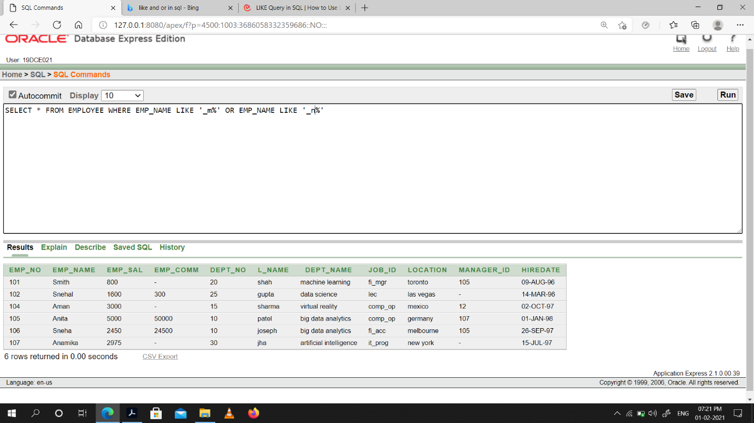

(4) Find the list of all customer name whose branch is in ‘andheri’ or ‘dadar’ or ‘virar’.

Snap-Shot:

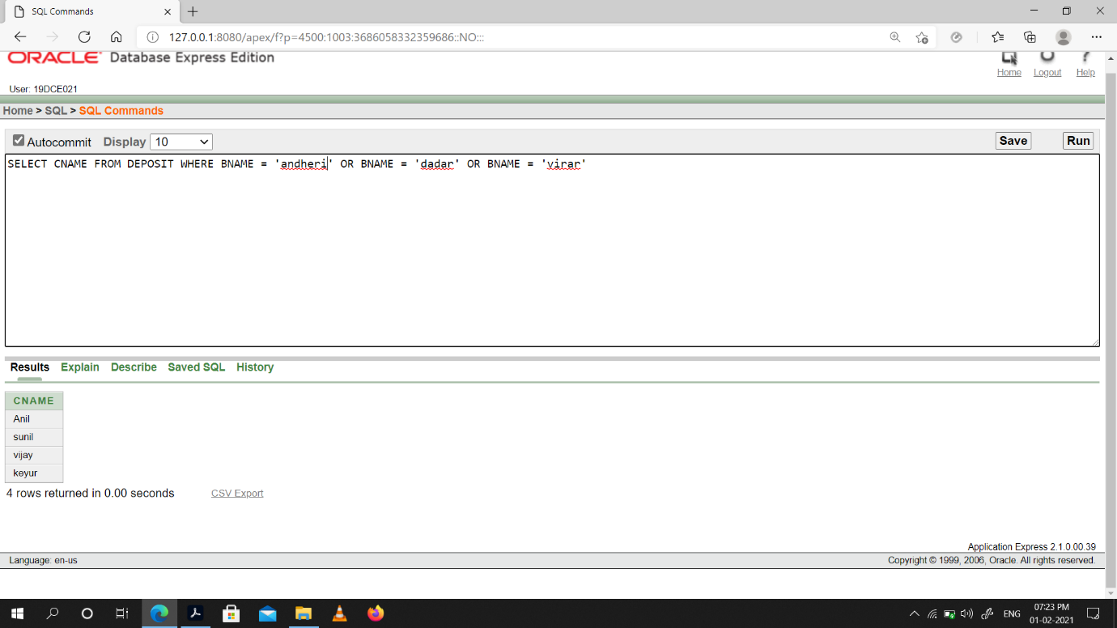

(5) Display the job name whose first three character in job id field is ‘FI_’.

Snap-Shot:

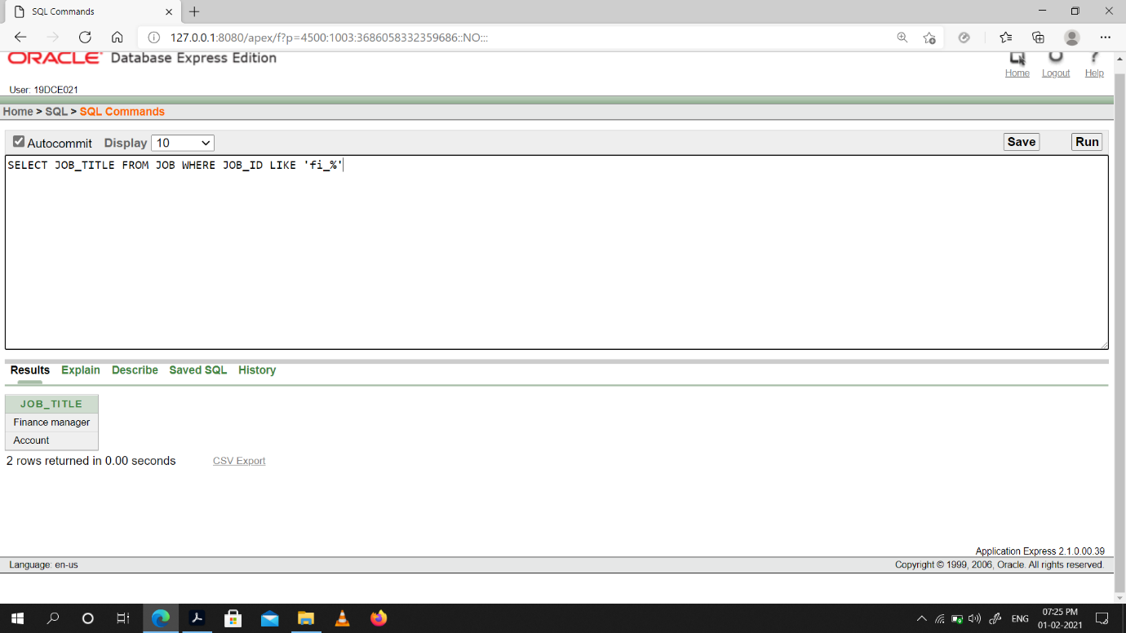

(6) Display the title/name of job who’s last three character are ‘_MGR’ and their maximum salary is greater than Rs 12000.

Snap-Shot:

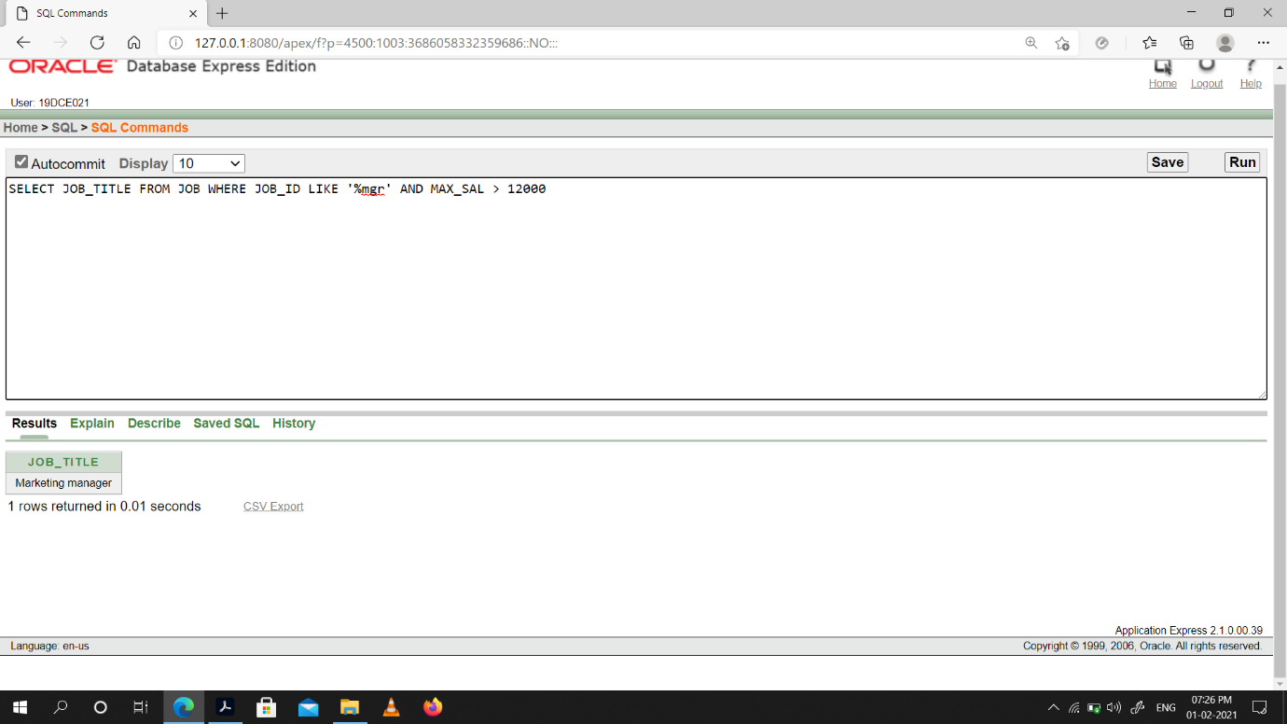

(7) Display the non-null values of employees and also employee name second character

should be ‘n’ and string should be 5-character long.

Snap-Shot:

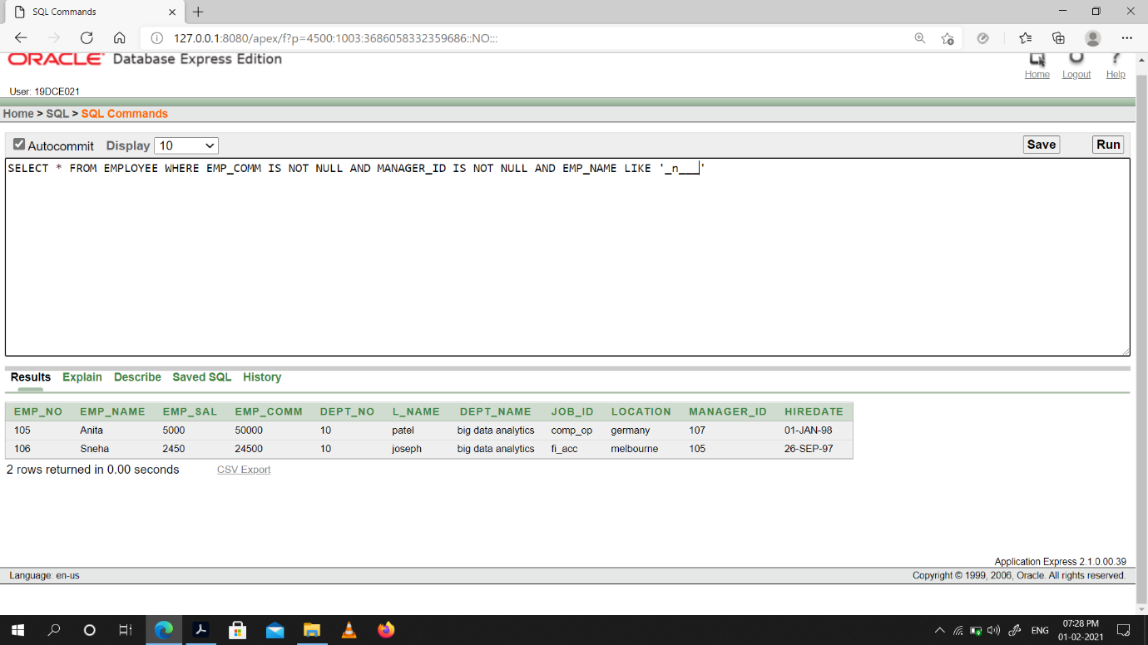

(8) Display the null values of employee and also employee name’s third character should be ‘a’.

Snap-Shot:

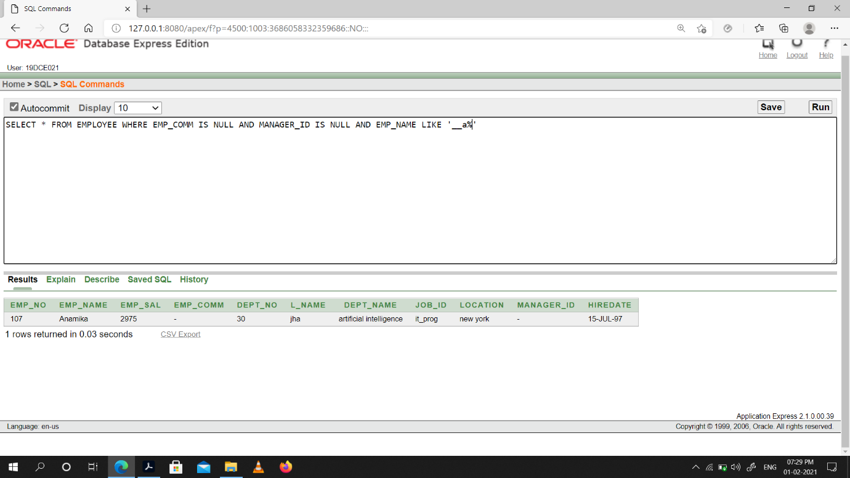

(9) What will be output if you are giving LIKE predicate as ‘%\_%’ ESCAPE ‘\’

Snap-Shot:

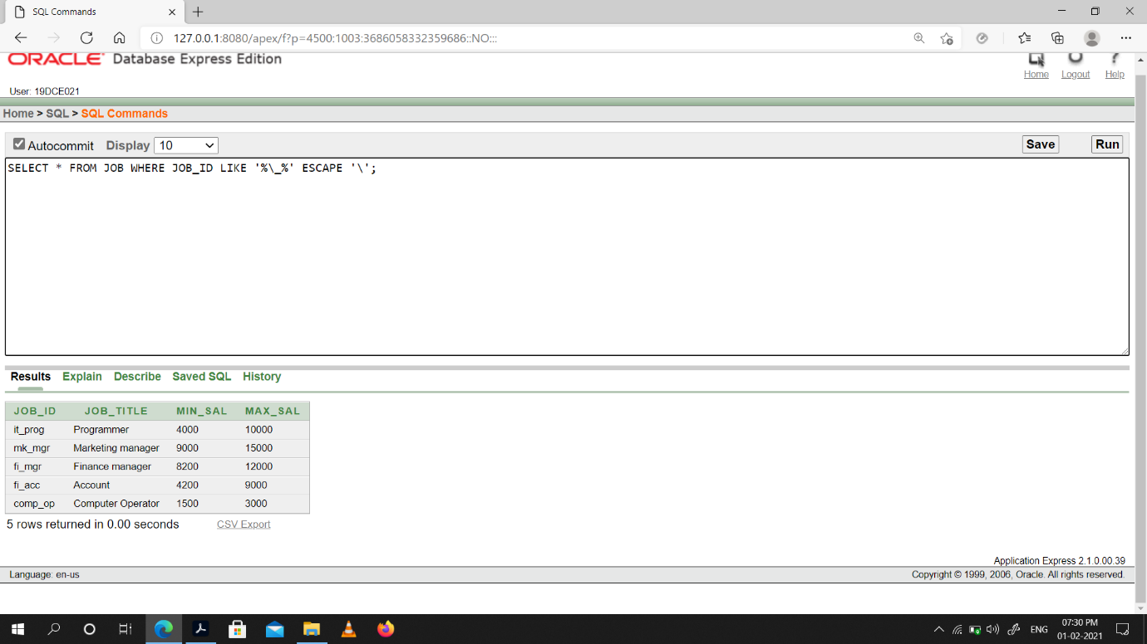

**Conclusion:** We Learned how to use Like Predicate & perform specific queries.

**Practical -5**

**To Perform various data manipulation commands, aggregate functions and sorting concept on all created tables.**

(1) List total deposit from deposit.

Snap-Shot:

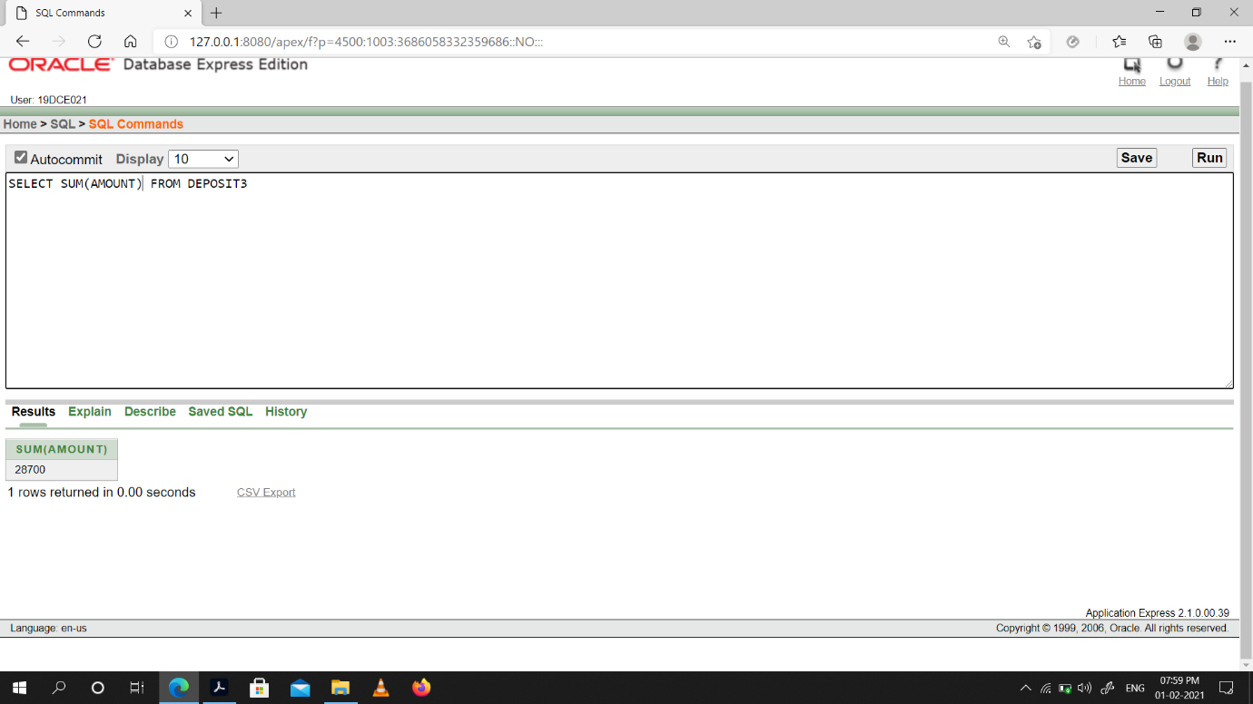

(2) List total loan from karolbagh branch

Snap-Shot:

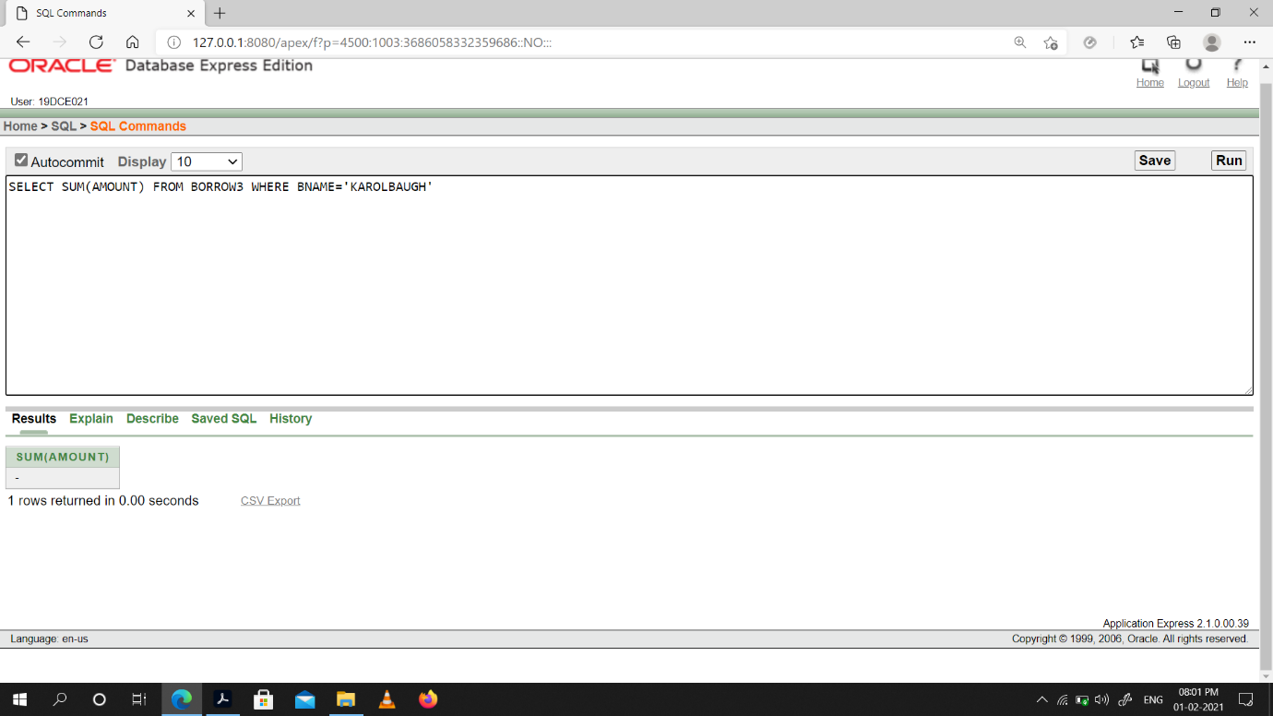

(3) Give maximum loan from branch vrce.

Snap-Shot:

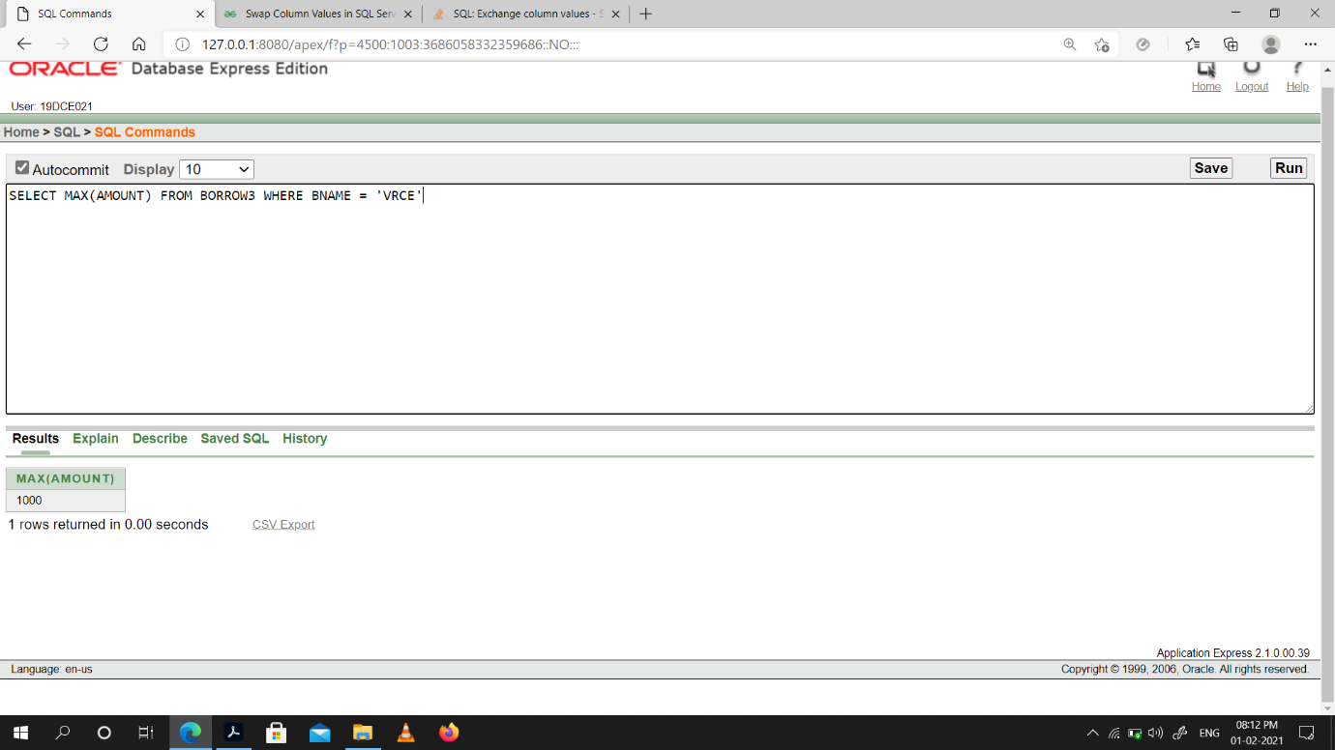

(4) Count total number of customers

Snap-Shot:

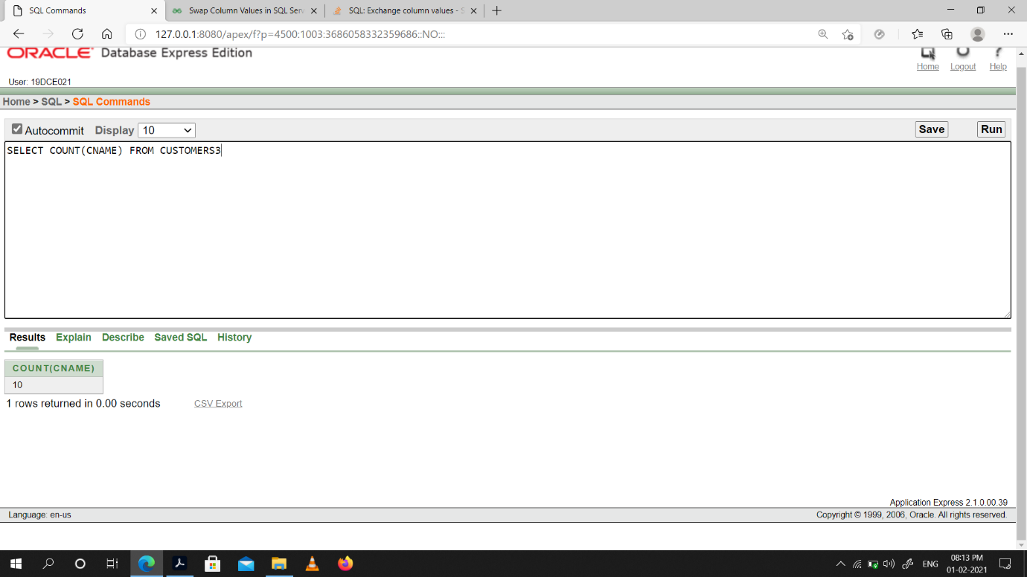

(5) Count total number of customer’s cities.

Snap-Shot:

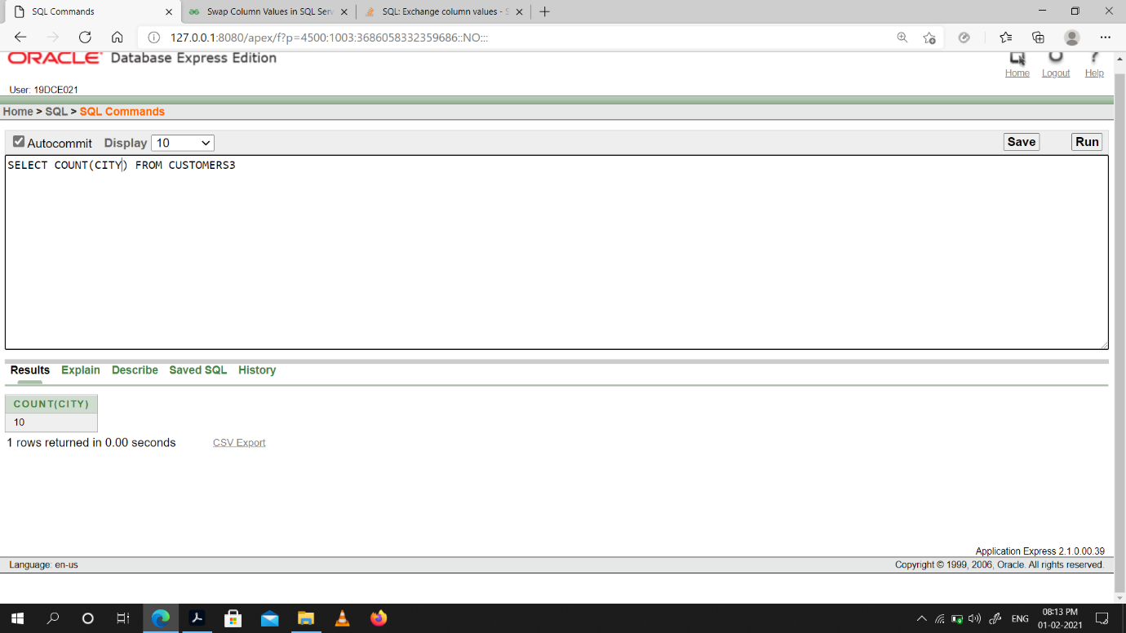

(6) Create table supplier from employee with all the columns.

Snap-Shot:

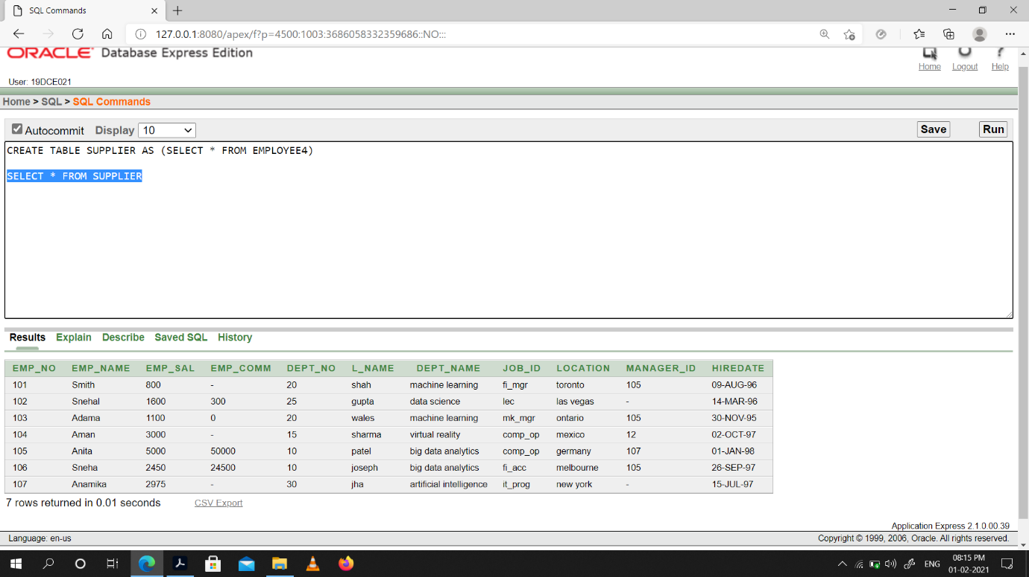

(7) Create table sup1 from employee with first two columns.

Snap-Shot:

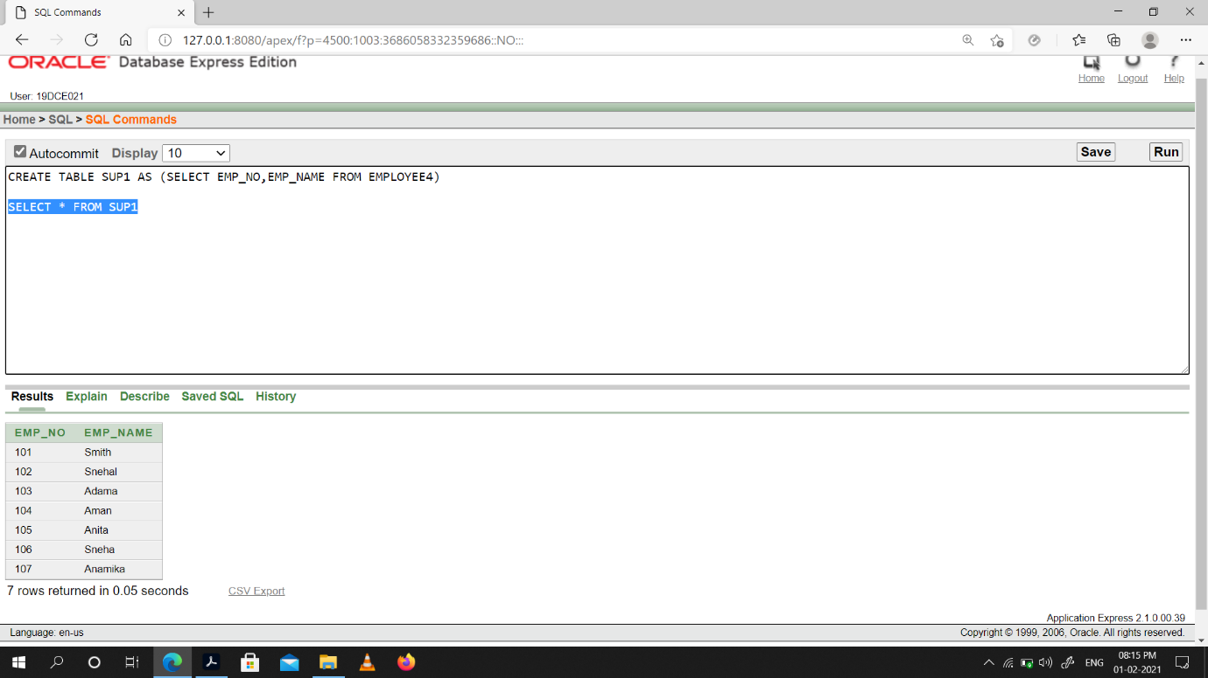

(8) Create table sup2 from employee with no data

Snap-Shot:

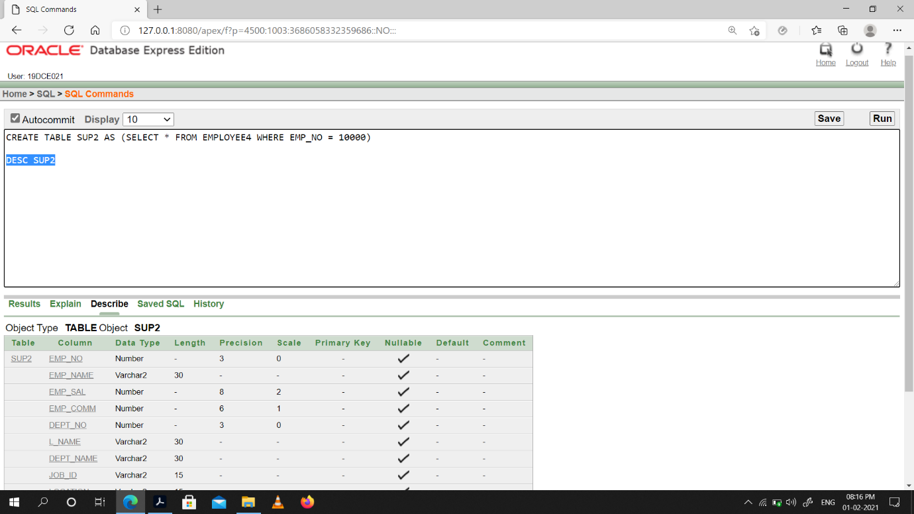

(9) Insert the data into sup2 from employee whose second character should be ‘n’ and string should be 5 characters long in employee name field.

Snap-Shot:

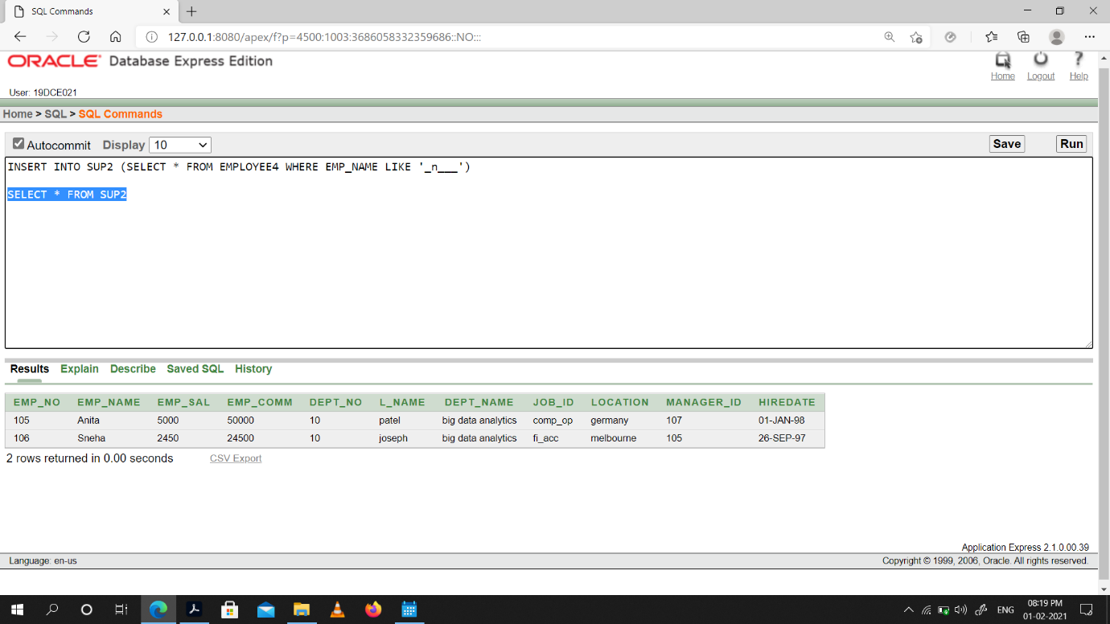

(10) Delete all the rows from sup1.

Snap-Shot:

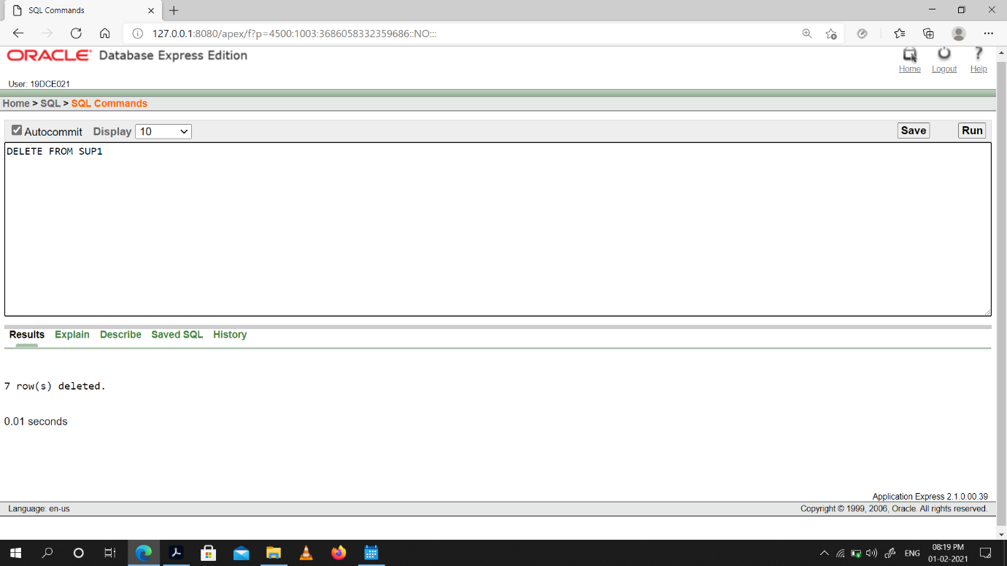

(11) Delete the detail of supplier whose sup_no is 103.

Snap-Shot:

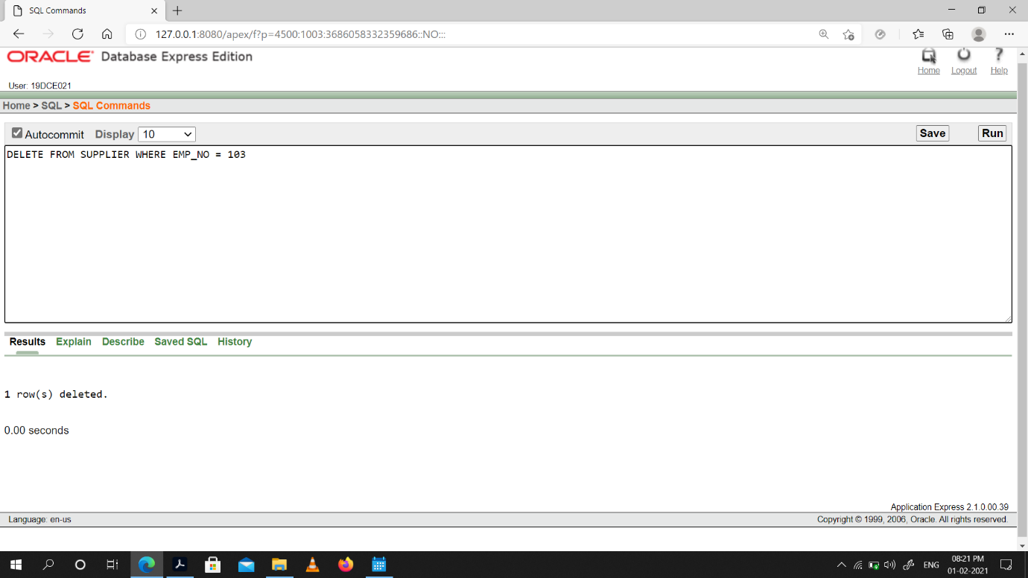

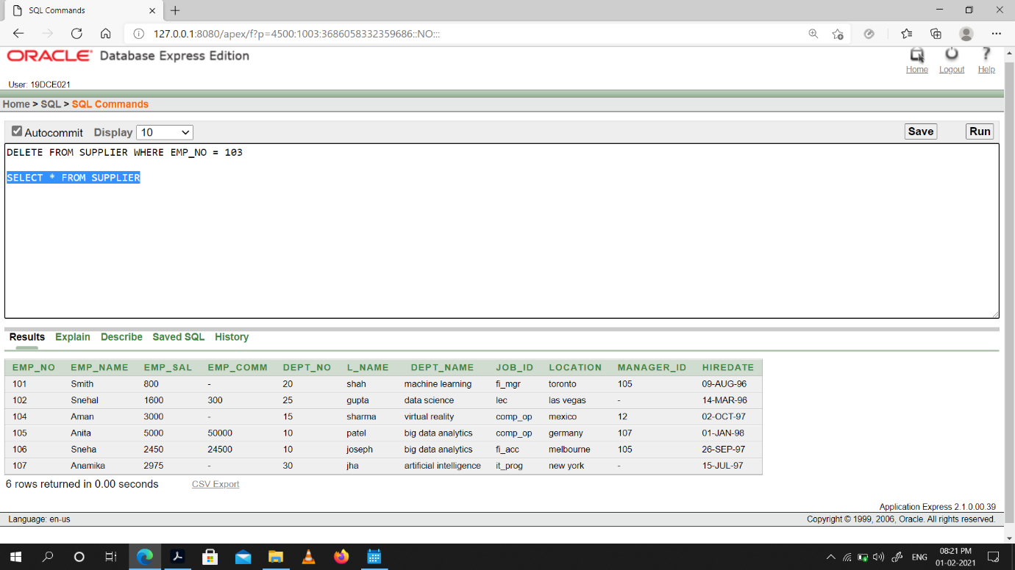

(12) Rename the table sup2.

Snap-Shot:

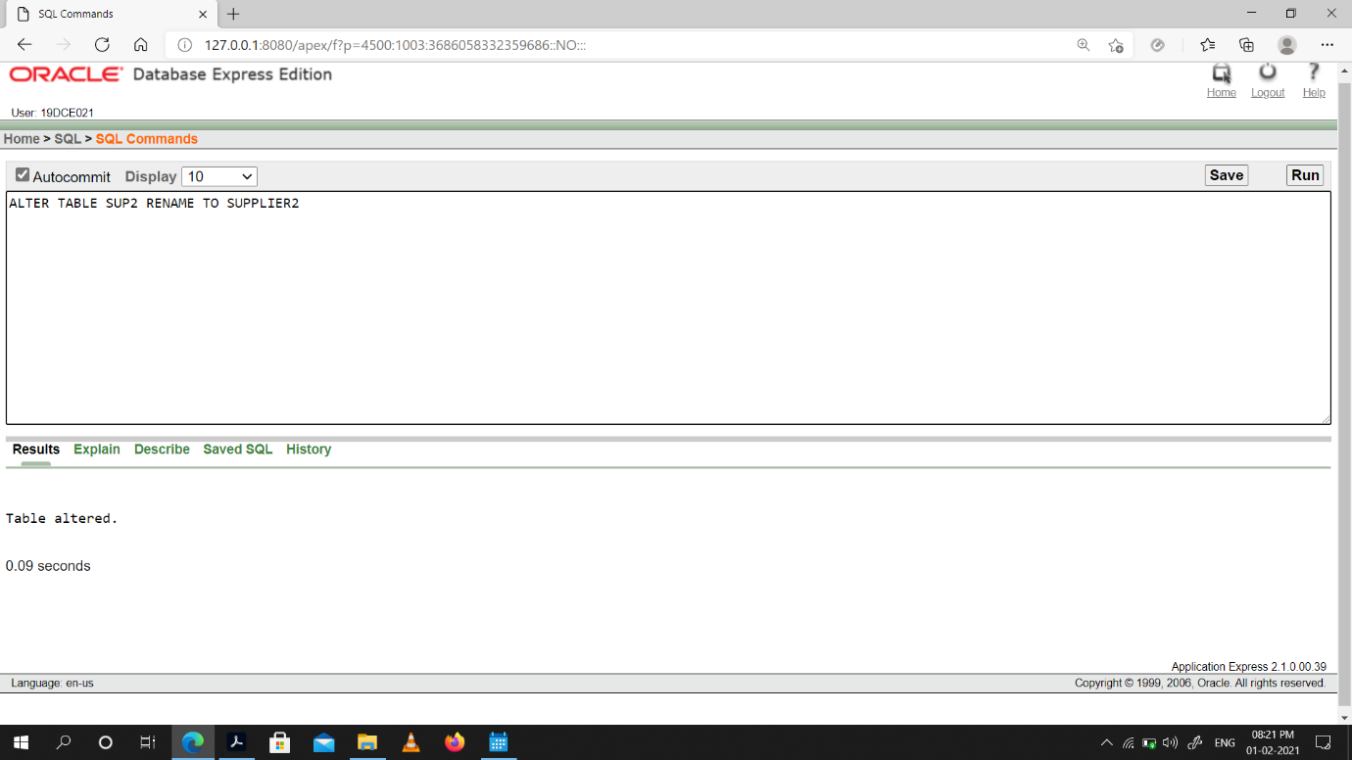

(13) Destroy table sup1 with all the data.

Snap-Shot:

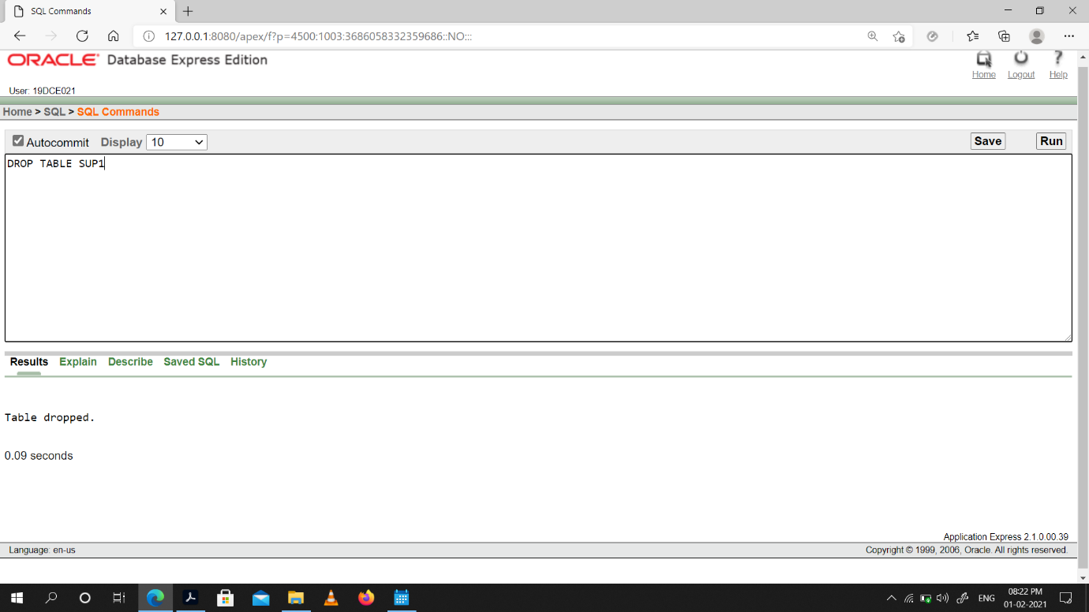

(14) Update the value dept_no to 10 where second character of emp. name is ‘m’.

Snap-Shot:

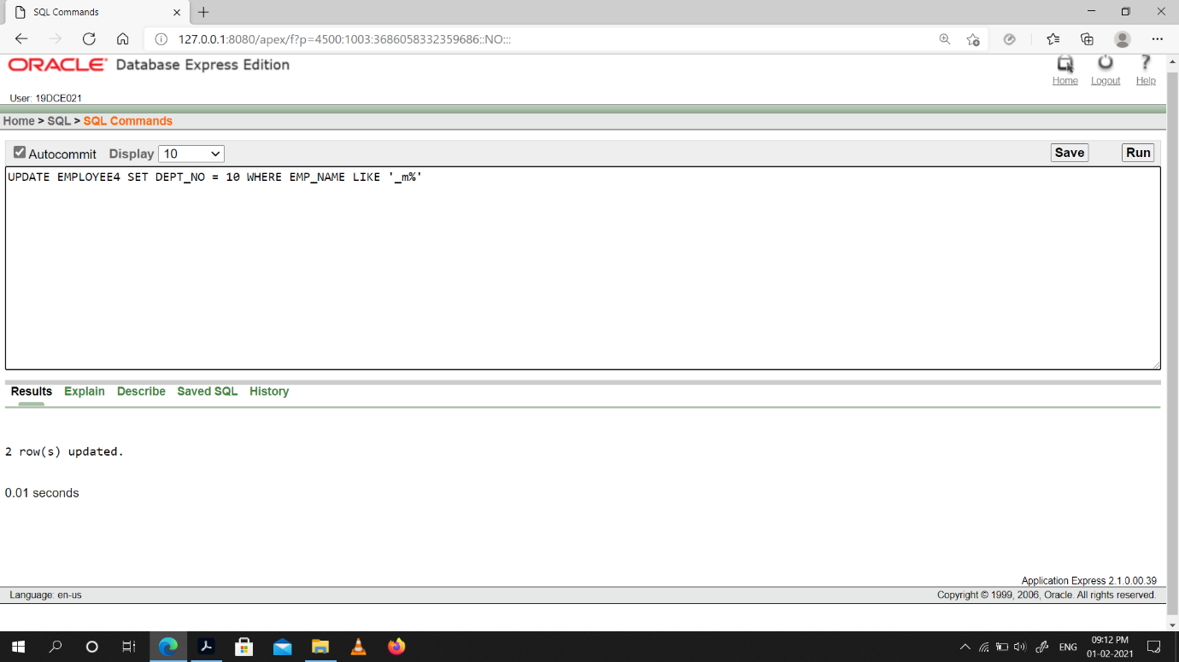

(15) Update the value of employee name whose employee number is 103.

Snap-Shot:

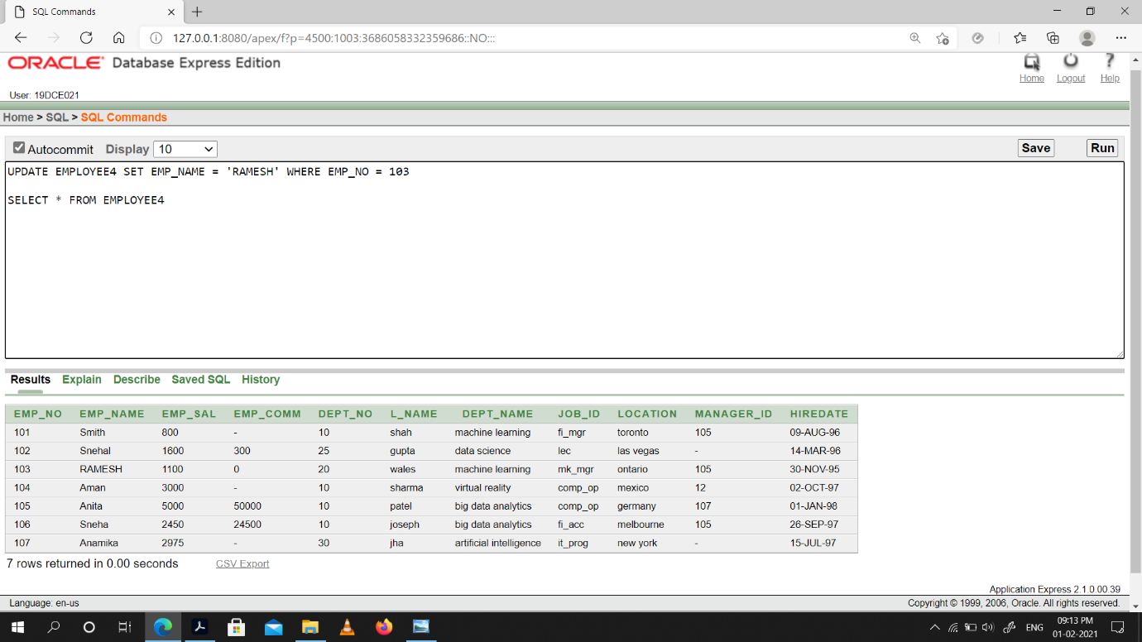

(16) Add one column phone to employee with size of column is 10.

Snap-Shot:

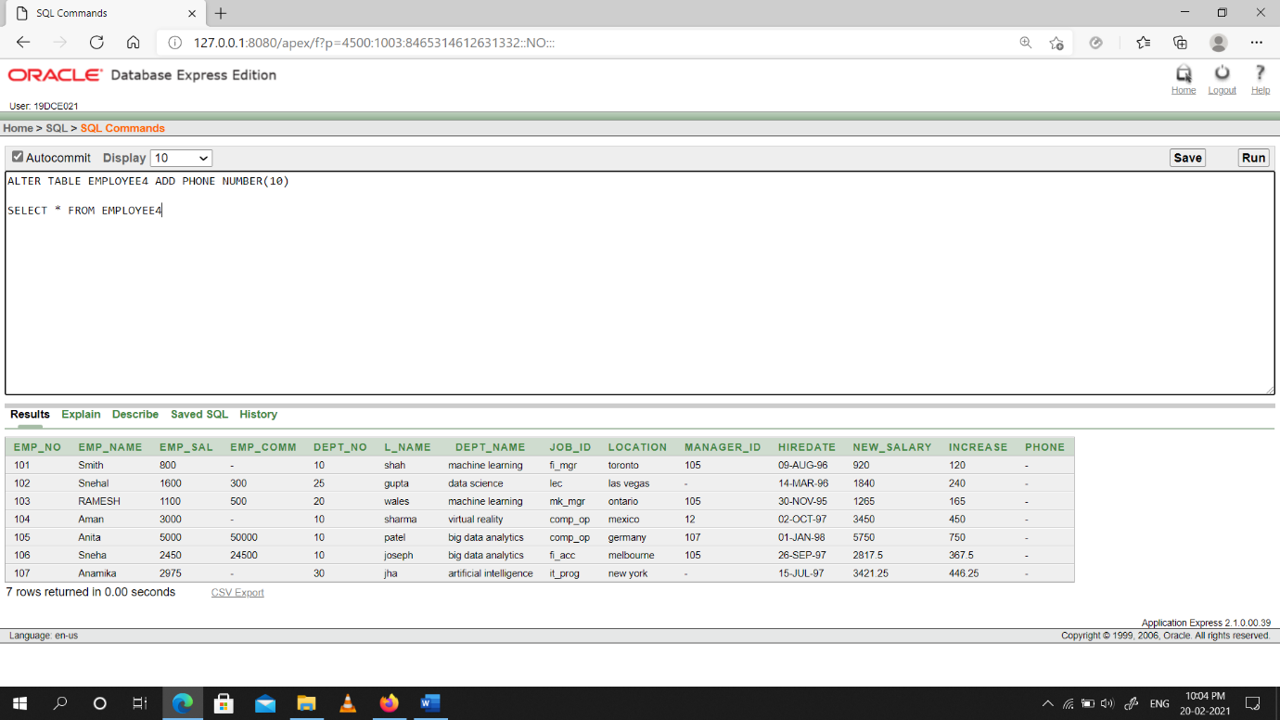

(17) Modify the column emp_name to hold maximum of 30 characters.

Snap-Shot:

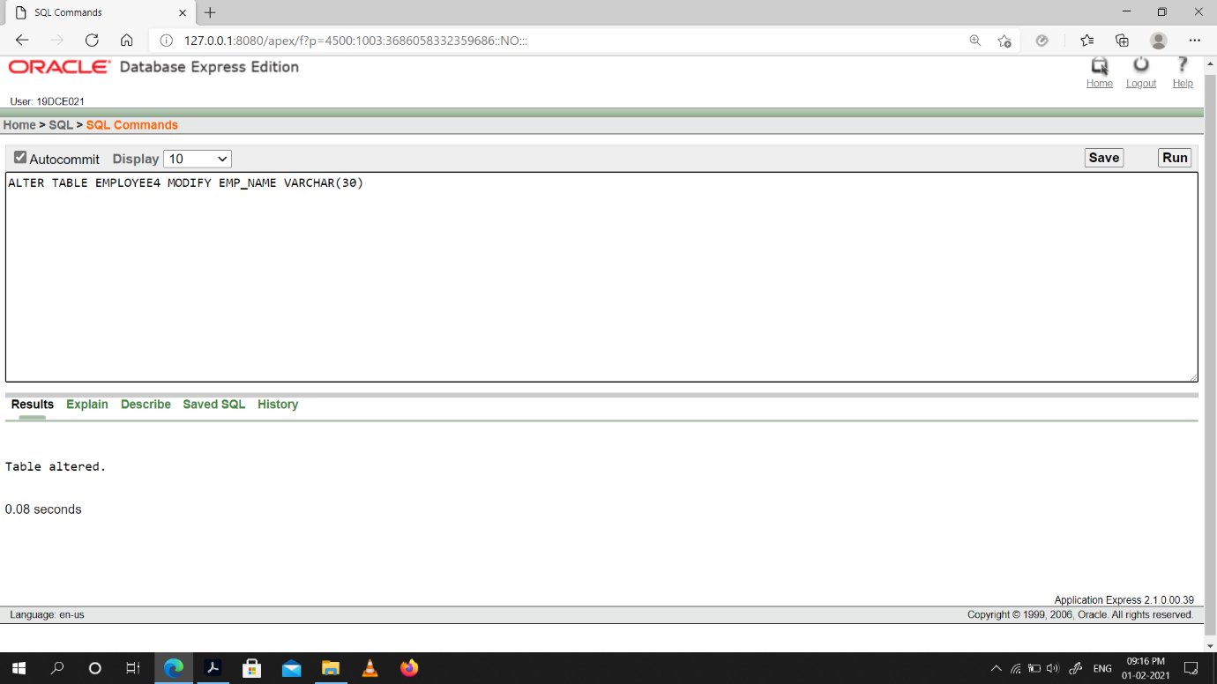

(18) Count the total no as well as distinct rows in dept_no column with a condition of salary greater than 1000 of employee

Snap-Shot:

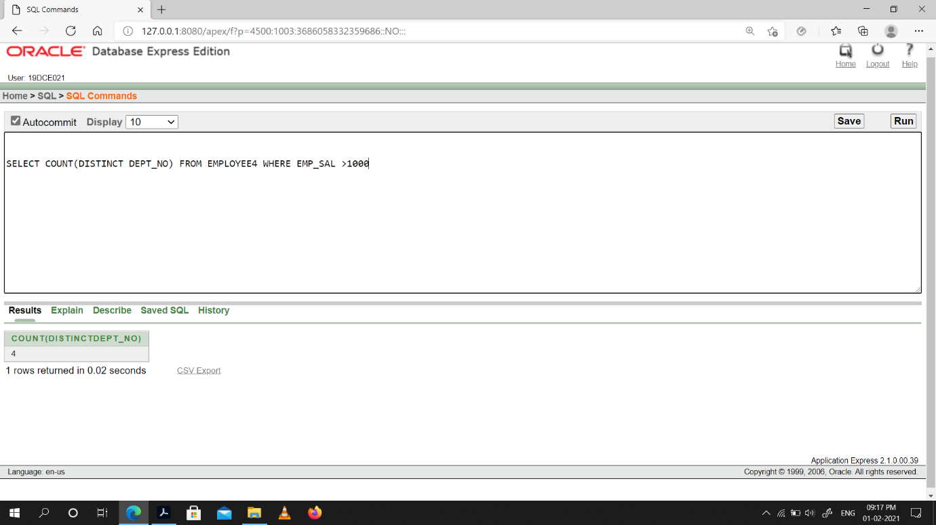

(19) Display the detail of all employees in ascending order, descending order of their name and no.

Snap-Shot:

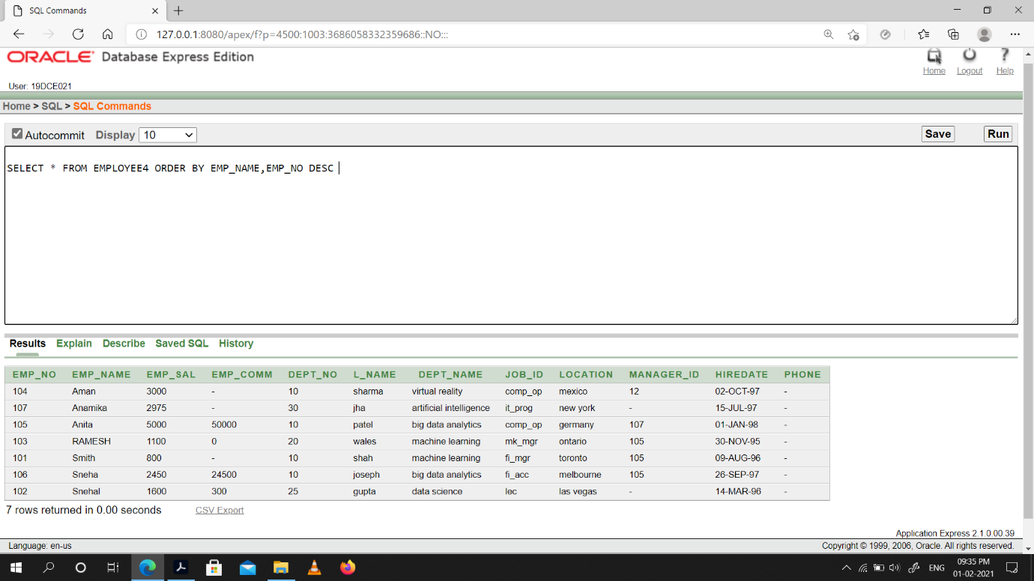

(20) Display the dept_no in ascending order and accordingly display emp_comm in descending order.

Snap-Shot:

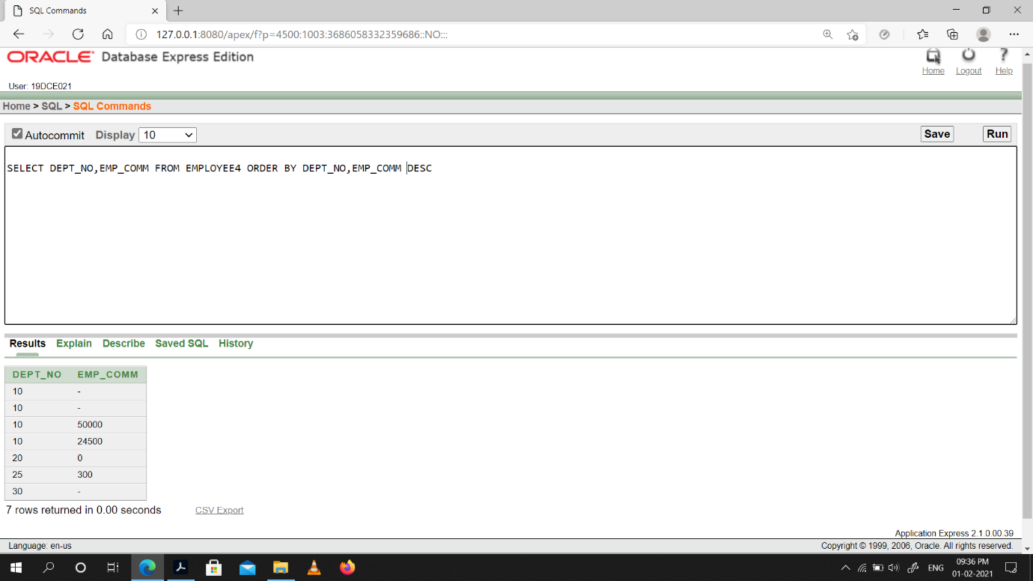

(21) Update the value of emp_comm to 500 where dept_no is 20.

Snap-Shot:

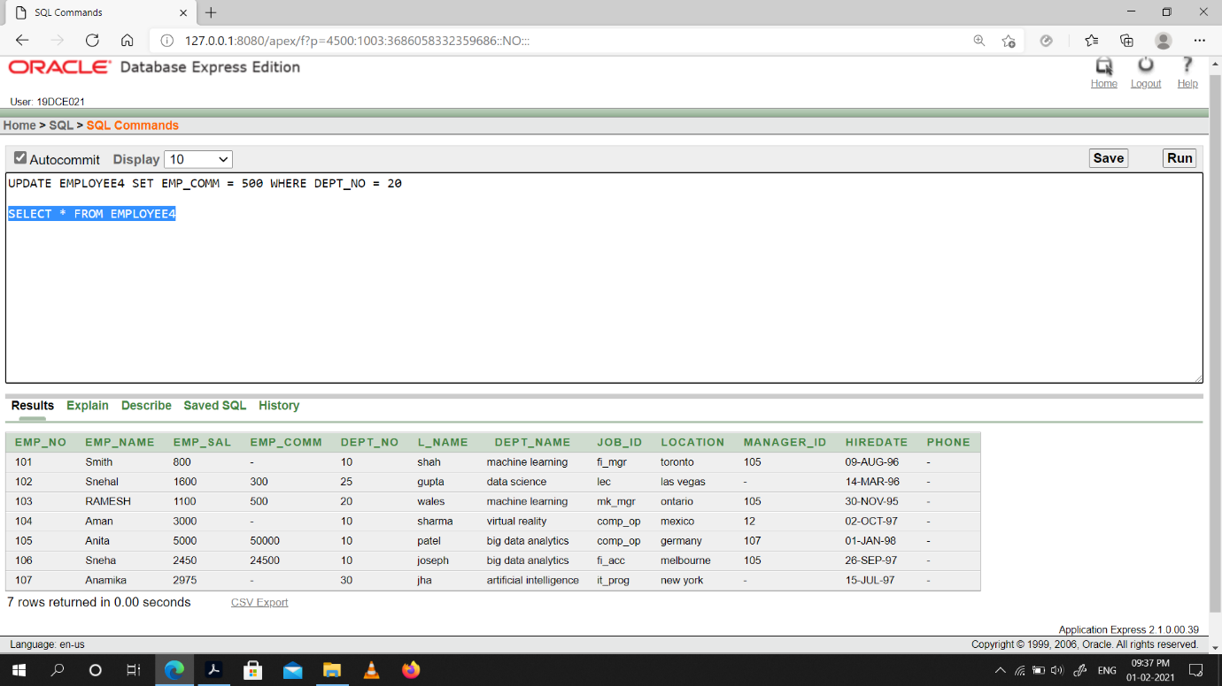

(22) Display the emp_comm in ascending order with null value first and accordingly sort employee salary in descending order.

Snap-Shot:

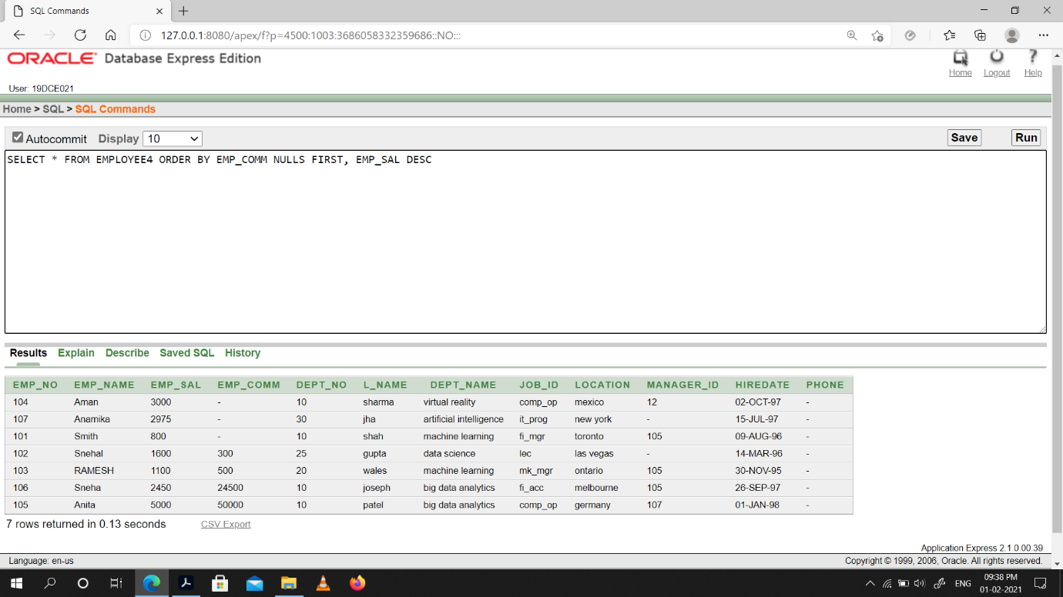

(23) Display the emp_comm in ascending order with null value last and accordingly sort emp_no in descending order.

Snap-Shot:

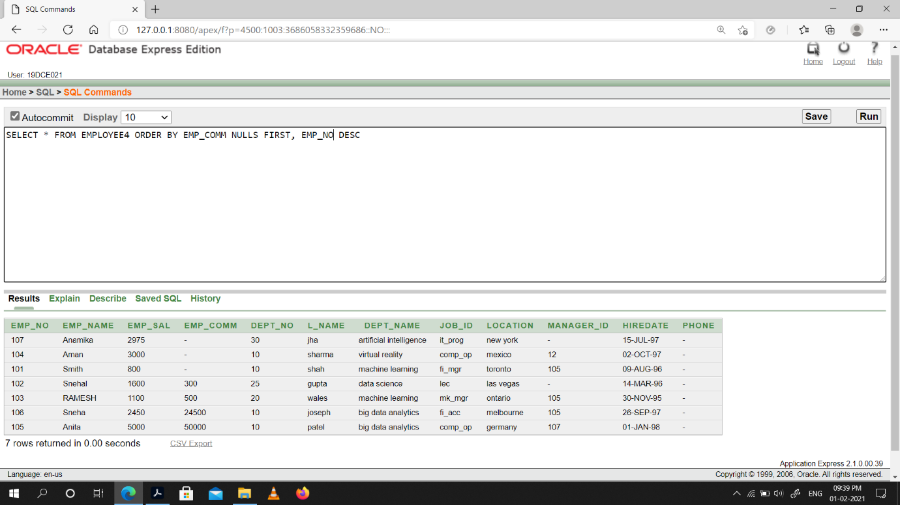

**Conclusion:** We Learned how to use aggregate functions, DML queries & Sorting.

**Practical -6**

**To study Single-row functions.**

(1) Write a query to display the current date. Label the column Date.

Snap-Shot:

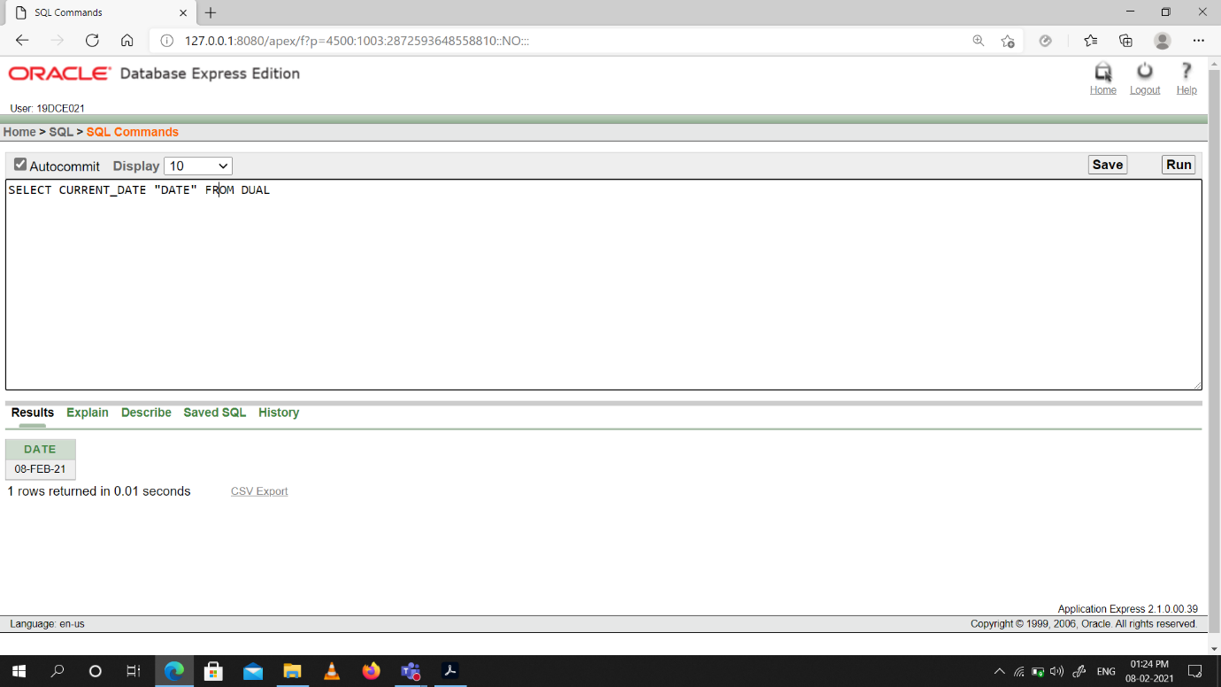

(2) For each employee, display the employee number, salary, and salary increased by 15% and expressed as a whole number. Label the column New Salary.

Snap-Shot:

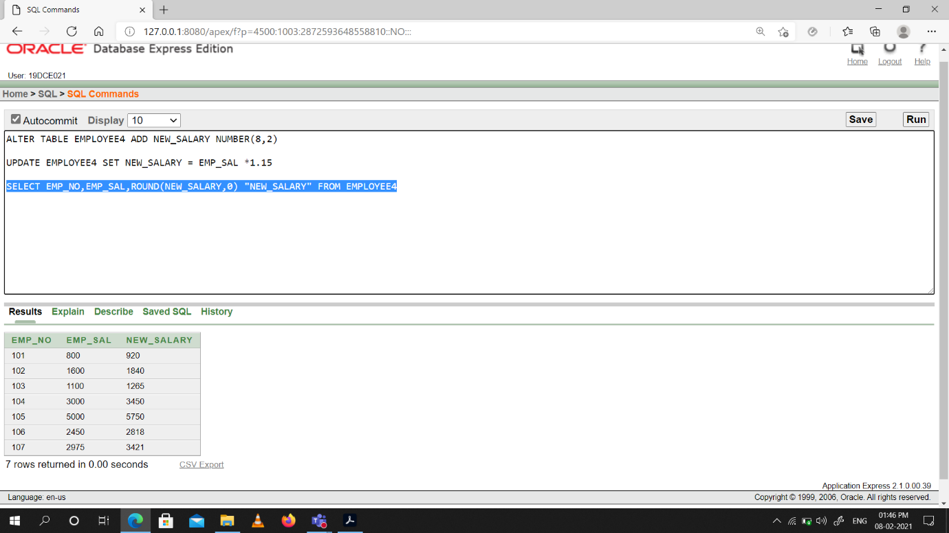

(3) Modify your query no (2) to add a column that subtracts the old salary from the new salary. Label the column Increase.

|  |  |
| --- | --- |
| Snap-Shot:    (4) Write a query that displays the employee’s names with the first letter capitalized and all other letters lowercase, and the length of the names, for all employees whose name starts with J, A, or M. Give each column an appropriate label. Sort the results by the employees’ last names.  Snap-Shot:    (5) Write a query that produces the following for each employee:  <employee last name> earns <salary> monthly  Snap-Shot:    (6) Display the name, date, number of months employed and day of the week on which the employee has started. Order the results by the day of the week starting with Monday.  Snap-Shot:    (7) Display the date of emp in a format that appears as Seventh of June 1994 12:00:00 AM.  Snap-Shot:    (8) Write a query to calculate the annual compensation of all employees (sal +comm.). | |
| Snap-Shot: | |
|  |  |

**Conclusion:** We Learned how to use Single-row functions**.**

**Practical -7**

**Displaying data from Multiple Tables (join)**

(1) Give details of customers ANIL.

Snap-Shot:

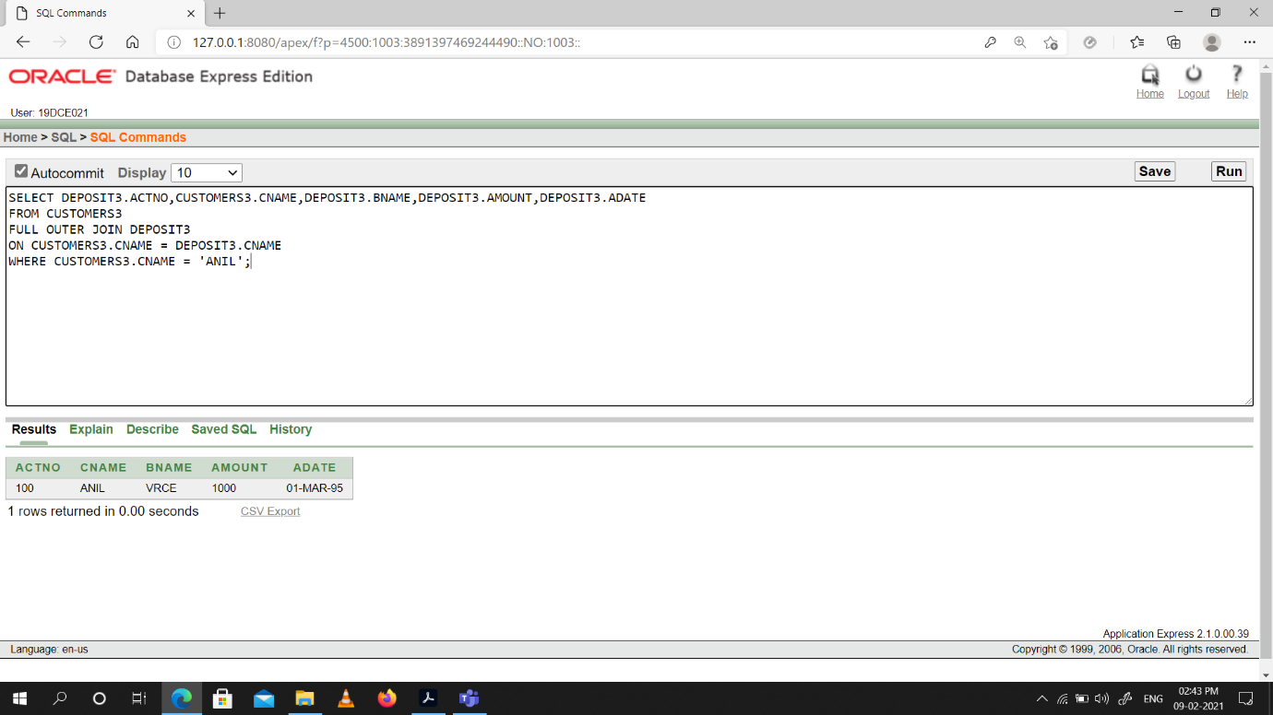

(2) Give name of customer who are borrowers and depositors and having living city nagpur

Snap-Shot:

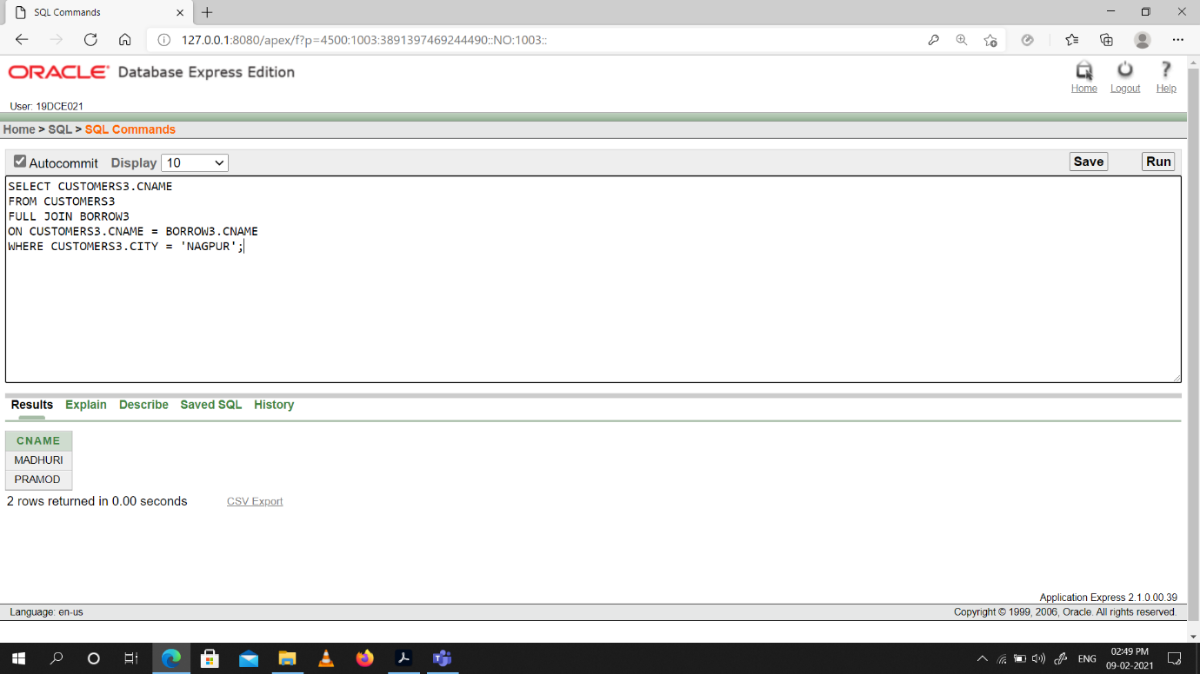



(3) Give city as their city name of customers having same living branch.

Snap-Shot:

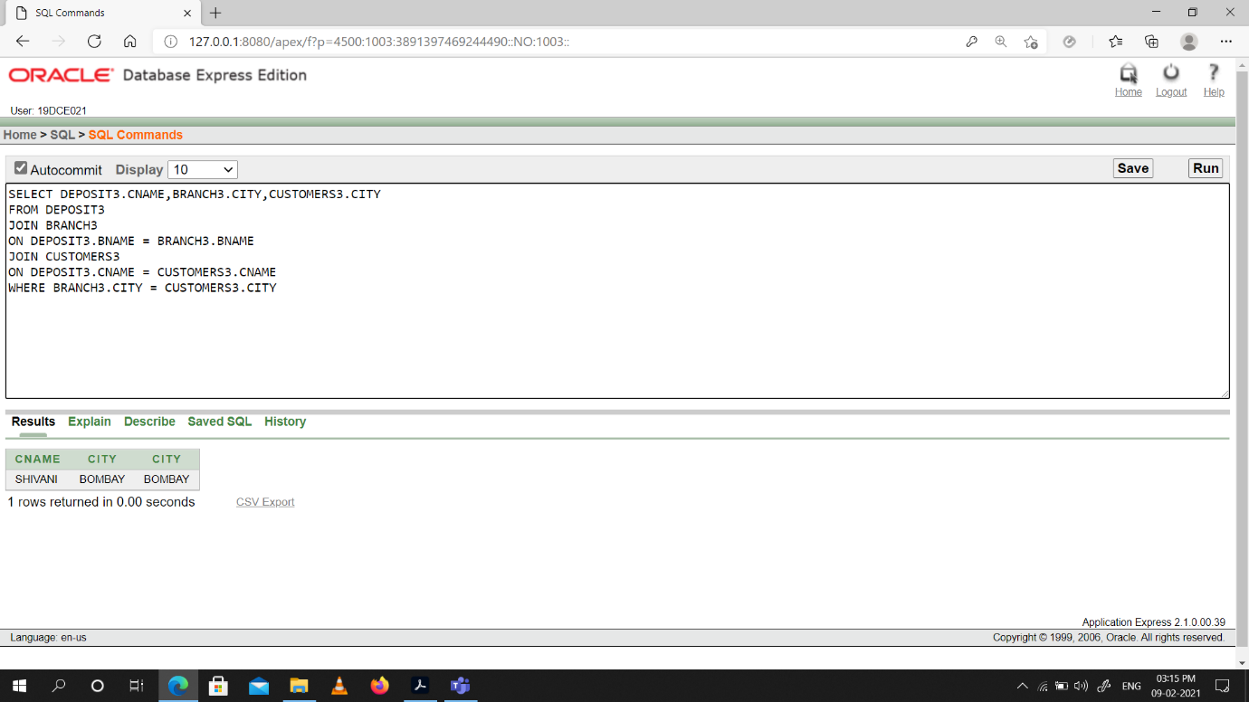

(4) Write a query to display the last name, department number, and department name for all employees.

Snap-Shot:

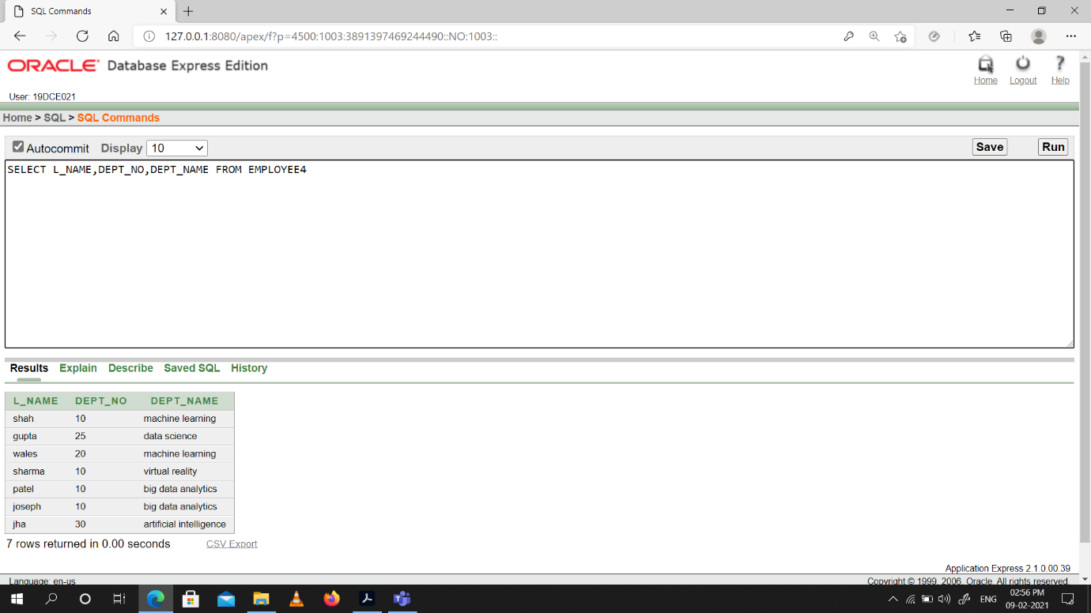

(5) Create a unique listing of all jobs that are in department 30. Include the location of the department in the output

Snap-Shot:

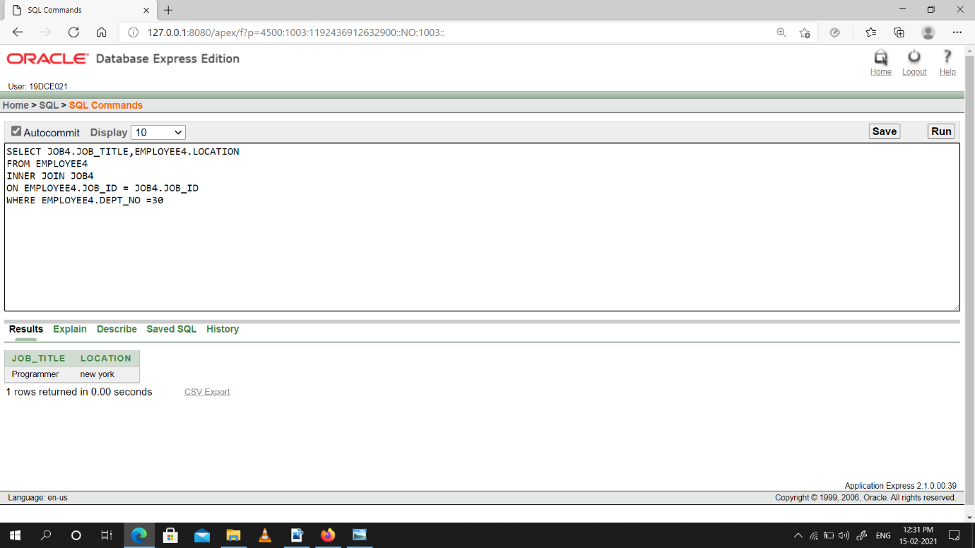

(6) Write a query to display the employee name, department number, and department name

for all employees who work in NEW YORK.

Snap-Shot:

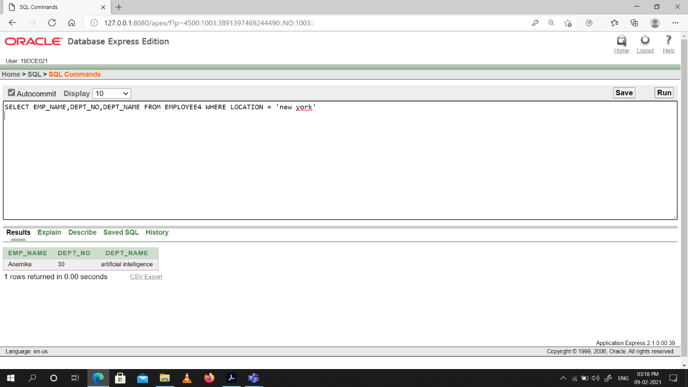

(7) Display the employee last name and employee number along with their manager’s last name and manager number. Label the columns Employee, Emp#, Manager, and Mgr#, respectively.

Snap-Shot:

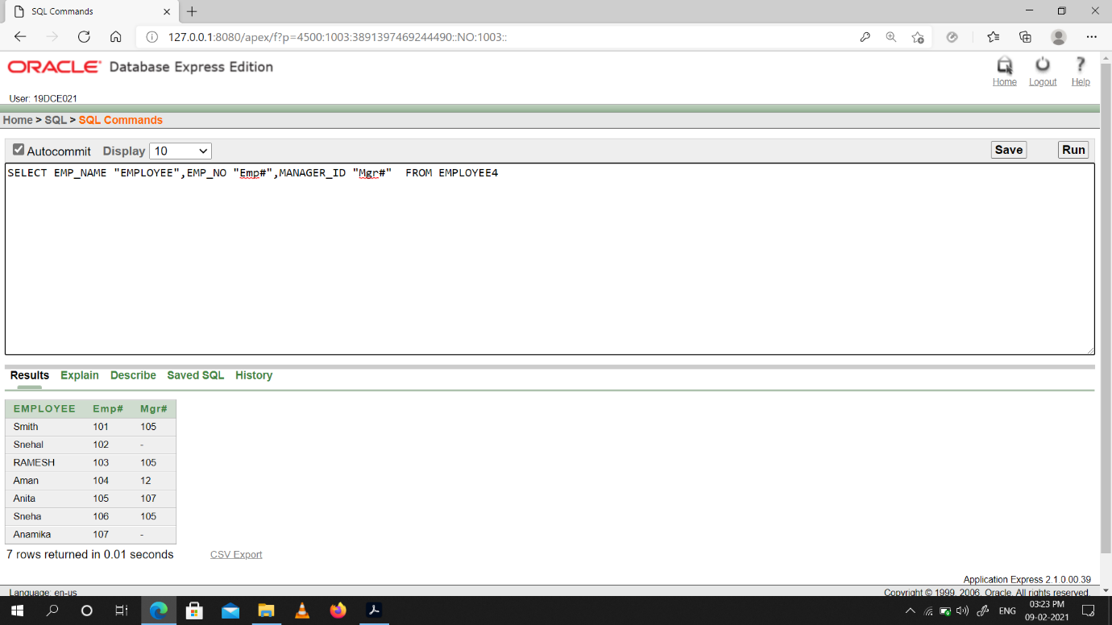

(8) Create a query to display the name and hire date of any employee hired after employee “smith”.

Snap-Shot:

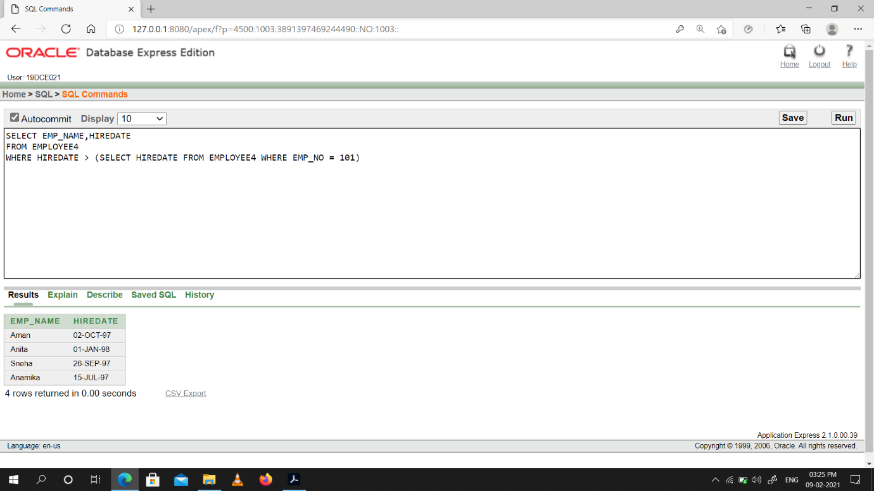

**Conclusion:** We Learned how to display data using join from multiple tables.

**Practical -8**

**To apply the concept of Aggregating Data using Group functions.**

(1) List total deposit of customer having account date after 1-jan-96.

Snap-Shot:

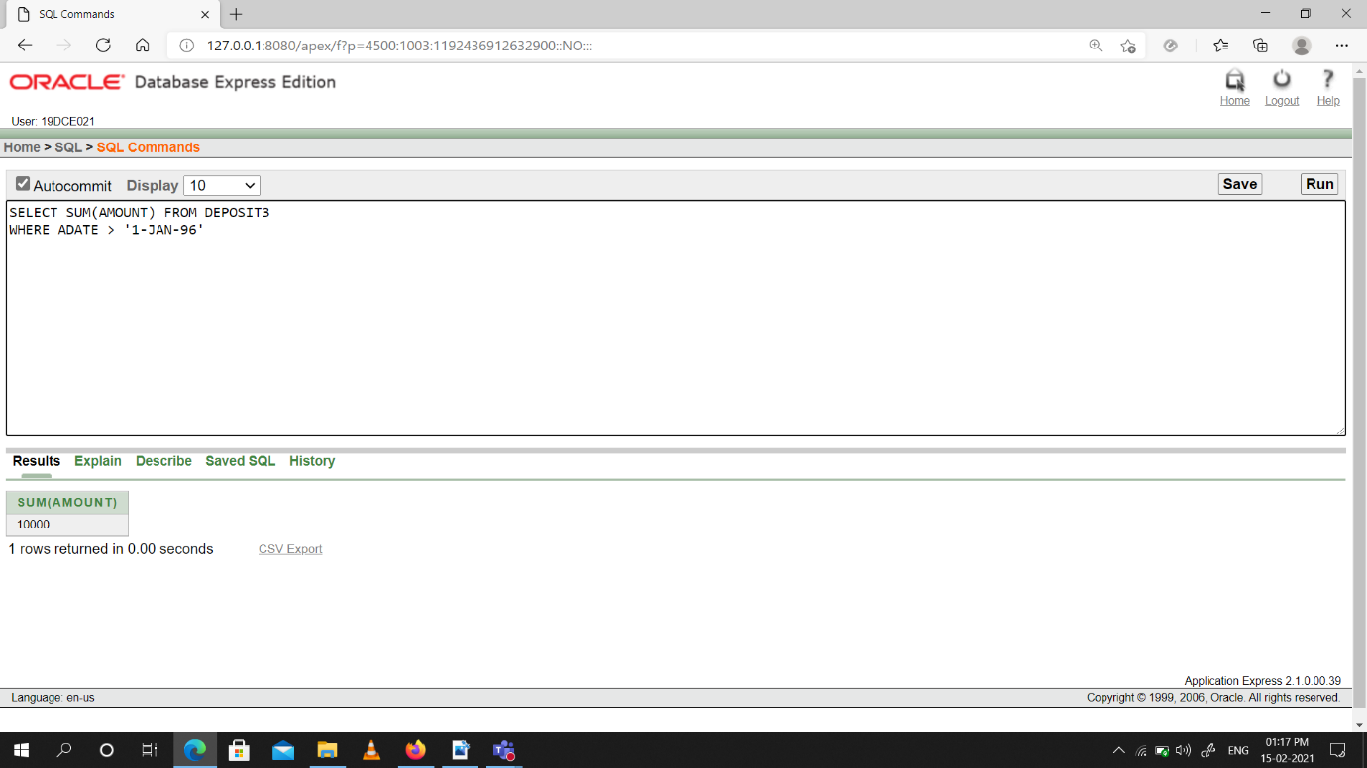

(2) List total deposit of customers living in city Nagpur.

Snap-Shot: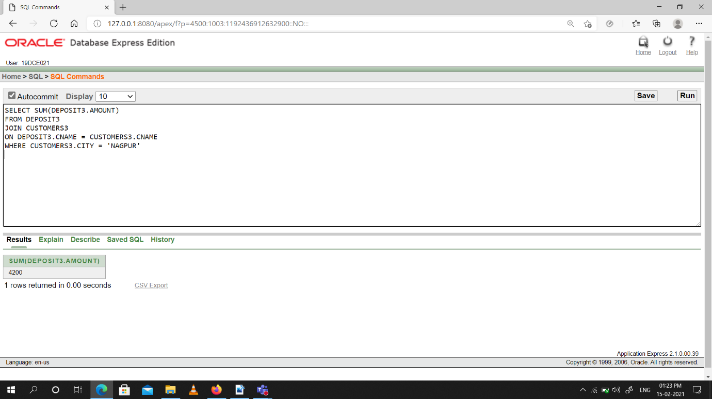

(3) List maximum deposit of customers living in Bombay.

Snap-Shot:

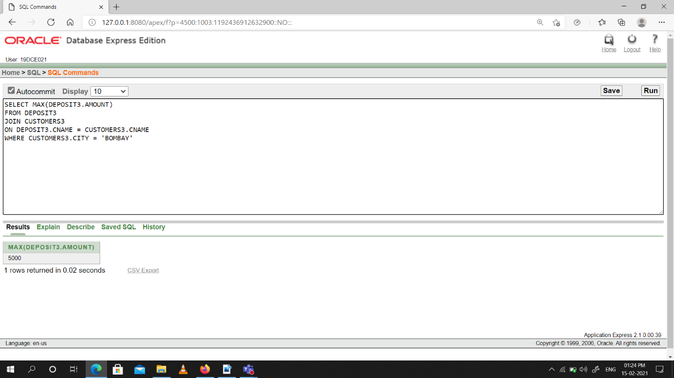

(4) Display the highest, lowest, sum, and average salary of all employees. Label the columns Maximum, Minimum, Sum, and Average, respectively. Round your results to the nearest whole number.

Snap-Shot:

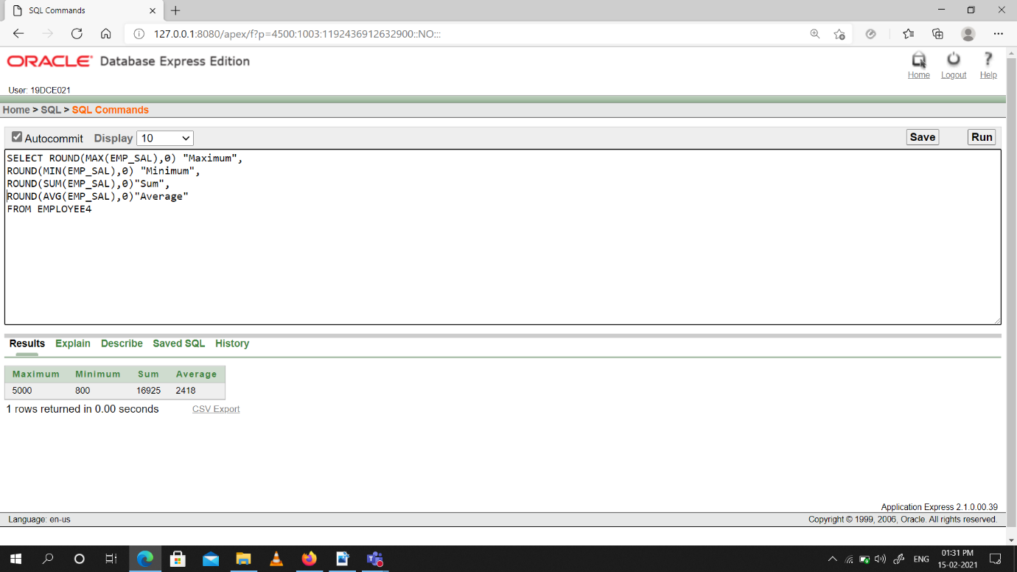

(5) Write a query that displays the difference between the highest and lowest salaries. Label the column DIFFERENCE.

Snap-Shot:

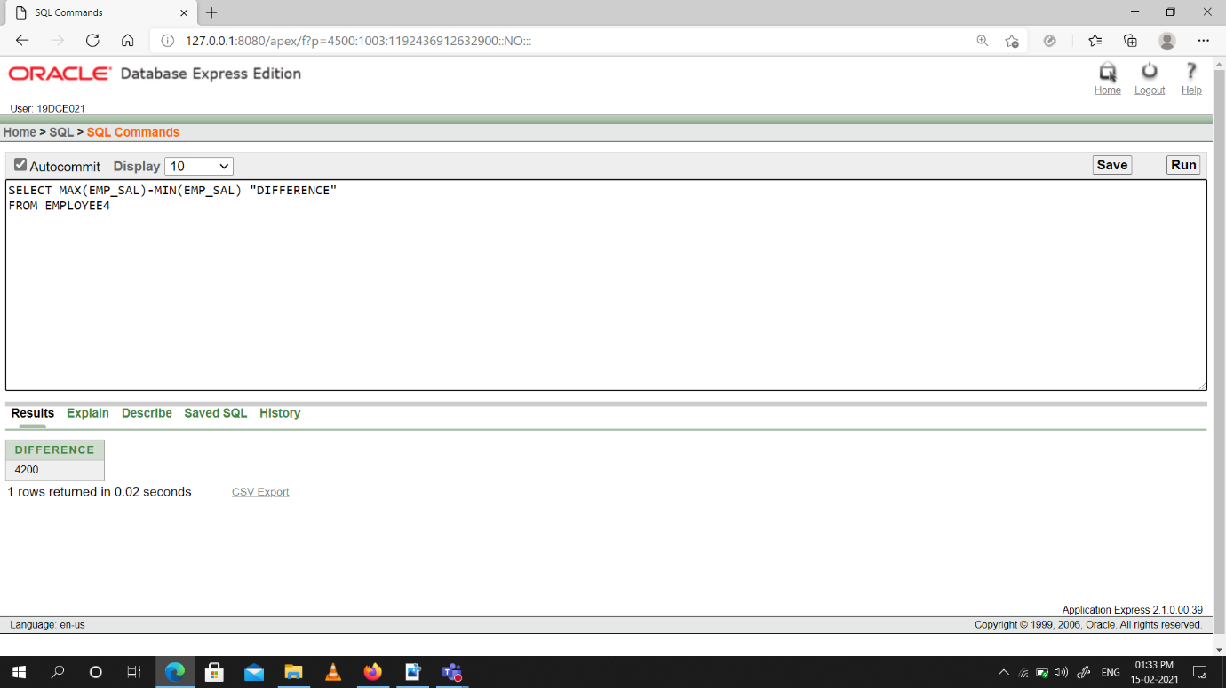

(6) Create a query that will display the total number of employees and, of that total, the number of employees hired in 1995, 1996, 1997, and 1998

Snap-Shot:

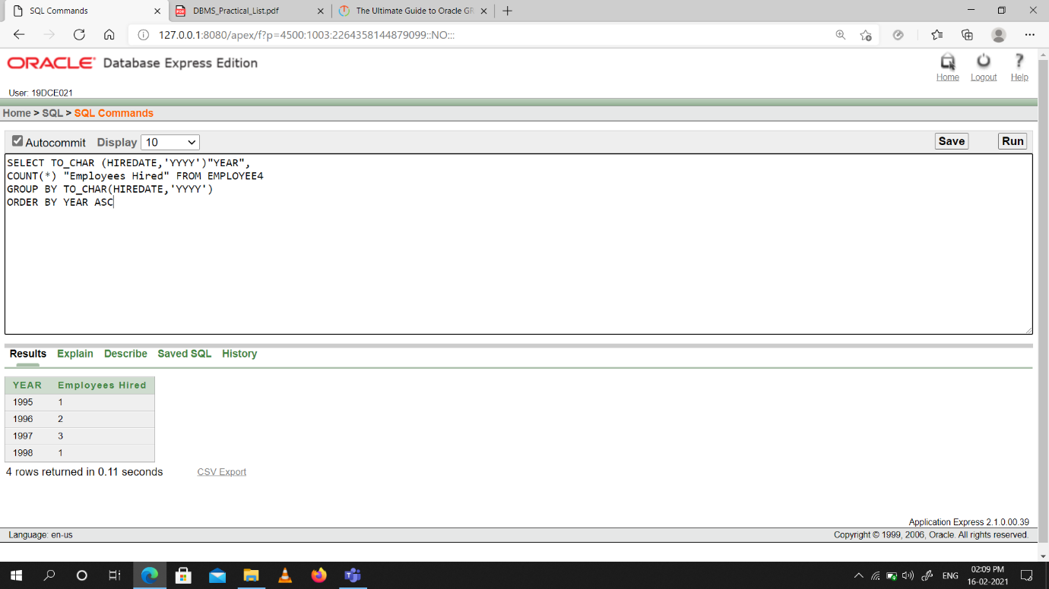

(7) Find the average salaries for each department without displaying the respective department numbers.

Snap-Shot:

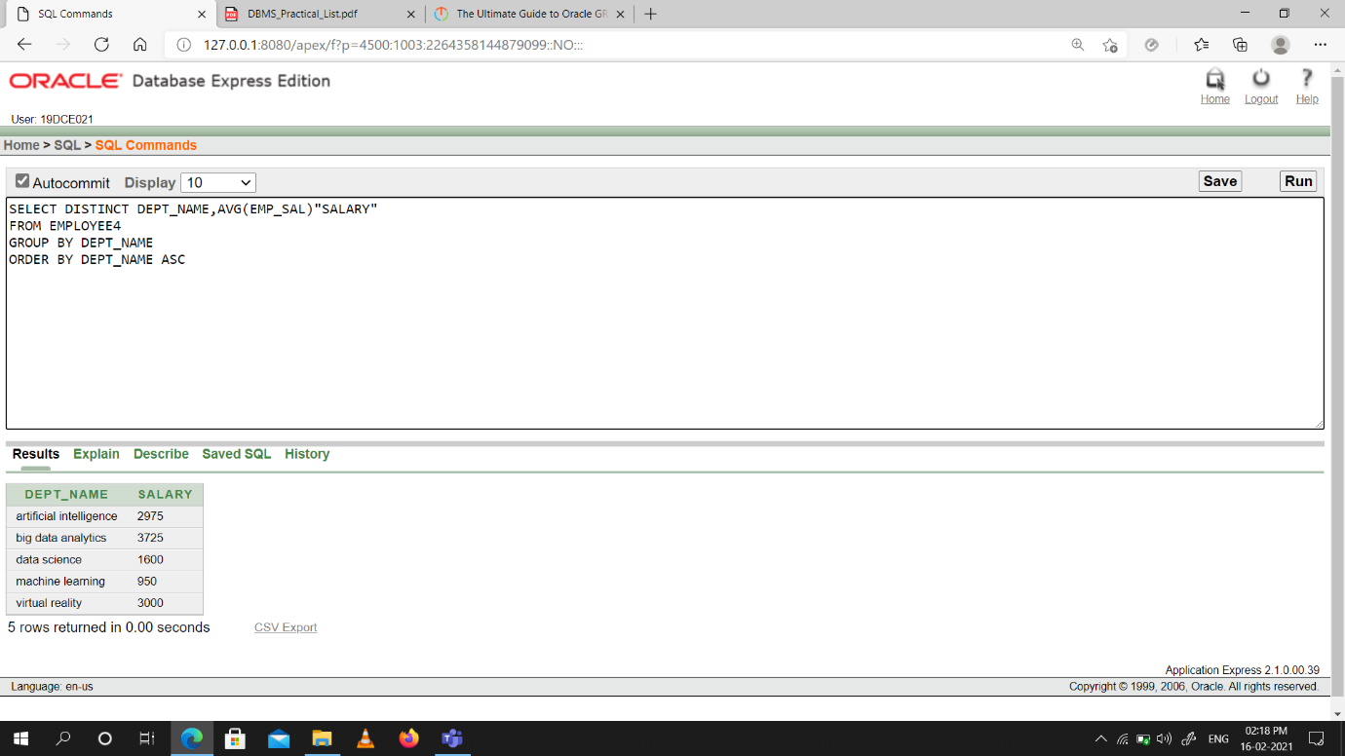

(8) Write a query to display the total salary being paid to each job title, within each department.

Snap-Shot:

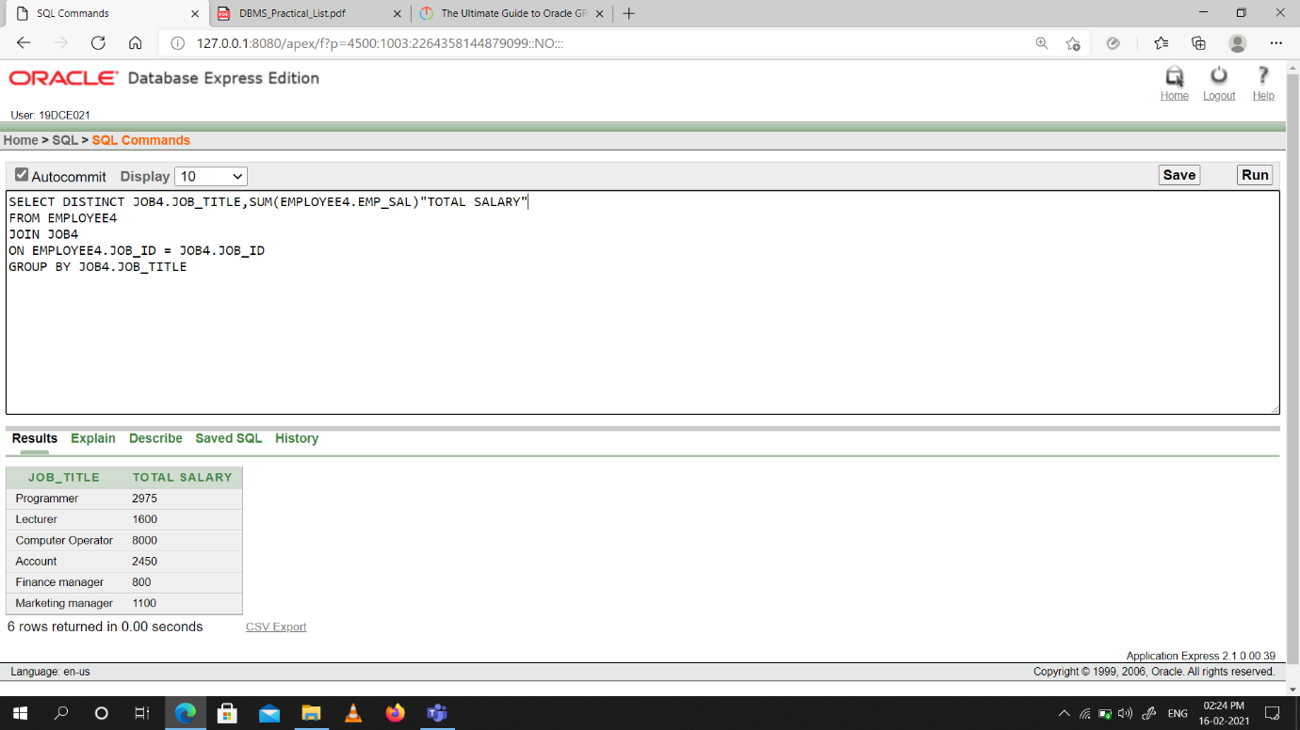

(9) Find the average salaries > 2000 for each department without displaying the respective department numbers.

Snap-Shot:

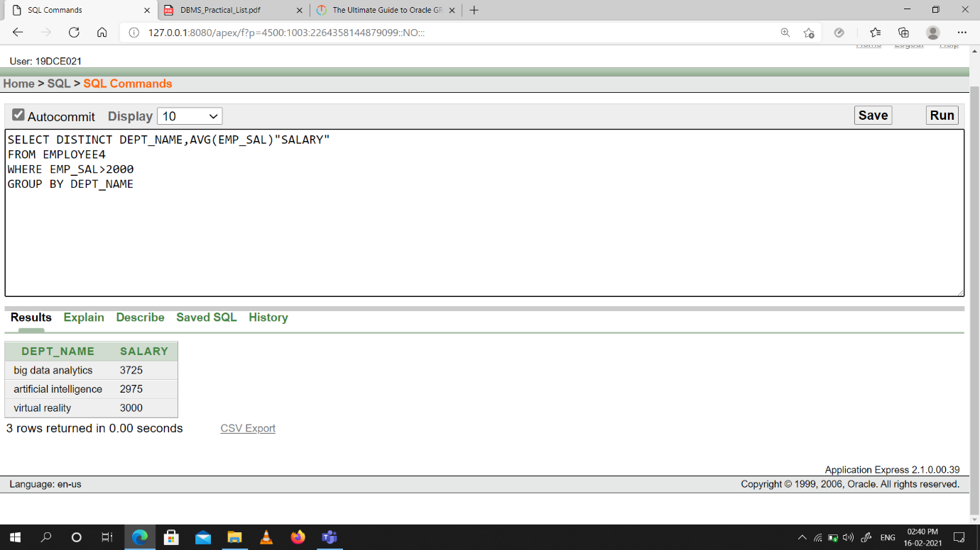

(10) Display the job and total salary for each job with a total salary amount exceeding

3000 and sorts the list by the total salary.

Snap-Shot:

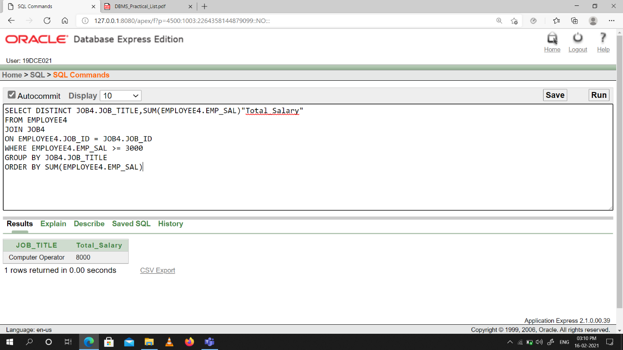

(11) List the branches having sum of deposit more than 5000 and located in city Bombay.

Snap-Shot:

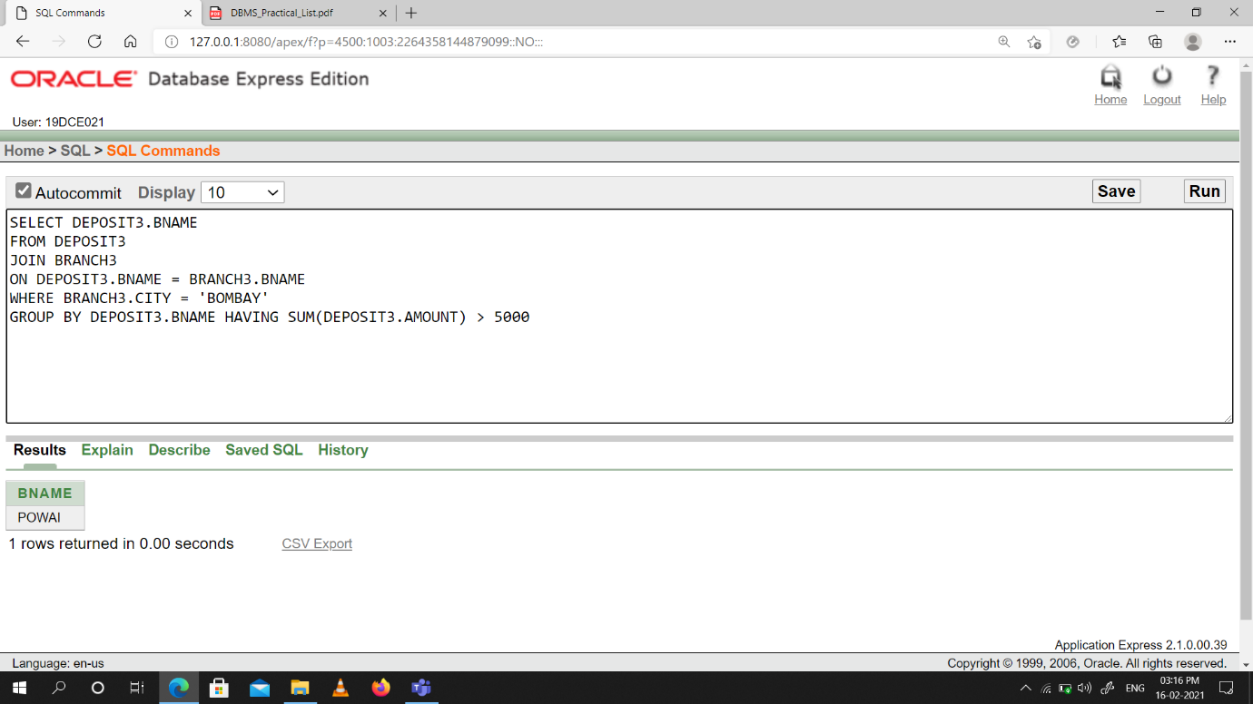

**Conclusion:** We Learned about Aggregating Data using Group functions.

**Practical -9**

**To solve queries using the concept of sub query.**

(1) Write a query to display the last name and hire date of any employee in the same department as smith. Exclude smith.

Snap-Shot:

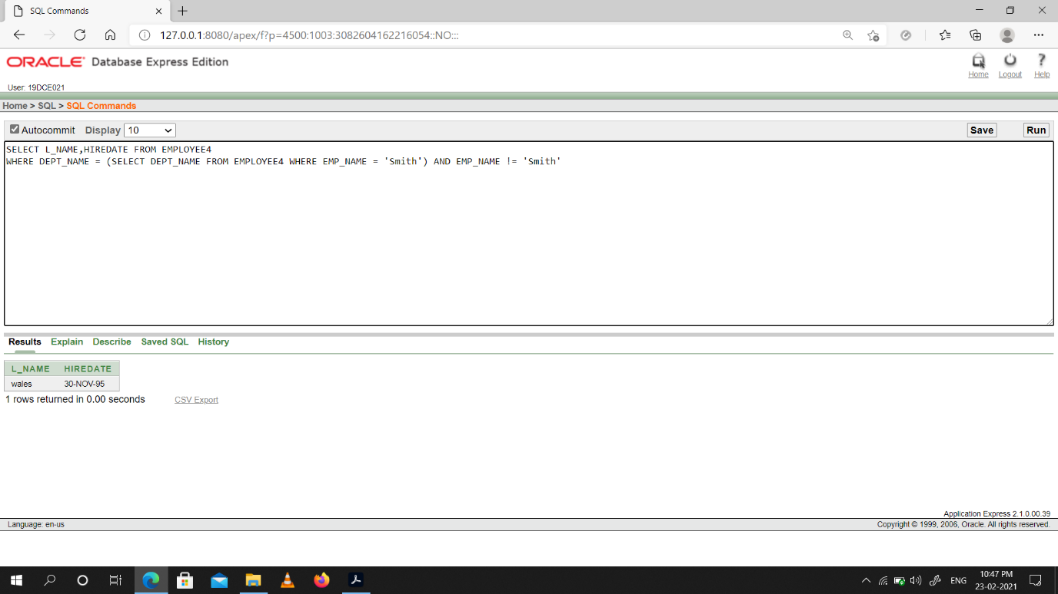

(2) Give name of customers who are depositors having same branch city of mr. sunil.

Snap-Shot:

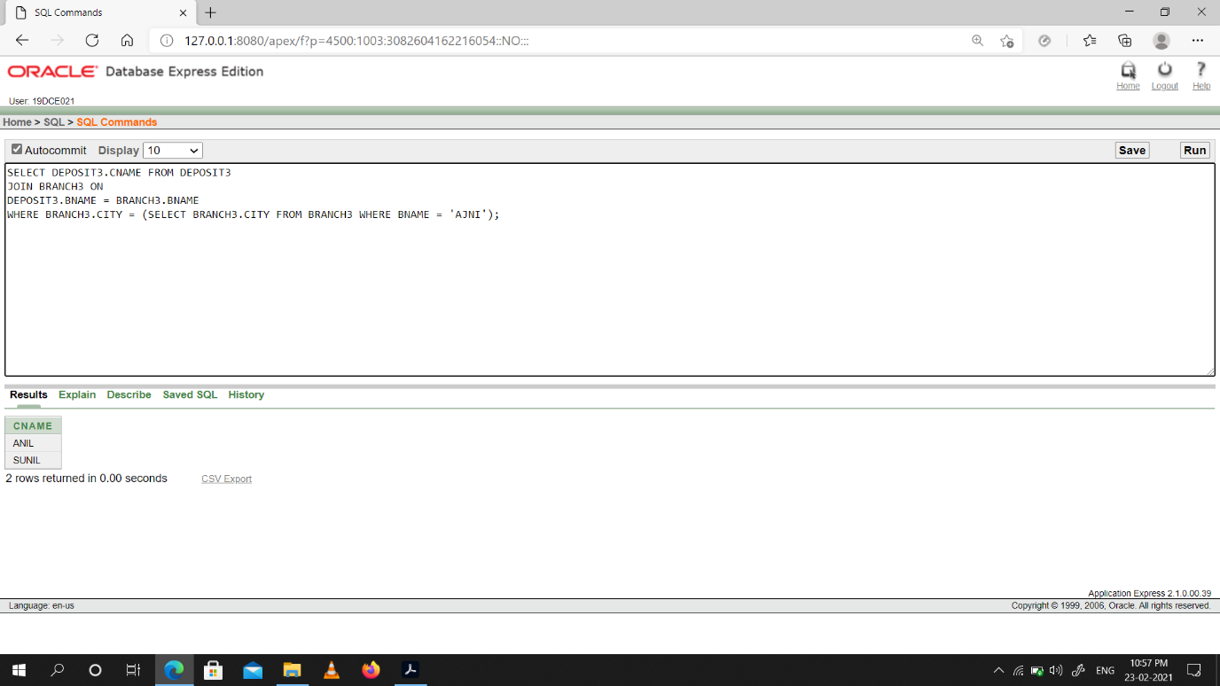

(3) Give deposit details and loan details of customer in same city where pramod is living.

Snap-Shot:

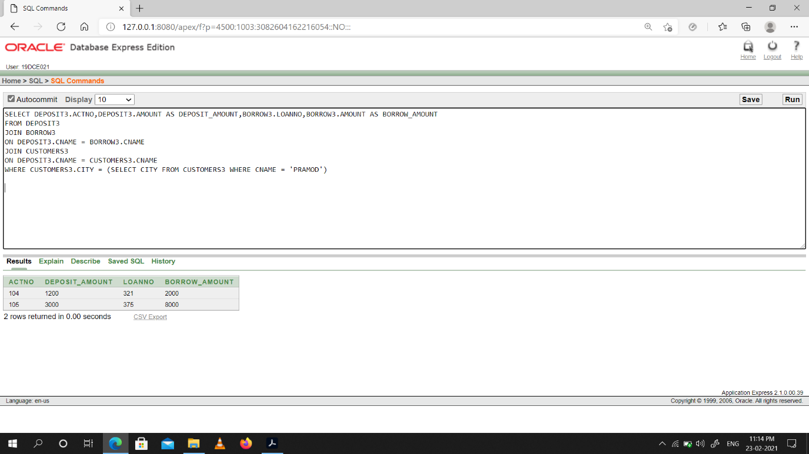

(4) Create a query to display the employee numbers and last names of all employees who earn more than the average salary. Sort the results in ascending order of salary.

Snap-Shot:

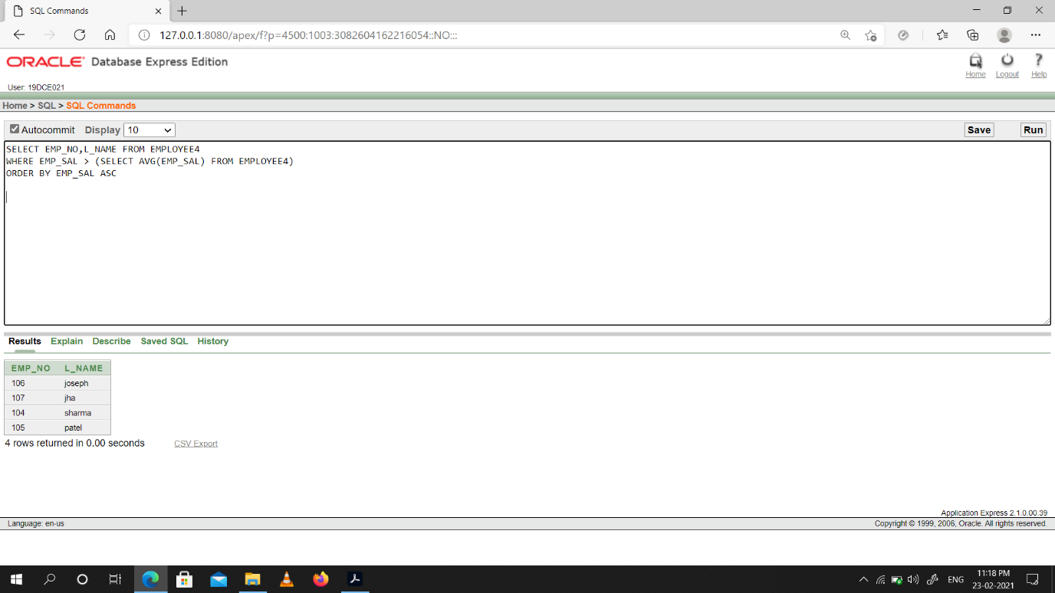

(5) Give names of depositors having same living city as mr. anil and having deposit amount greater than 2000

Snap-Shot:

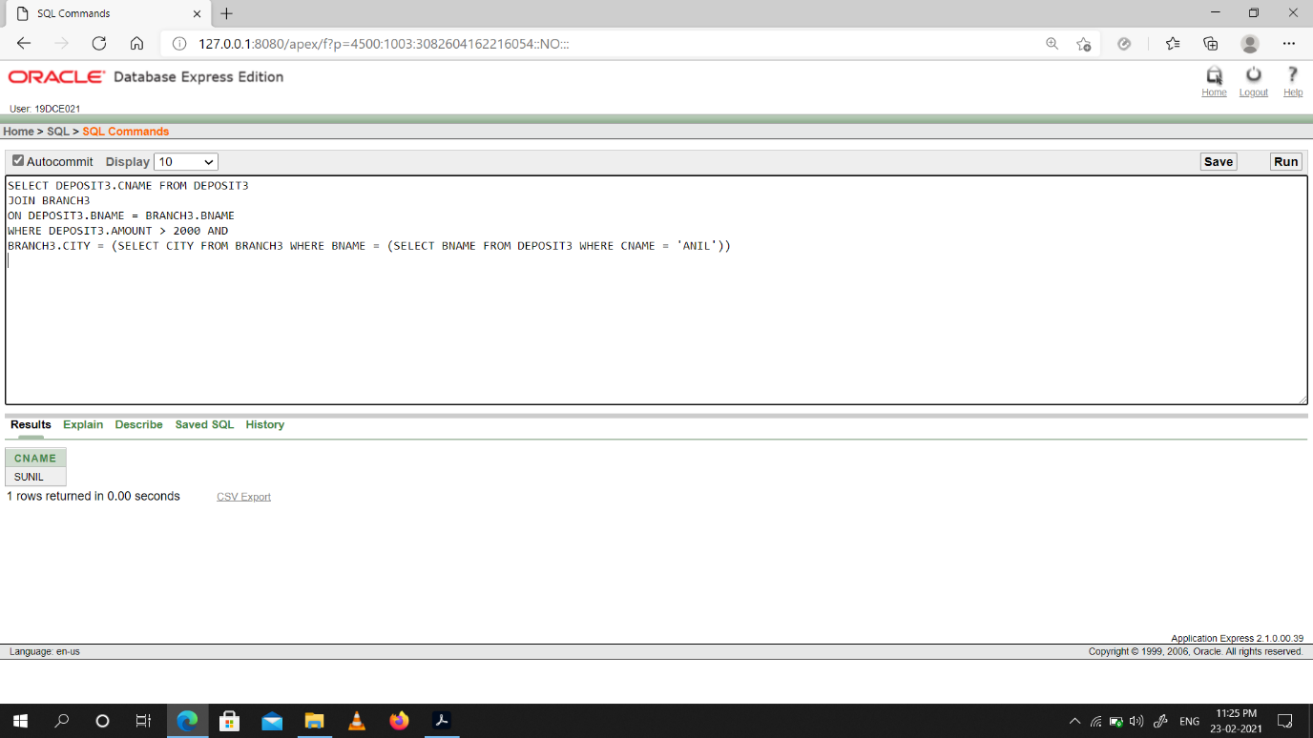

(6) Display the last name and salary of every employee who reports to ford.

Snap-Shot:

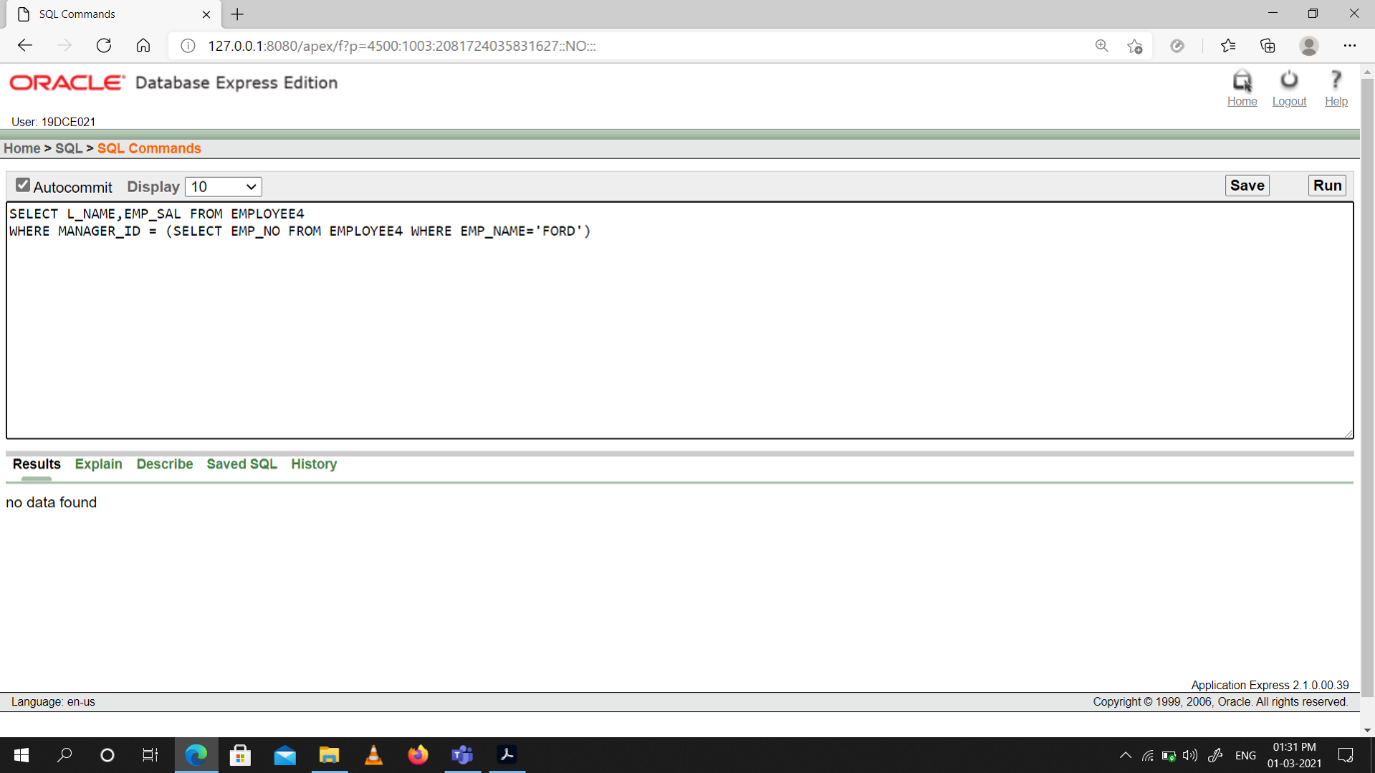

(7) Display the department number, name, and job for every employee in the Accounting department.

Snap-Shot:

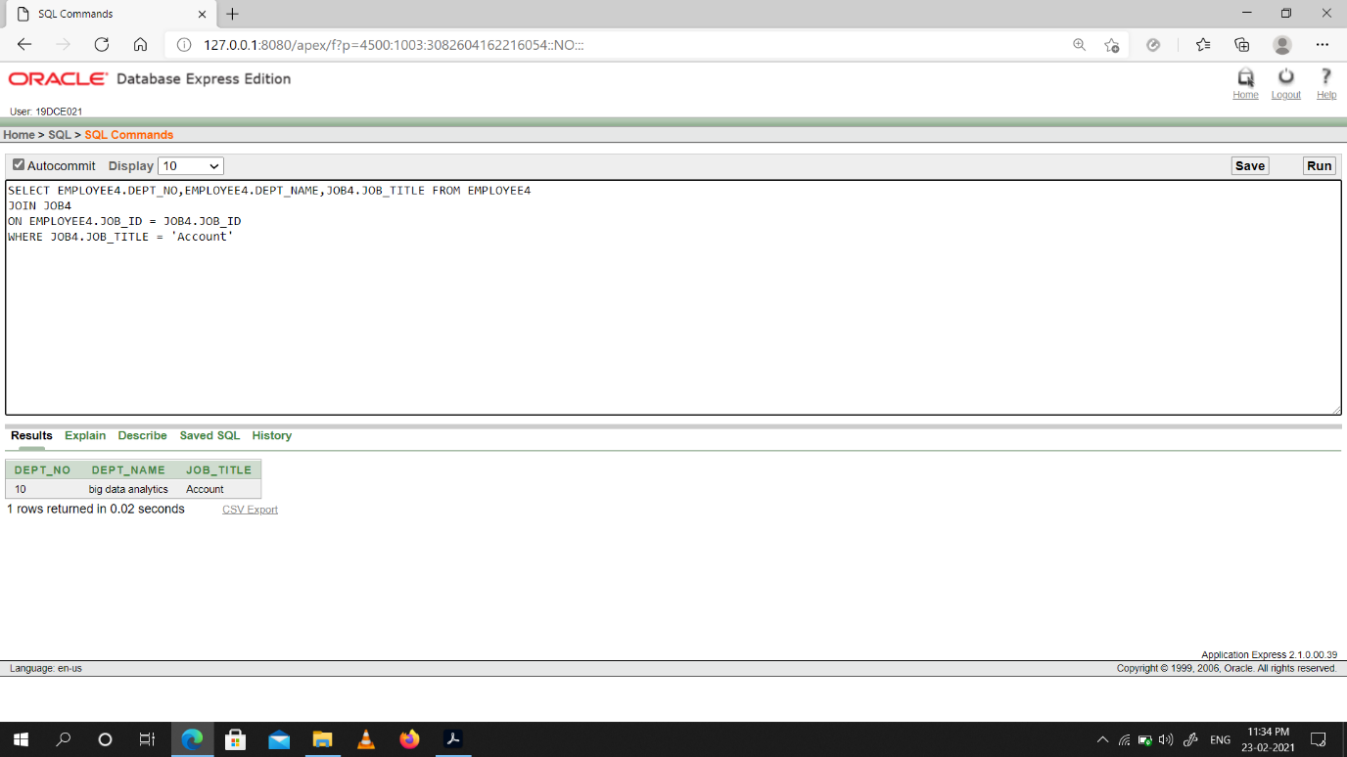

(8) List the name of branch having highest number of depositors.

Snap-Shot:

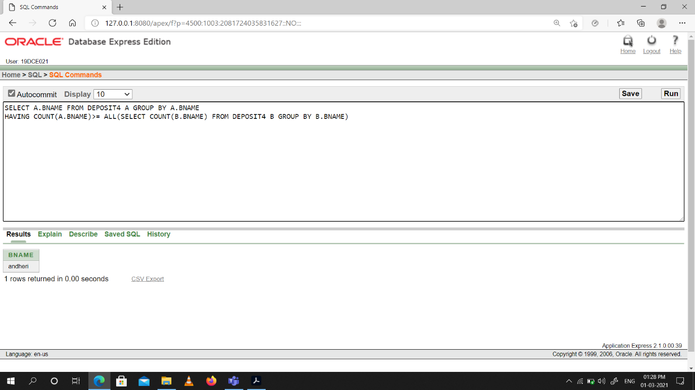

(9) Give the name of cities where in which the maximum numbers of branches are located.

Snap-Shot:

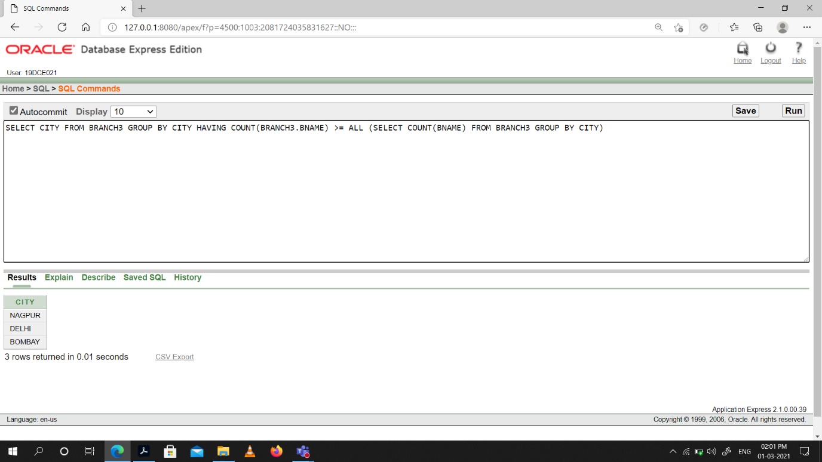

(10) Give name of customers living in same city where maximum depositors are

located.

Snap-Shot:

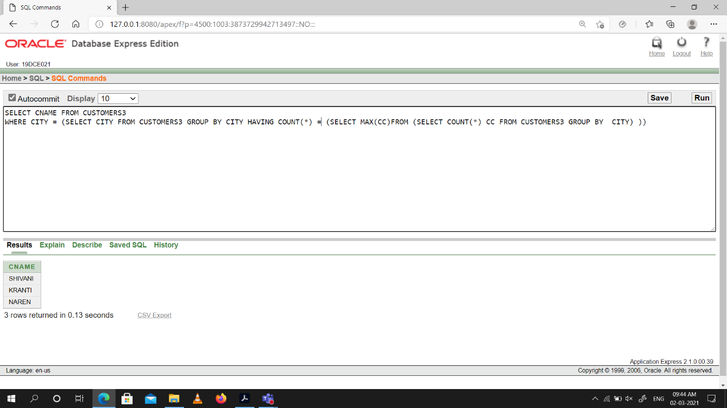

**Conclusion:** From This practical I learned how to perform sub-queries.

**Practical -10**

**Manipulating Data**

(1) Give 10% interest to all depositors.

Snap-Shot:

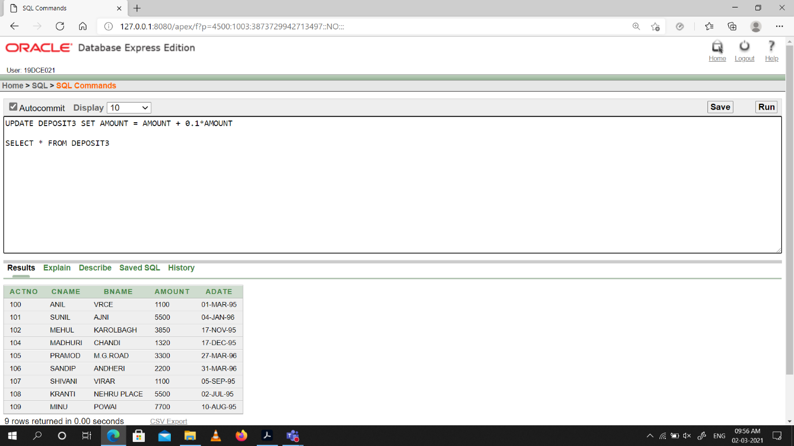

(2) Give 10% interest to all depositors having branch vrce.

Snap-Shot:

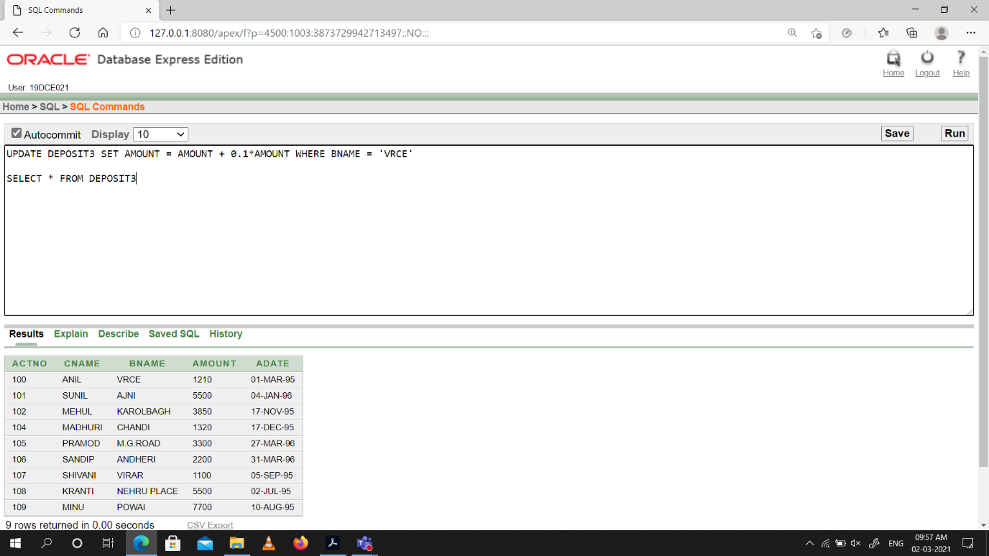

(3) Give 10% interest to all depositors living in Nagpur and having branch city Bombay.

Snap-Shot:

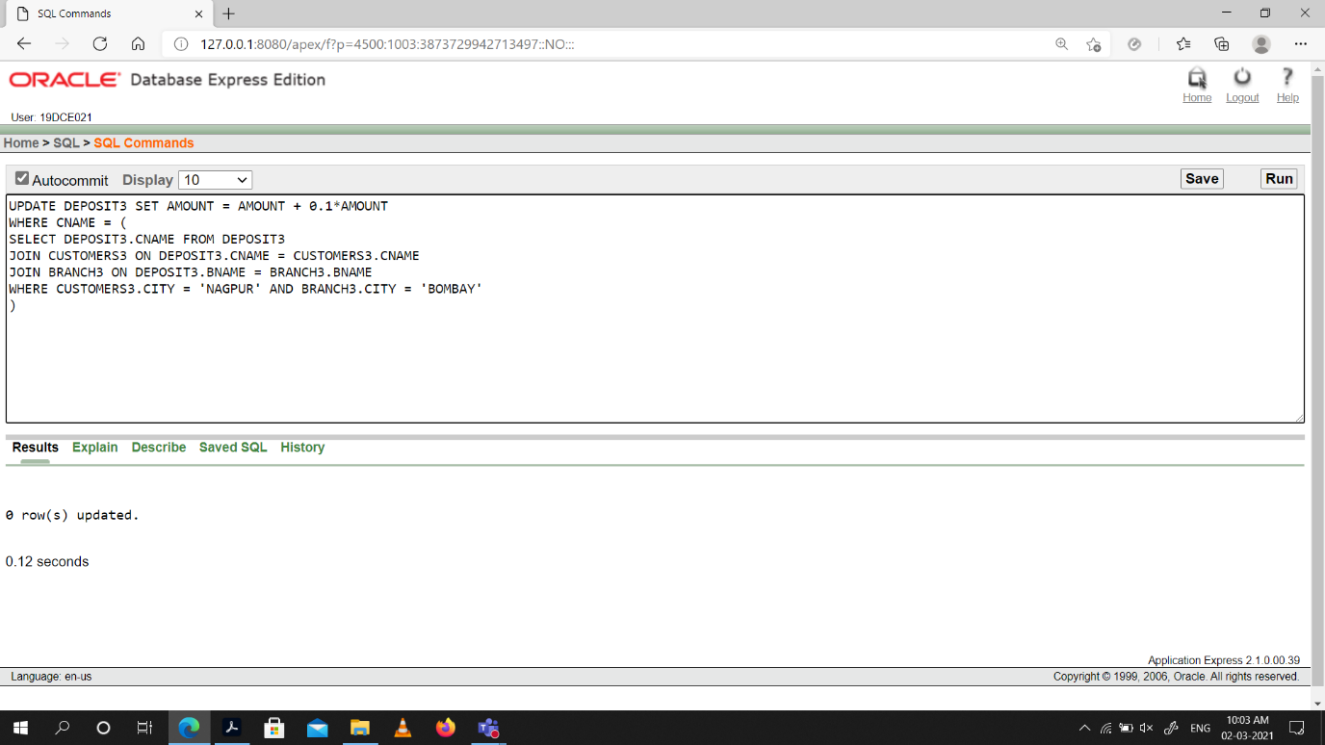

(4) Write a query which changes the department number of all employees with empno 7788’s job to employee 7844’current department number.

Snap-Shot:

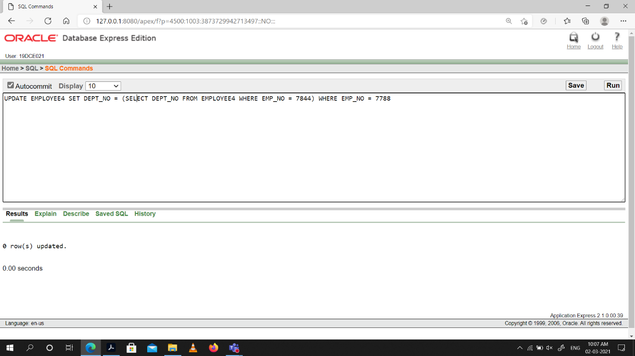

(5) Transfer 10 Rs from account of anil to Sunil if both are having same branch.

Snap-Shot:

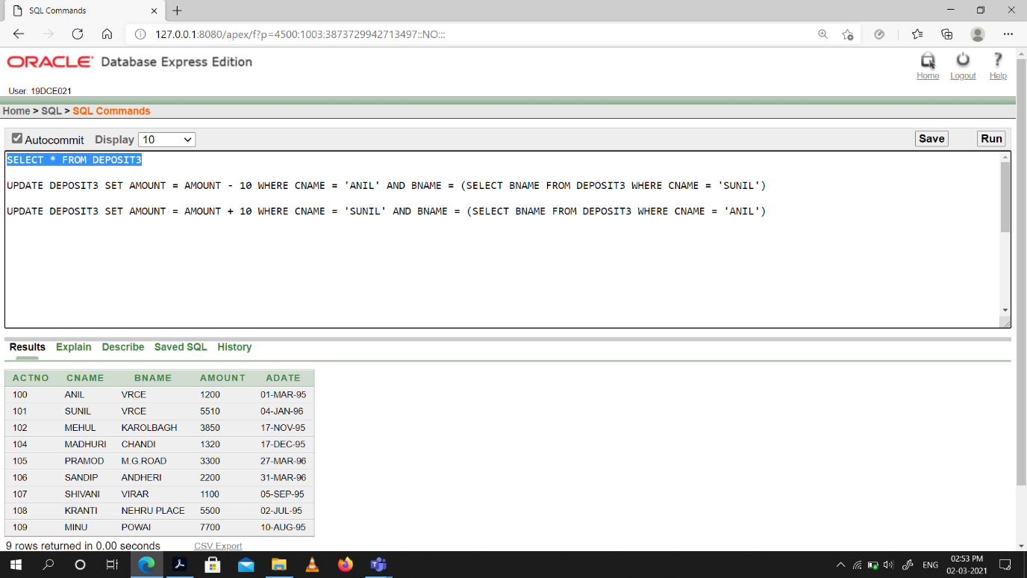

(6) Give 100 Rs more to all depositors if they are maximum depositors in their respective branch.

Snap-Shot:

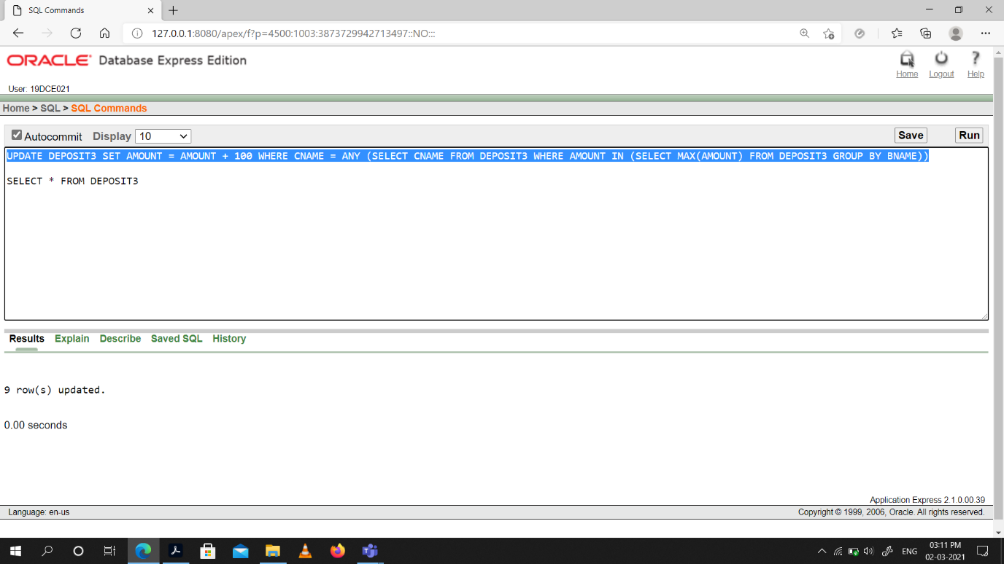

(7) Delete depositors of branches having number of customers between 1 to 3.

Snap-Shot:

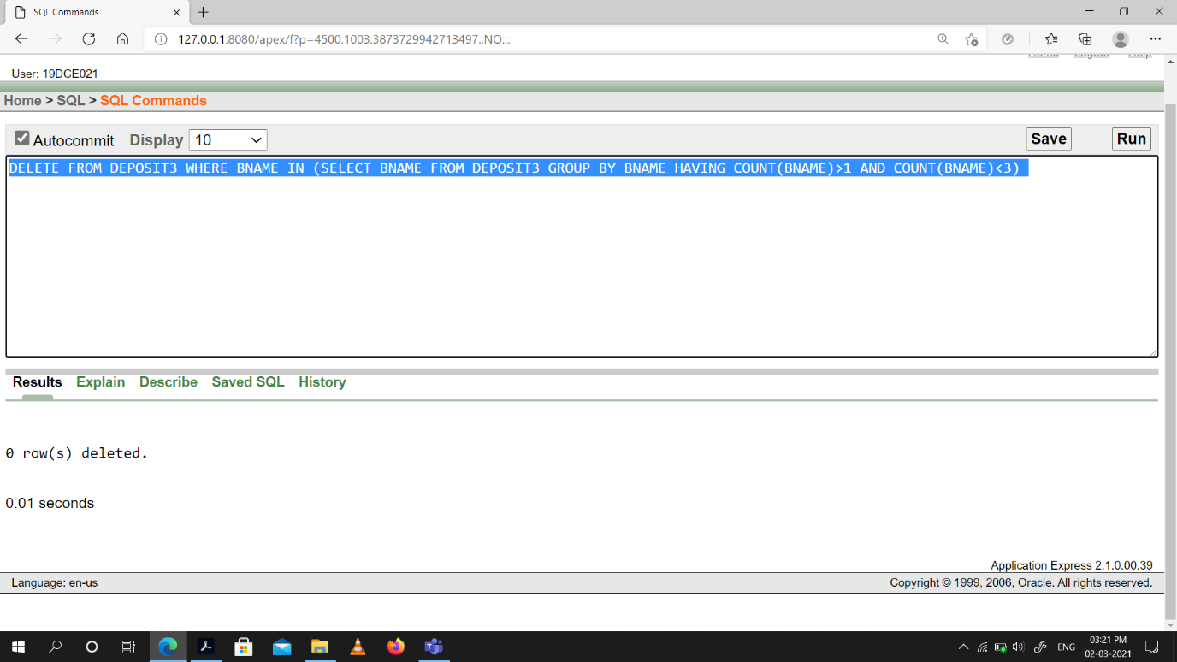

(8) Delete deposit of vijay.

Snap-Shot:

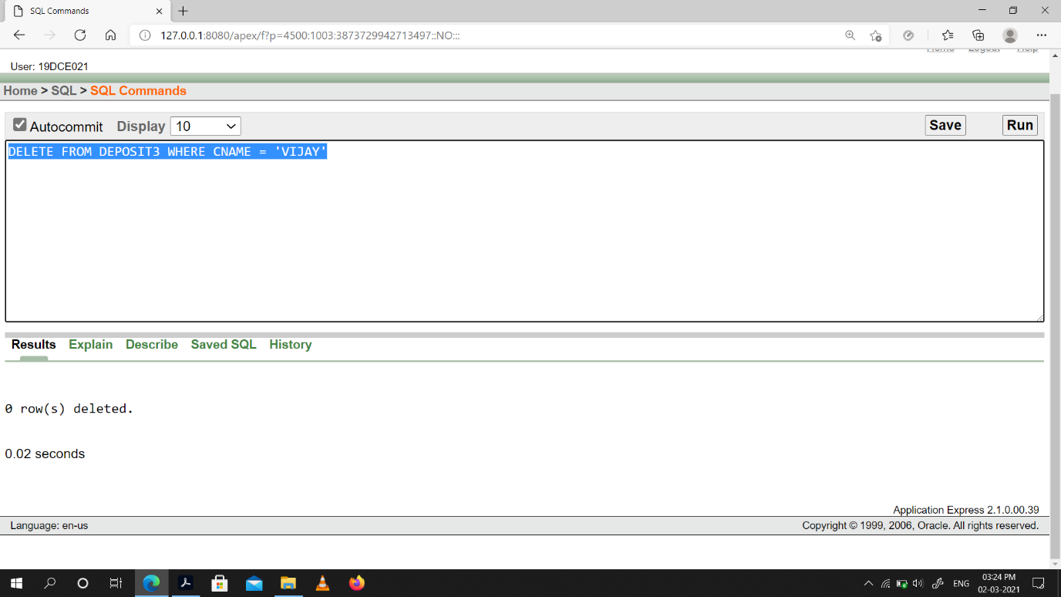

(9) Delete borrower of branches having average loan less than 1000.

Snap-Shot:

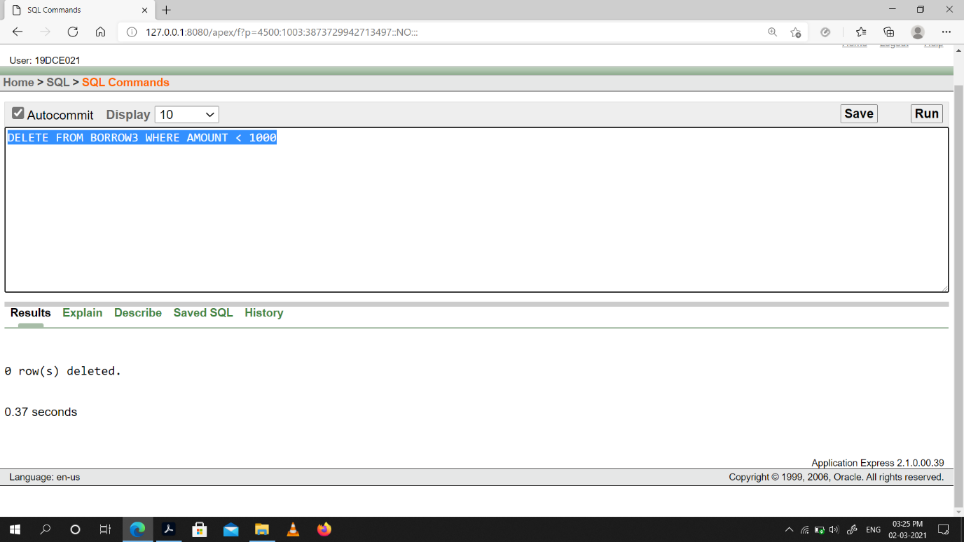

**Conclusion:** From this practical I learned how to manipulate data.

**Practical -11**

**Add and Remove constraint**

(1) Add primary key constraint on job_id in job table.

Snap-Shot:

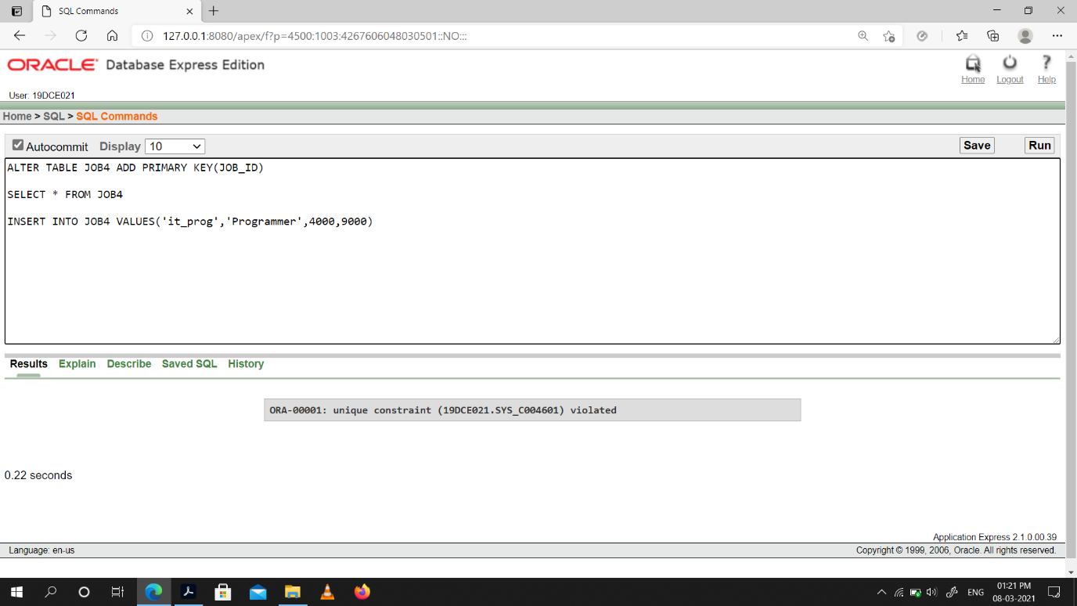

(2) Add foreign key constraint on employee table referencing job table.

Snap-Shot: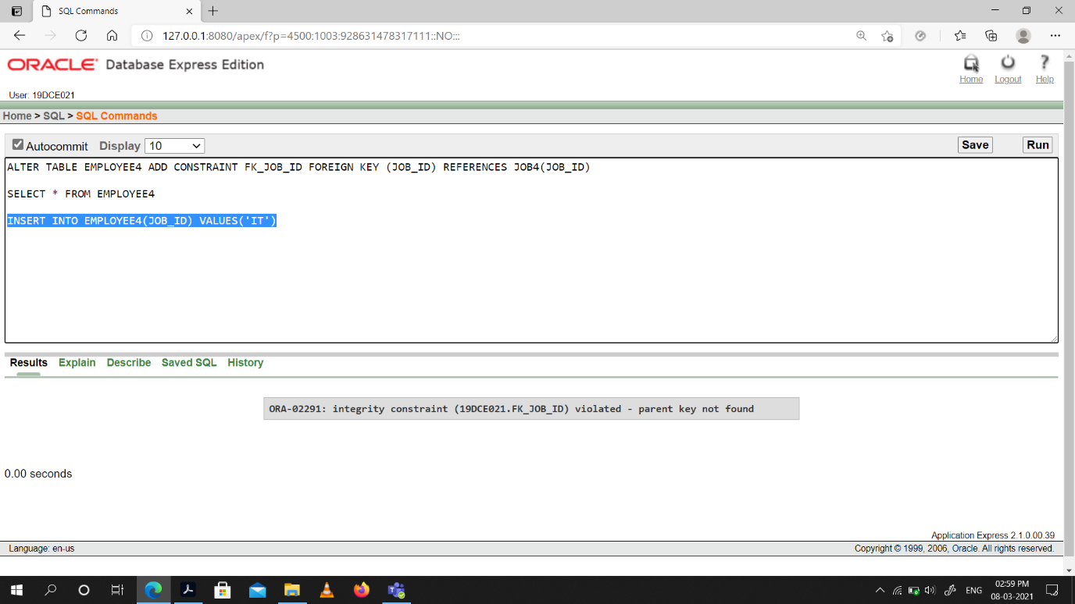

(3) Add composite primary key on lock table (lock table does not exist, while creating table add composite key)

Snap-Shot:

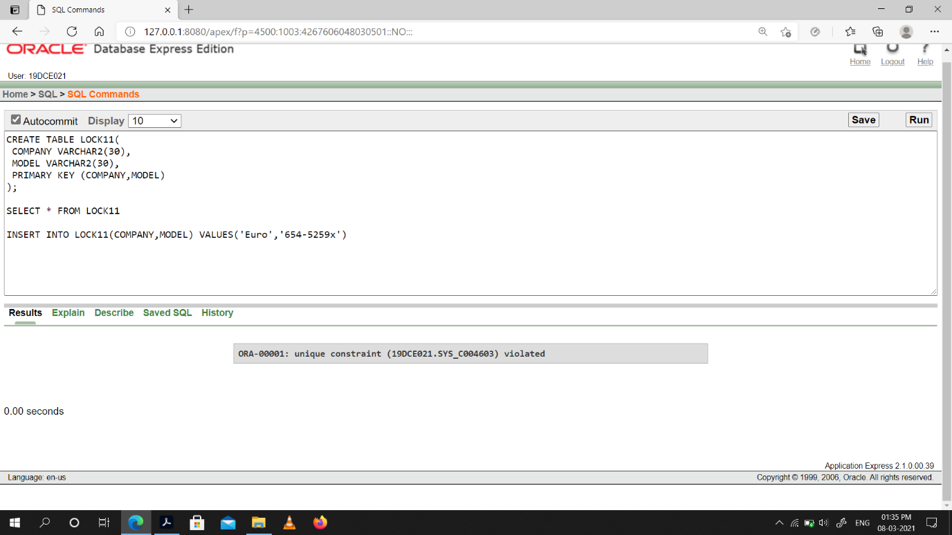

(4) Remove primary key constraint on job_id

Snap-Shot:

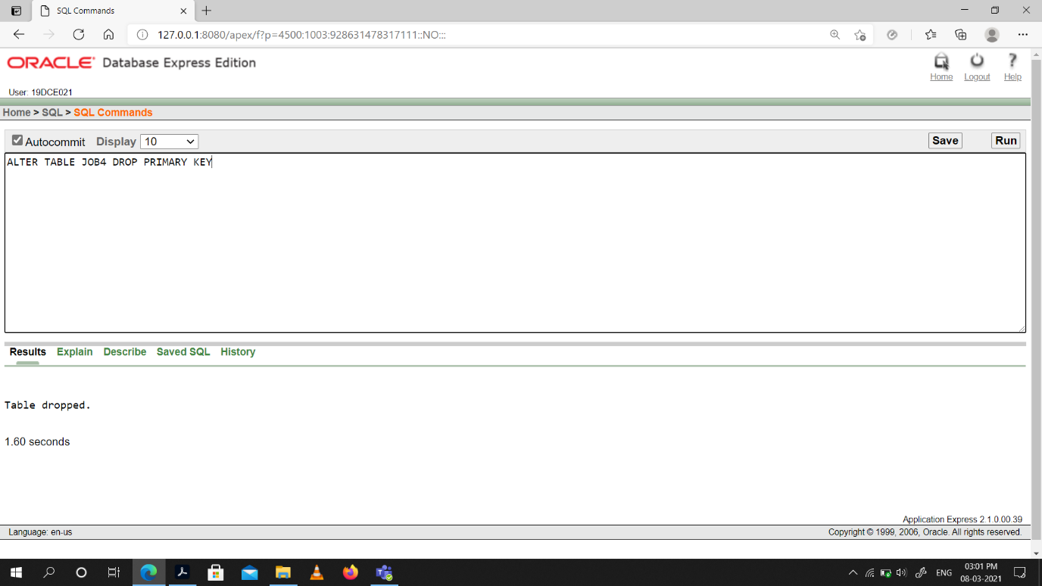

(5) Remove foreign key constraint on employee table

Snap-Shot:

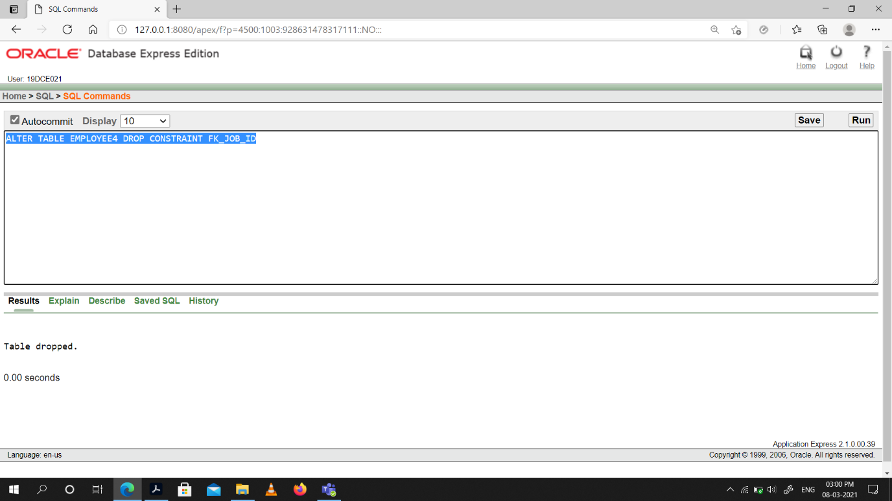

**Conclusion:** From this practical I learned how to remove and add constraints on a table.

**Practical -12**

(12.1) Data Dictionary

Snap-shot:

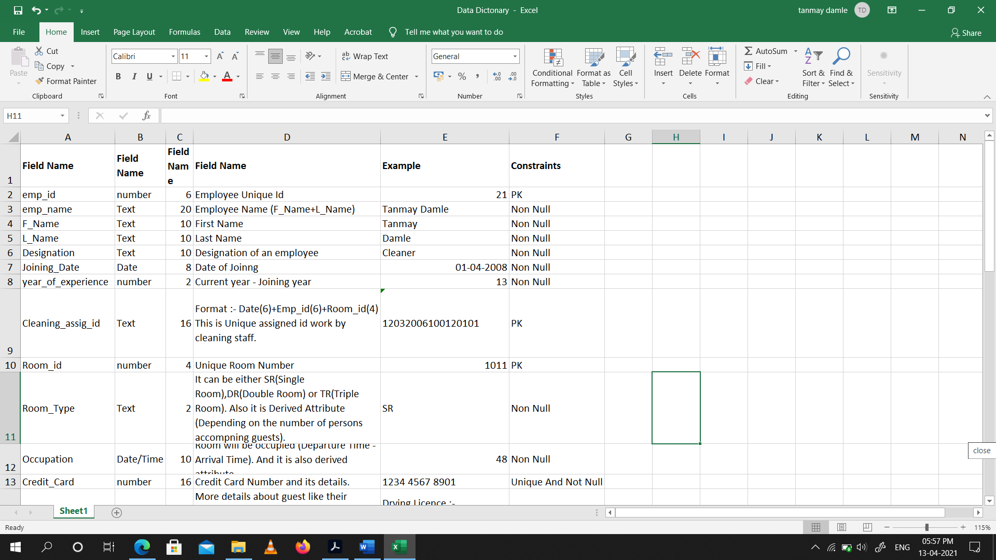

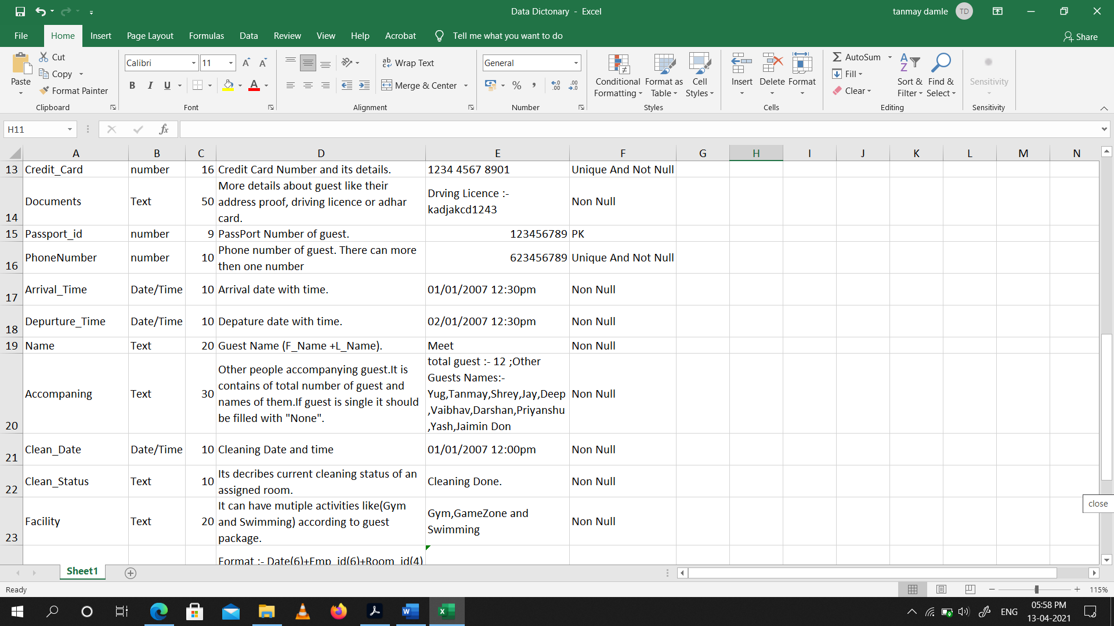

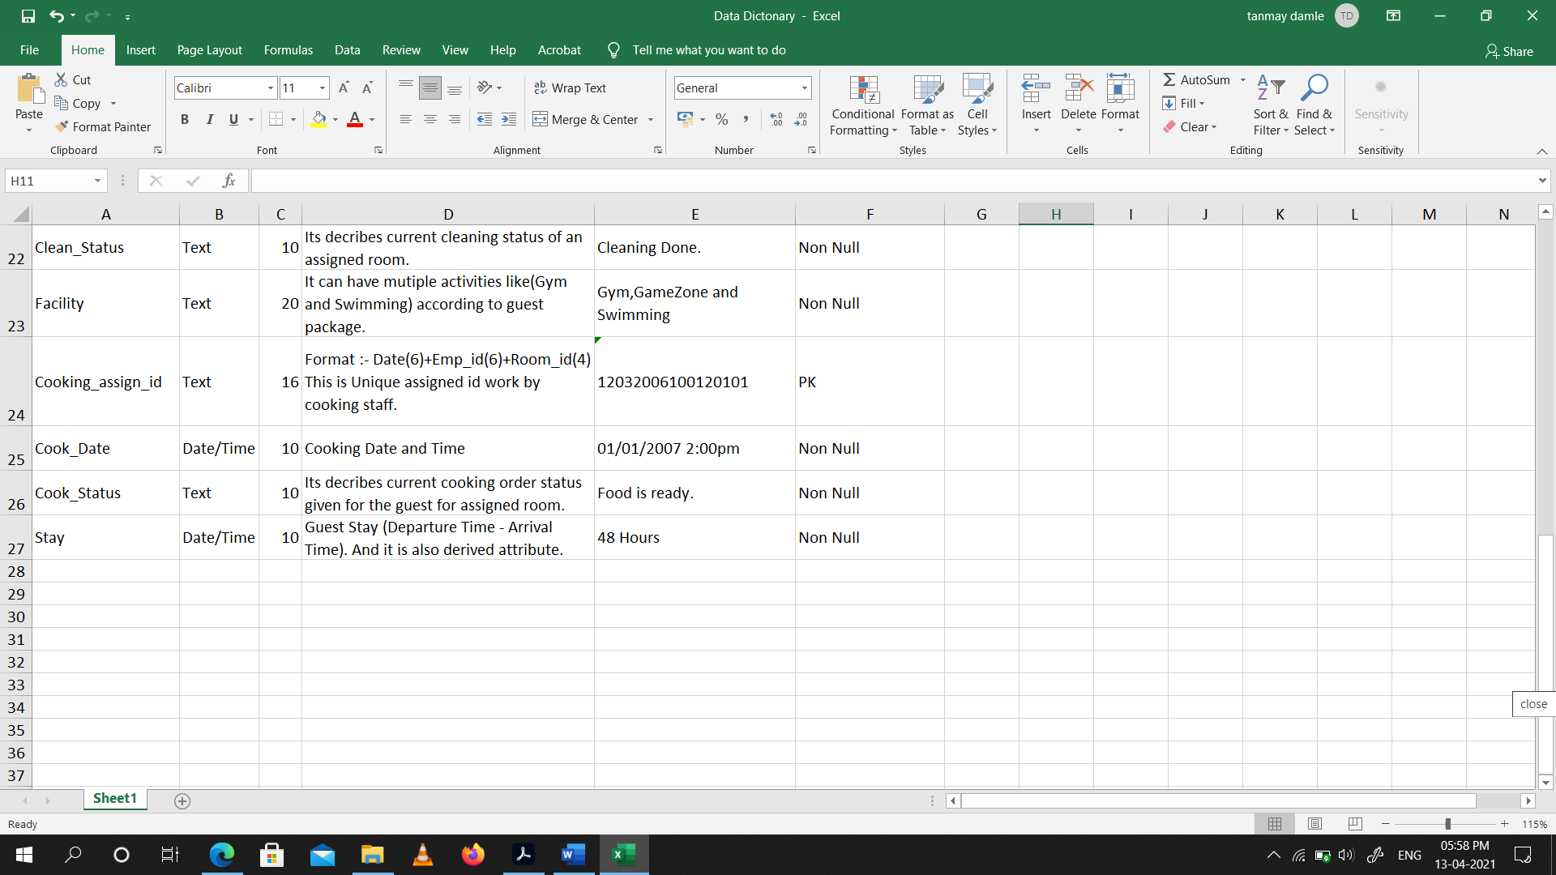

(12.2) E-R Diagram.

Snap-shot:

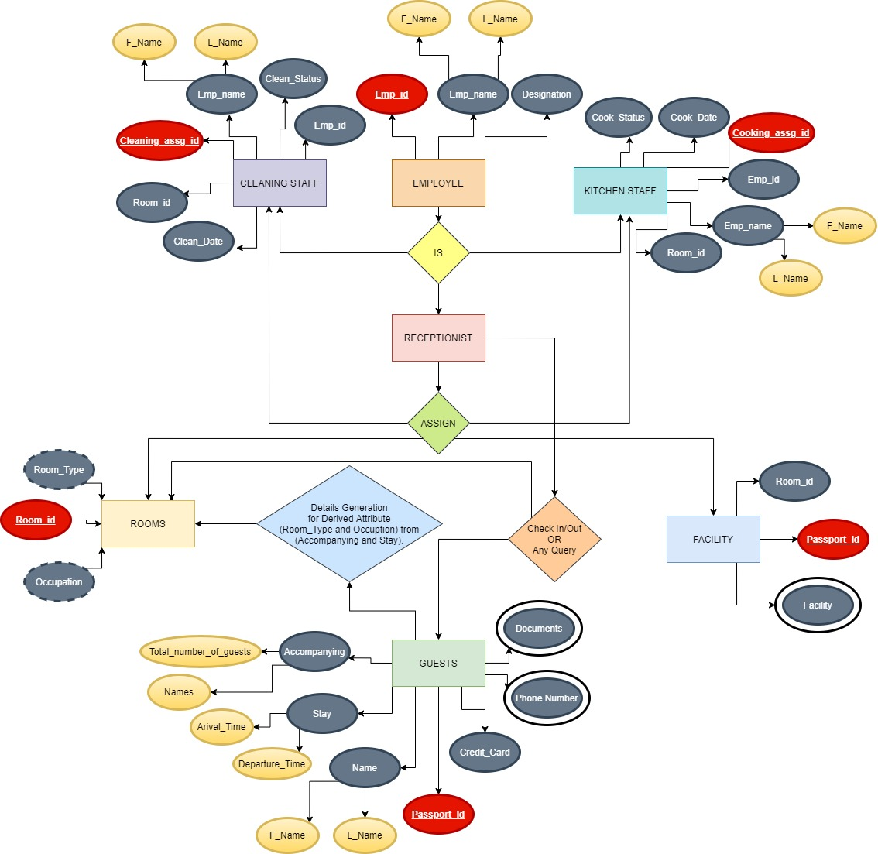

**Conclusion:** From This Practical I Learned how to make an E-R Diagram.

**Practical -13**

**To perform basic PL/SQL blocks**

Write a PL-SQL block to find Sum and average of three numbers.

**Code**:

DECLARE

x number;

y number;

z number;

total number;

average number;

BEGIN

x:= 10;

y:= 20;

z:= 30;

total:= x+y+z;

average:= total/3;

DBMS_OUTPUT.PUT_LINE('Sum is '||total);

DBMS_OUTPUT.PUT_LINE('Average is '||average);

END;

Snap-Shot:

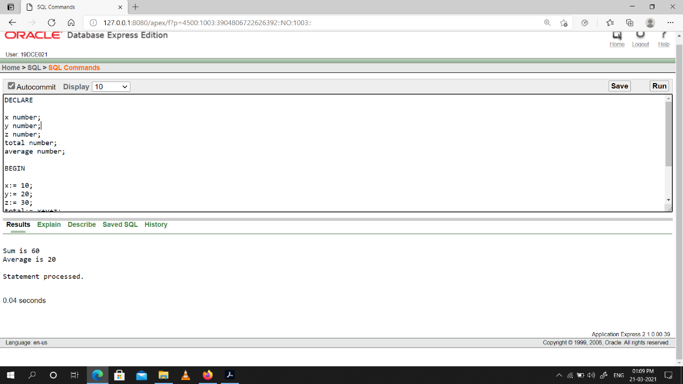

**Conclusion:** From this practical I learned How to write code in PL/SQL.

**Practical -14**

**To perform the concept of loop**

Find the factorial of a number in pl/sql using for, While and Simple Loop.

**Code:**

Basic Loop

DECLARE

x number := 5;

fact number :=1;

BEGIN

LOOP

fact:= fact * x;

x:= x-1;

IF x<2 THEN

exit;

END IF;

END LOOP;

dbms_output.put_line('Factorial is: ' || fact);

END;

While Loop

DECLARE

x number := 5;

fact number :=1;

BEGIN

WHILE x>=2 LOOP

fact:= fact * x;

x:= x-1;

END LOOP;

dbms_output.put_line('Factorial is: ' || fact);

END;

Snap-Shot:

Basic Loop

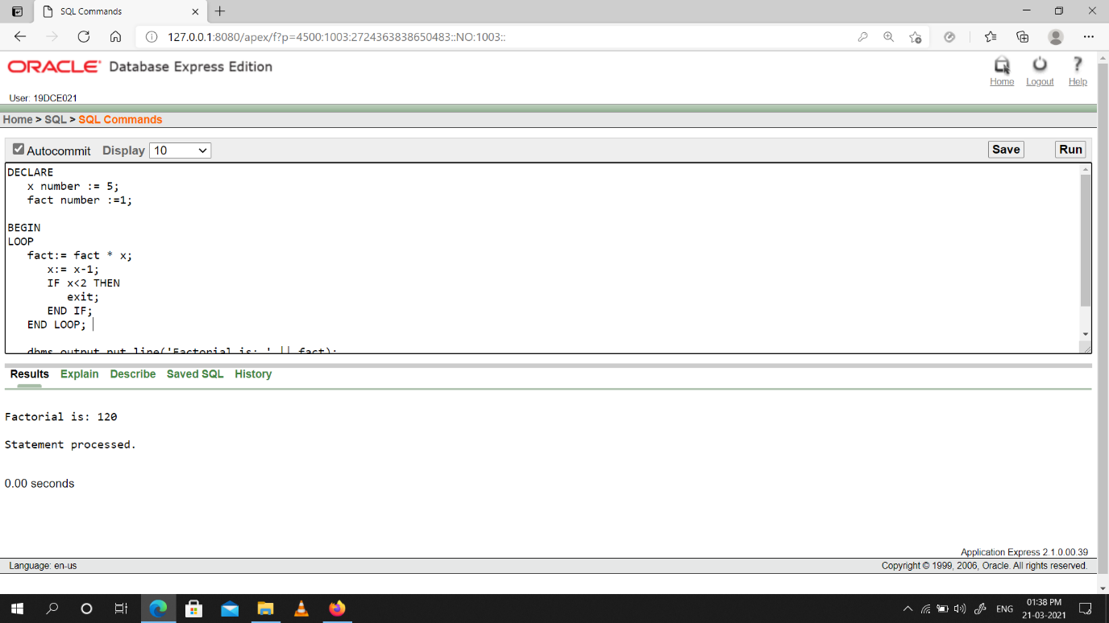

While Loop

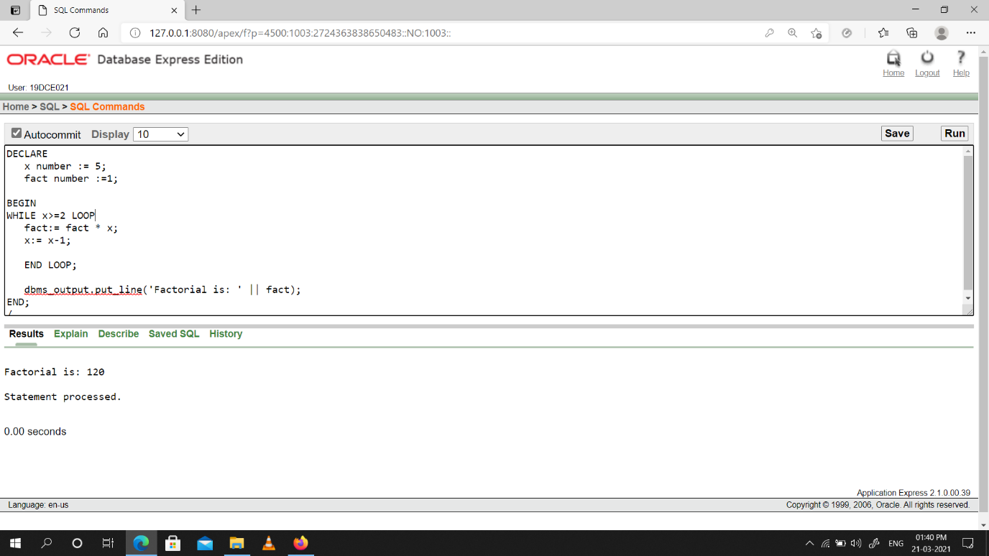

**Conclusion:** From this practical I learned How to write simple loop & while loop in PL/SQL.

**Practical -15**

**To understand the concept of “select into” and “% type” attribute**.

Create an EMPLOYEES table that is a replica of the EMP table. Add a new column, STARS, of VARCHAR2 data type and length of 50 to the EMPLOYEES table for storing asterisk (*).

Create a PL/SQL block that rewards an employee by appending an asterisk in the STARS column for every Rs1000/- of the employee’s salary. For example, if the employee has a salary amount of Rs8000/-, the string of asterisks should contain eight asterisks. If the employee has a salary amount of Rs12500/-, the string of asterisks should contain 13 asterisks.

Update the STARS column for the employee with the string of asterisks.

**Code:**

DECLARE

EMP1 EMP%ROWTYPE;

CNT NUMBER:=1;

CNT_TOTAL NUMBER;

STARSX EMP1.STARS%TYPE;

BEGIN

CNT_TOTAL:= 7;

WHILE CNT<=CNT_TOTAL LOOP

SELECT * INTO EMP1 FROM EMP WHERE EMP_NO = 100+CNT;

IF EMP1.EMP_SAL > 3000 THEN

STARSX := '* * * *';

ELSIF EMP1.EMP_SAL >2000 THEN

STARSX := '* * *';

ELSIF EMP1.EMP_SAL >1000 THEN

STARSX := '* *';

ELSE

STARSX := '*';

END IF;

UPDATE EMP SET STARS = STARSX

WHERE EMP_NO = EMP1.EMP_NO;

CNT:=CNT+1;

END LOOP;

END;

Snap-Shot:

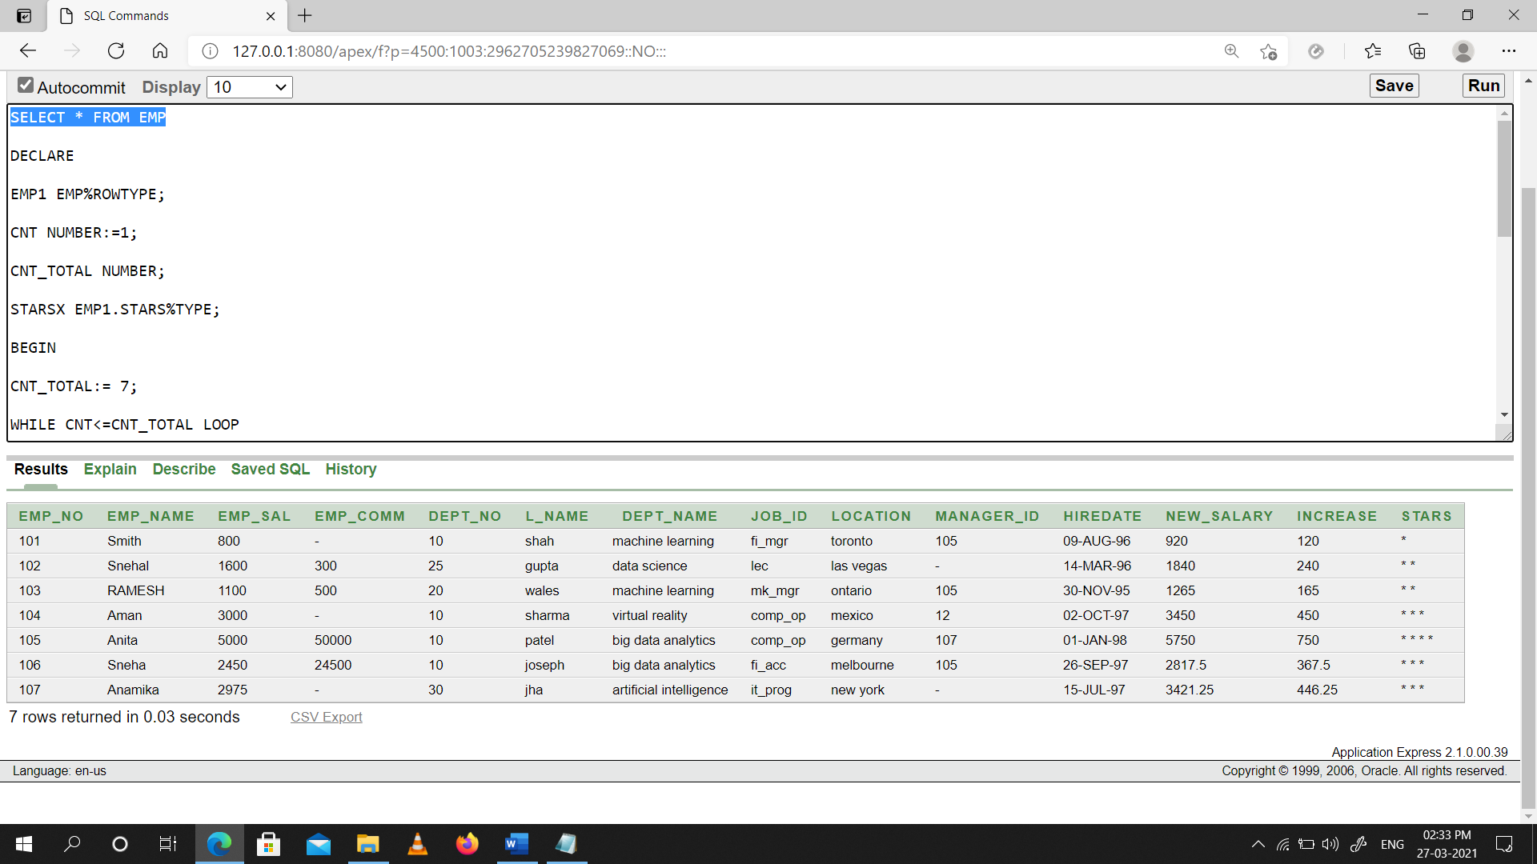

**Conclusion:** From this practical I learned how to update columns through PL/SQL.

**Practical -16**

**To perform the concept of cursor**

**(a)** Display all the information of EMP table using %ROWTYPE.

**Code:**

DECLARE

EMP1 EMP%ROWTYPE;

CNT NUMBER:=1;

CNT1 NUMBER:=7;

BEGIN

DBMS_OUTPUT.PUT_LINE( ' EMP_NO ' || ' EMP_NAME ' || ' EMP_SAL ' ||' EMP_COMM ' ||' DEPT_NO ' || ' L_NAME ' ||' DEPT_NAME ' || ' JOB_ID ' || ' LOCATION ' || ' MANAGER_ID ' || ' HIREDATE ');

WHILE CNT < CNT1 LOOP

SELECT * INTO EMP1 FROM EMP WHERE EMP_NO = 100+CNT;

DBMS_OUTPUT.PUT_LINE( EMP1.EMP_NO || ' '|| EMP1.EMP_NAME || ' ' || EMP1.EMP_SAL || ' ' || EMP1.EMP_COMM || ' ' || EMP1.DEPT_NO || ' ' || EMP1.L_NAME || ' ' || EMP1.DEPT_NAME|| ' ' || EMP1.JOB_ID || ' ' || EMP1.LOCATION || ' ' || EMP1.MANAGER_ID|| ' ' || EMP1.HIREDATE);

CNT:= CNT+1;

END LOOP;

END;

Snap-shot:

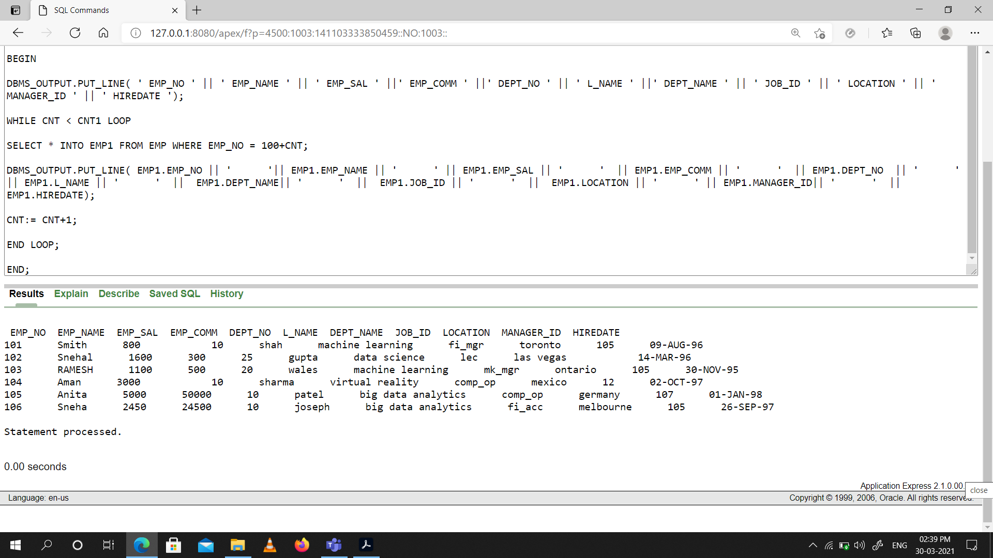

**(b)** Create a PL/SQL block that does the following:

**Code:**

DECLARE

EMP1 EMP%ROWTYPE;

X EMP.DEPT_NO%TYPE:= :X;

CURSOR C1 IS SELECT EMP_NAME,EMP_SAL,MANAGER_ID,L_NAME FROM EMP WHERE DEPT_NO = X;

BEGIN

DBMS_OUTPUT.PUT_LINE( 'EMP_NAME ' || 'EMP_SAL ' || 'MAANGER_ID ');

FOR EMP1 IN C1 LOOP

DBMS_OUTPUT.PUT_LINE( EMP1.EMP_NAME ||' ' || EMP1.EMP_SAL || ' ' || EMP1.MANAGER_ID);

END LOOP;

DBMS_OUTPUT.PUT_LINE('----------------------------');

FOR EMP1 IN C1 LOOP

IF EMP1.EMP_SAL < 1000 THEN

DBMS_OUTPUT.PUT_LINE(EMP1.L_NAME||' Is due for a Raise.');

ELSE

DBMS_OUTPUT.PUT_LINE(EMP1.L_NAME||' Is not due for a Raise.');

END IF;

END LOOP;

END;

Snap-shot:

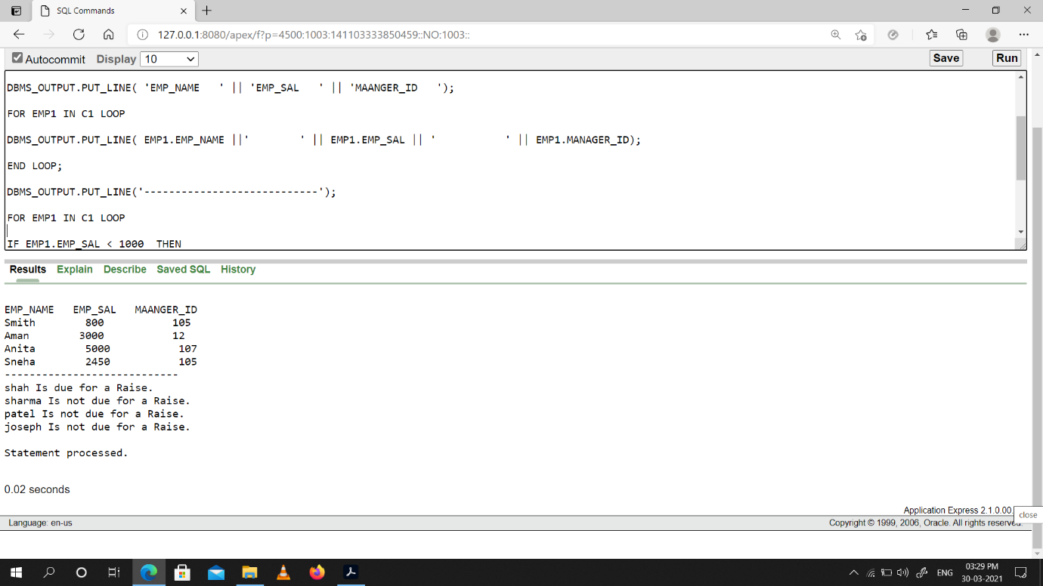

**Conclusion:** From this Practical I learned how to perform the concept of cursor.

**Practical -17**

**To perform the concept of trigger**

Write a PL/SQL block to update the salary where deptno is 10. Generate trigger that will store the original record in other table before updation take place.

**Code:**

STEP 1 : CREATE BACKUP TABLE

CREATE TABLE SALARY(

EMP_NO NUMBER,

EMP_SAL NUMBER

);

STEP 2: ADD TRIGGER

CREATE OR REPLACE TRIGGER COPY_SALARY

BEFORE UPDATE

ON EMPLOYEE4

FOR EACH ROW

DECLARE

EMP_SAL NUMBER;

EMP_NO NUMBER;

BEGIN

EMP_SAL := :OLD.EMP_SAL;

EMP_NO := :OLD.EMP_NO;

INSERT INTO SALARY

VALUES (EMP_NO,EMP_SAL);

END;

STEP 3: UPDATE VALUE IN EMP WHERE DEPT_NO = 10

UPDATE EMPLOYEE4 SET EMP_SAL = 3500 WHERE DEPT_NO = 10

STEP 4: AFTER UPDATE CHECK VALUES IN BOTH TABLES

SELECT * FROM EMPLOYEE4

SELECT * FROM SALARY ORDER BY EMP_NO

Snap-shots:

Employee Table Before Command Execution:

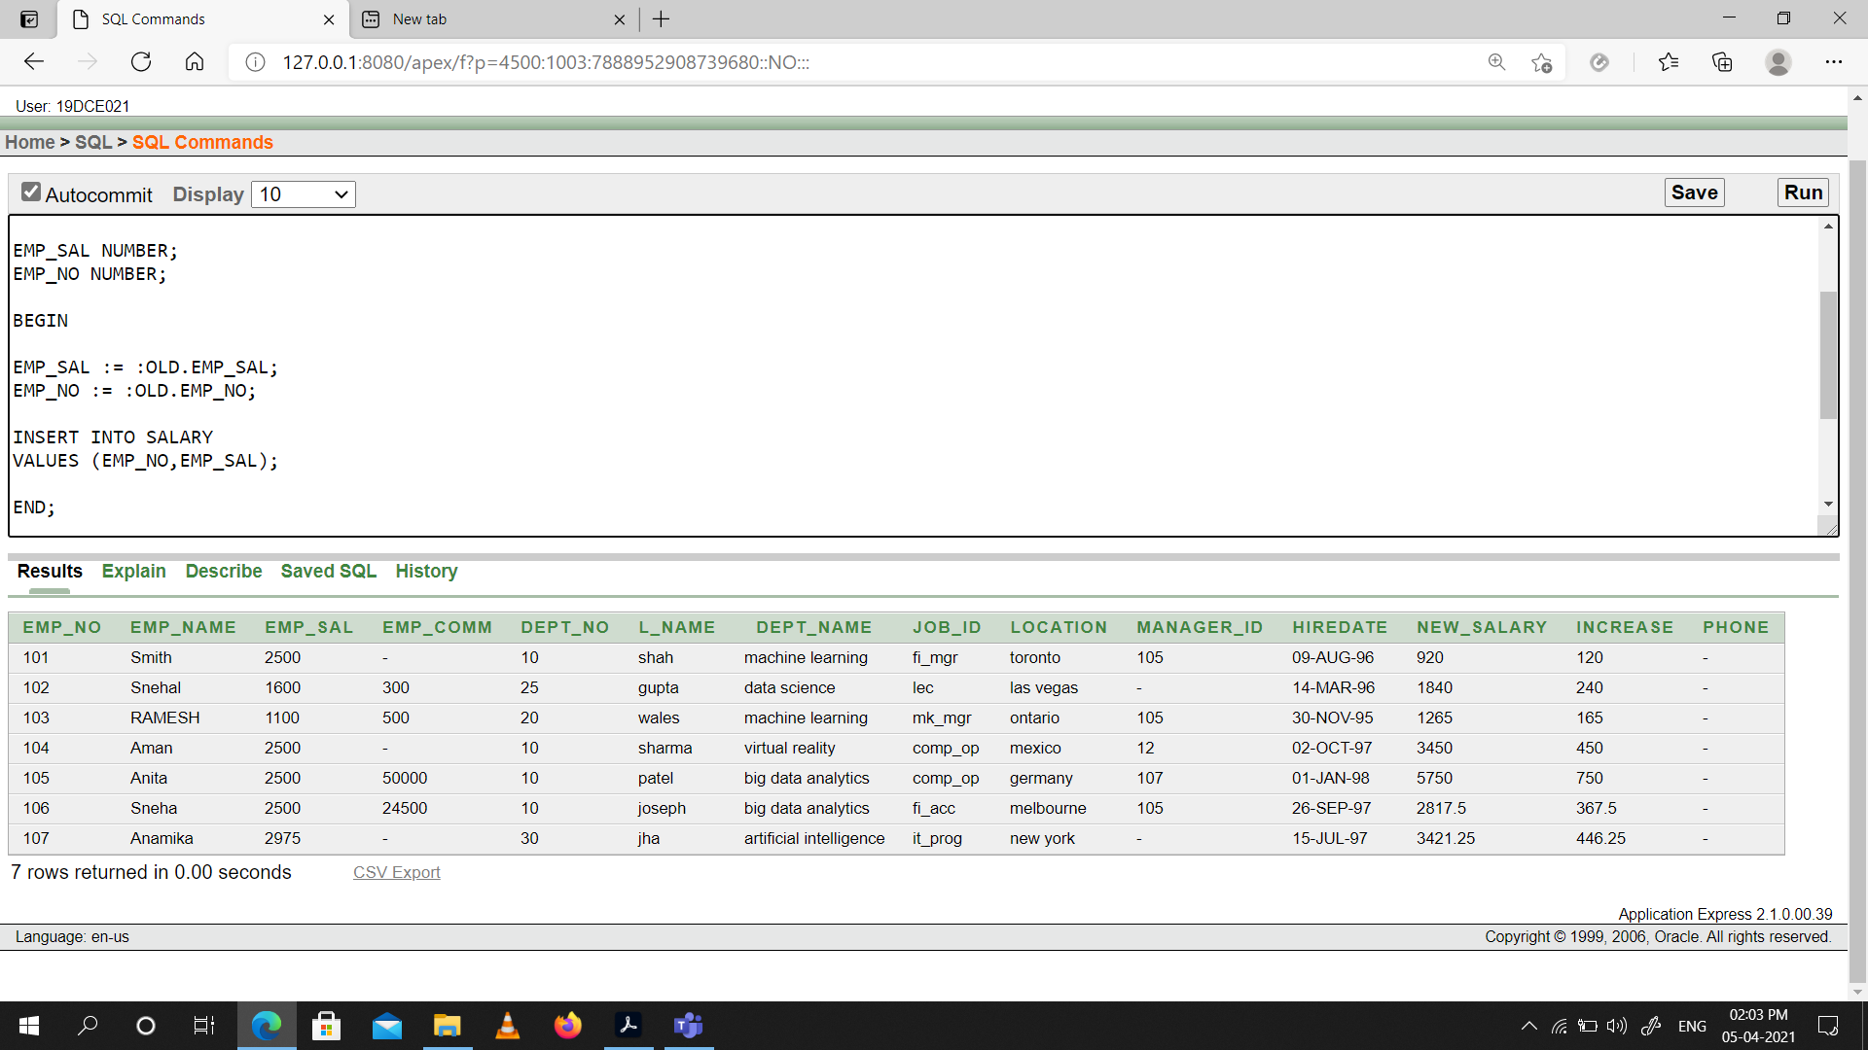

Employee Table After Command Execution:

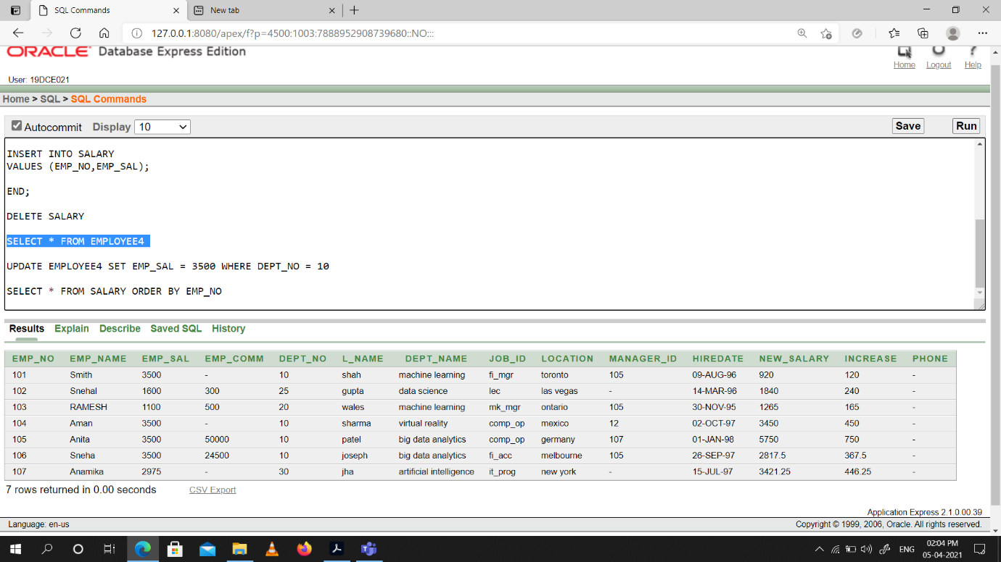

Salary Table After Command Execution having old values of Emp_Sal:

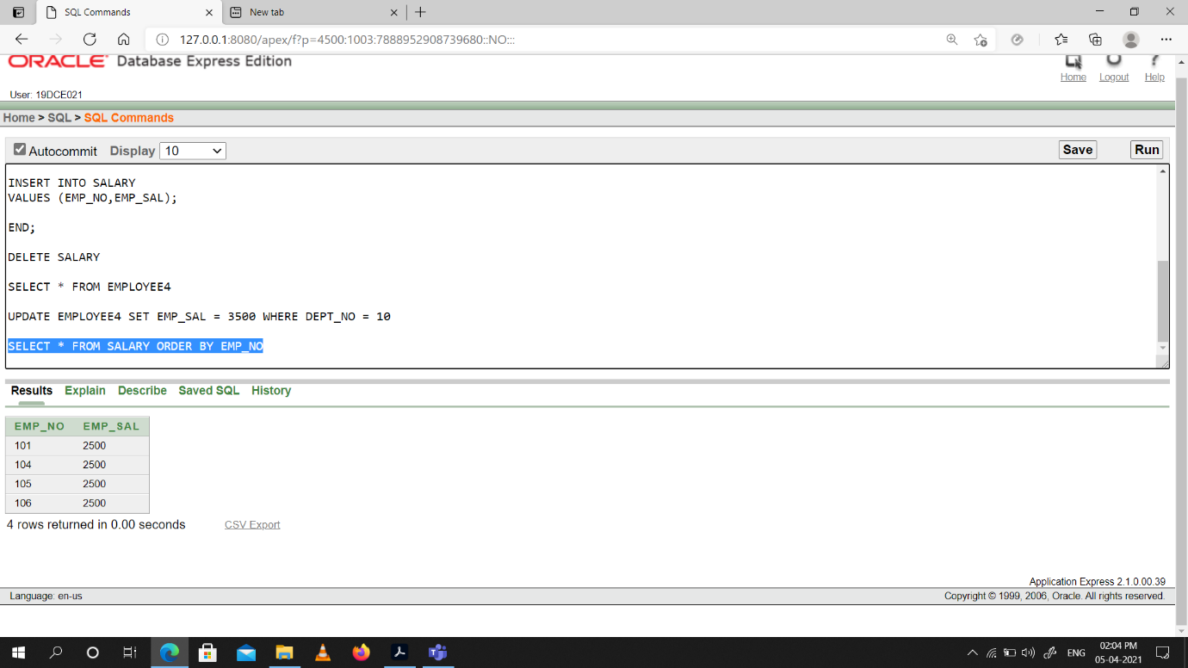

**Conclusion:** From this Practical I learned how to use trigger to perform certain tasks.

**Practical -18**

**To solve queries using the concept of View.**

(1) Write a query to create a view for that employee belongs to the location New York.

**Code:**

--create view

CREATE OR REPLACE VIEW NEW_YORK_EMP AS

SELECT * FROM EMPLOYEE4 WHERE LOCATION = 'new york'

--display view

SELECT * FROM NEW_YORK_EMP;

Snap-shot:

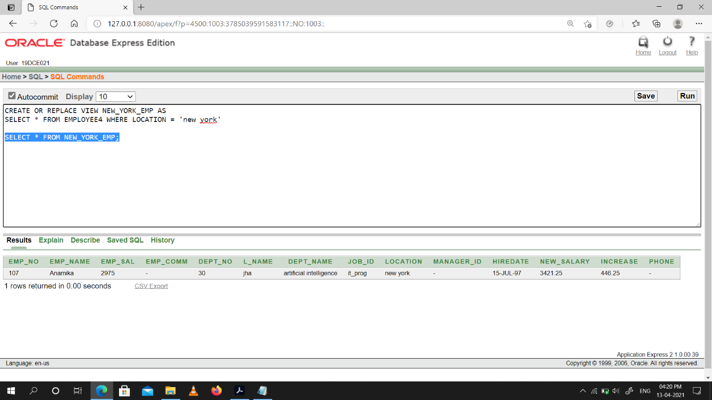

(2) Write a query to create a view for all employee with columns emp_id, emp_name,

and job_id.

**Code:**

--create view

CREATE OR REPLACE VIEW EMP1 AS

SELECT EMP_NO,EMP_NAME,JOB_ID FROM EMPLOYEE4

--display view

SELECT * FROM EMP1;

Snap-shot:

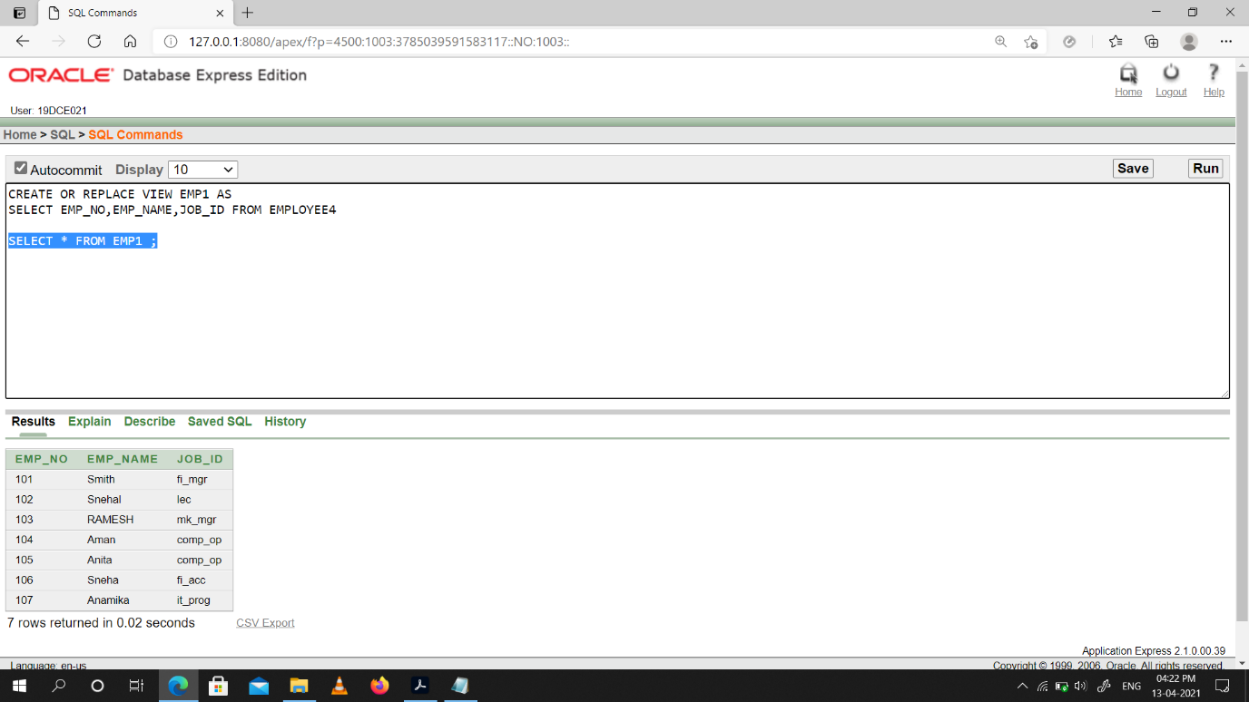

(3) Write a query to find the salesmen of the location New York who having salary more than 3000.

**Code:**

--create view

CREATE OR REPLACE VIEW EMP1 AS

SELECT EMP_NO,EMP_NAME,JOB_ID FROM EMPLOYEE4

--display view

SELECT * FROM EMP1;

Snap-shot:

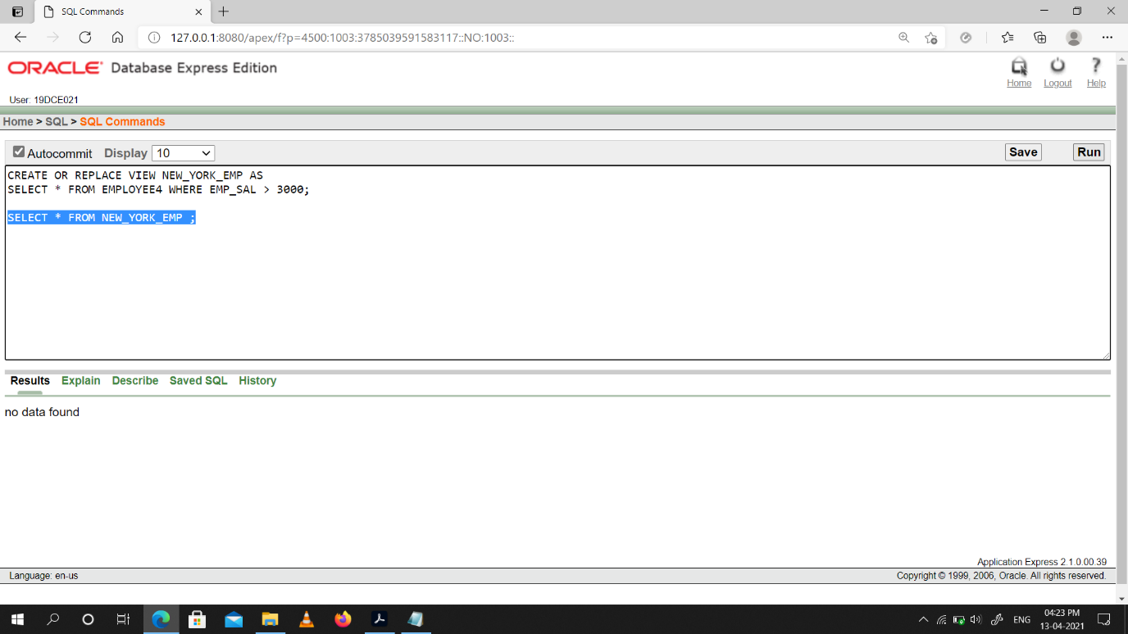

(4) Write a query to create a view to getting a count of how many employee we have at each department.

**Code:**

--create view

CREATE OR REPLACE VIEW DEPT_COUNTER AS

SELECT DEPT_NO,COUNT(*)"COUNT" FROM EMPLOYEE4 GROUP BY DEPT_NO;

--display view

SELECT * FROM DEPT_COUNTER;

Snap-shot:

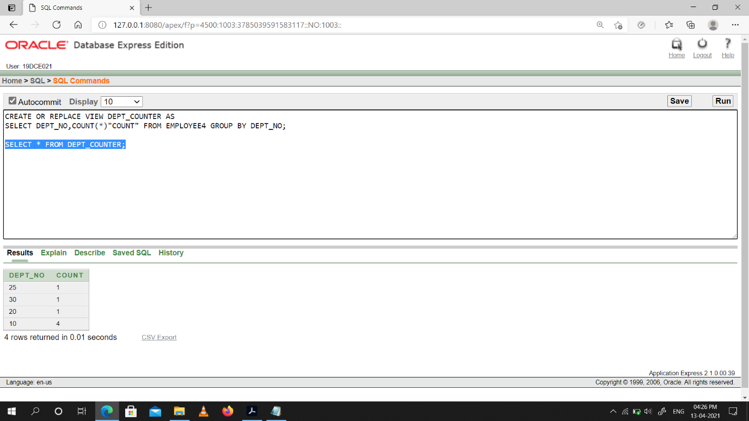

**Conclusion:** From This Practical I Learned how to create a view in oracle PL/SQL.

**Practical -19**

**To perform the concept of function and procedure**

Write a PL/SQL block to update the salary of employee specified by empid. If record exist, then update the salary otherwise display appropriate message. Write a function as well as procedure for updating salary.

**Code:**

**Using Procedure:**

STEP 1: CREATE A PROCEDURE

CREATE OR REPLACE PROCEDURE UPDATE_SAL(DEPT_ID IN NUMBER,NEW_EMP_SAL IN NUMBER)

IS

BEGIN

UPDATE EMPLOYEE4 SET EMP_SAL = NEW_EMP_SAL WHERE DEPT_NO = DEPT_ID;

DBMS_OUTPUT.PUT_LINE(‘Updated Salary Is: ‘|| NEW_EMP_SAL);

END;

STEP 2: EXECUTE THE COMMAND

BEGIN

UPDATE_SAL(20,1250);

END;

Snap-shot:

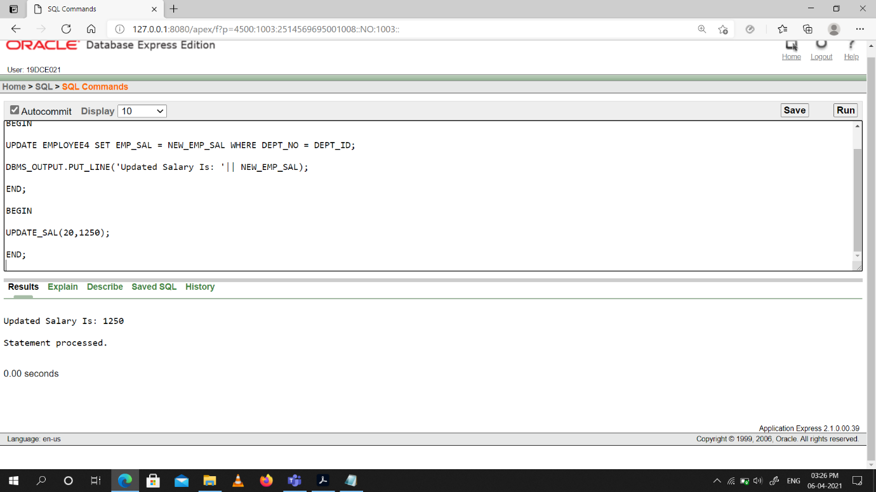

**Using Function:**

STEP 1: CREATE A FUNCTION

CREATE OR REPLACE FUNCTION UPDATE_SALARY(DEPT_ID NUMBER, EMP_NEW_SAL NUMBER)

RETURN NUMBER IS

BEGIN

UPDATE EMPLOYEE4 SET EMP_SAL = EMP_NEW_SAL WHERE DEPT_NO = DEPT_ID;

RETURN EMP_NEW_SAL;

END;

STEP 2: USE THAT FUCNTION IN OTHER PL/SQL BLOCKS

DECLARE

NEW_EMP_SAL EMPLOYEE4.EMP_SAL%TYPE;

EMP_NO EMPLOYEE4.EMP_NO%TYPE;

UPDATED_SAL NUMBER;

BEGIN

NEW_EMP_SAL := 3079;

EMP_NO := 20;

UPDATED_SAL:= 0;

UPDATED_SAL := UPDATE_SALARY(EMP_NO,NEW_EMP_SAL);

DBMS_OUTPUT.PUT_LINE(‘Updated Salary Is :’ || UPDATED_SAL);

END;

Snap-shot:

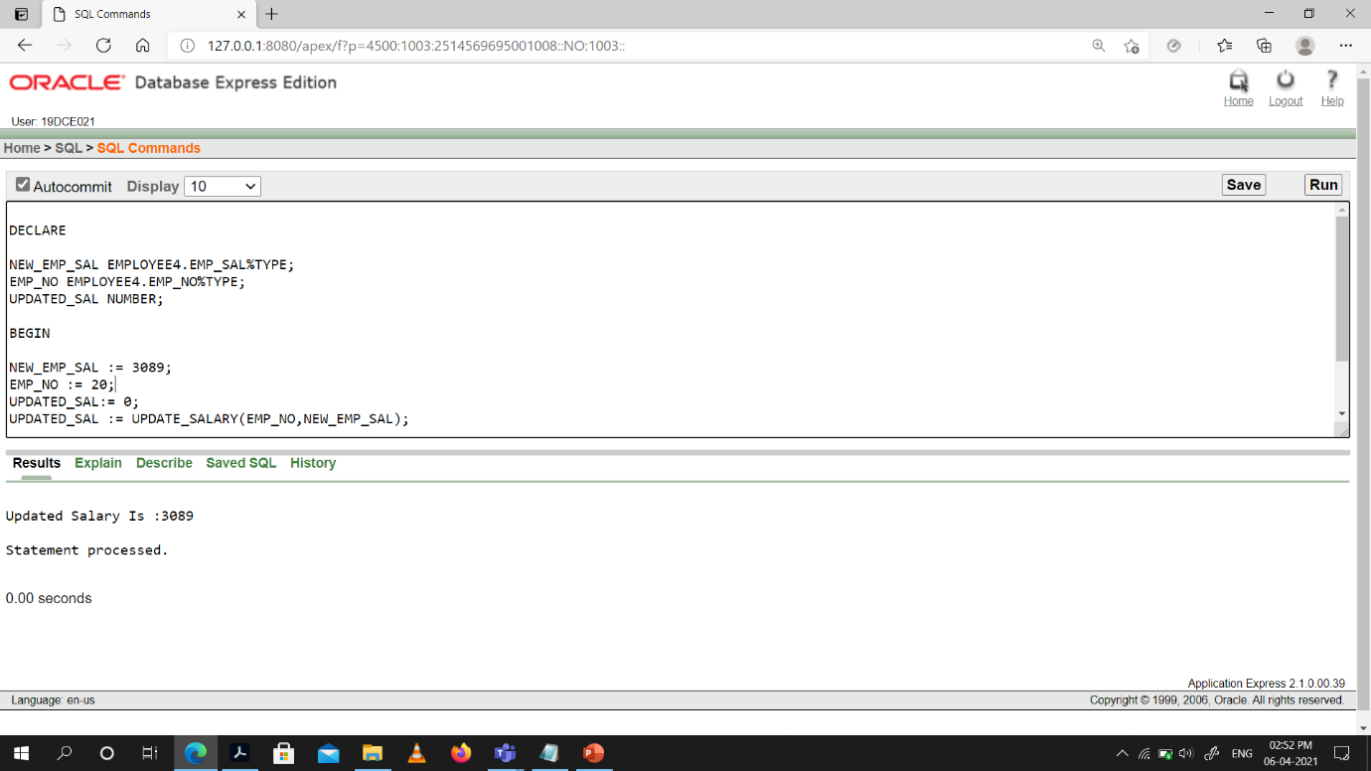

**Conclusion:** From this Practical I learned how to use Procedure & Functions which are pl/sql objects to perform tasks, making code reusable.

**Practical -20**

**To perform the concept of exception handler**

Write a PL/SQL block that will accept the employee code, amount and operation. Based on specified operation amount is added or deducted from salary of said employee. Use user defined exception handler for handling the exception.

**Code:**

declare

OPERATION VARCHAR(10);

AMOUNT NUMBER;

EMP_CODE EMPLOYEE4.EMP_NO%TYPE;

EMP1 EMPLOYEE4%ROWTYPE;

my_exp EXCEPTION;

begin

AMOUNT:= :AMOUNT;

OPERATION := :OPERATION;

EMP_CODE := :EMP_CODE;

SELECT * INTO EMP1 FROM EMPLOYEE4 WHERE EMP_NO = EMP_CODE;

IF EMP1.EMP_SAL <= 0 AND OPERATION = 'SUB' OR EMP1.EMP_SAL < AMOUNT AND OPERATION = 'SUB' THEN

RAISE my_exp;

END IF;

IF OPERATION = 'ADD' THEN

UPDATE EMPLOYEE4 SET EMP_SAL = EMP_SAL+ AMOUNT WHERE EMP_NO = EMP_CODE;

DBMS_OUTPUT.PUT_LINE('Added '|| AMOUNT || ' to the salary of employee.');

ELSIF OPERATION = 'SUB' THEN

UPDATE EMPLOYEE4 SET EMP_SAL = EMP_SAL - AMOUNT WHERE EMP_NO = EMP_CODE;

DBMS_OUTPUT.PUT_LINE('Deducted '|| AMOUNT || ' from the salary of employee.');

END IF;

EXCEPTION

WHEN NO_DATA_FOUND THEN

DBMS_OUTPUT.PUT_LINE('No Records Found');

WHEN my_exp THEN

DBMS_OUTPUT.PUT_LINE('We Can not Deduct Salary');

end;

Snap-shot:

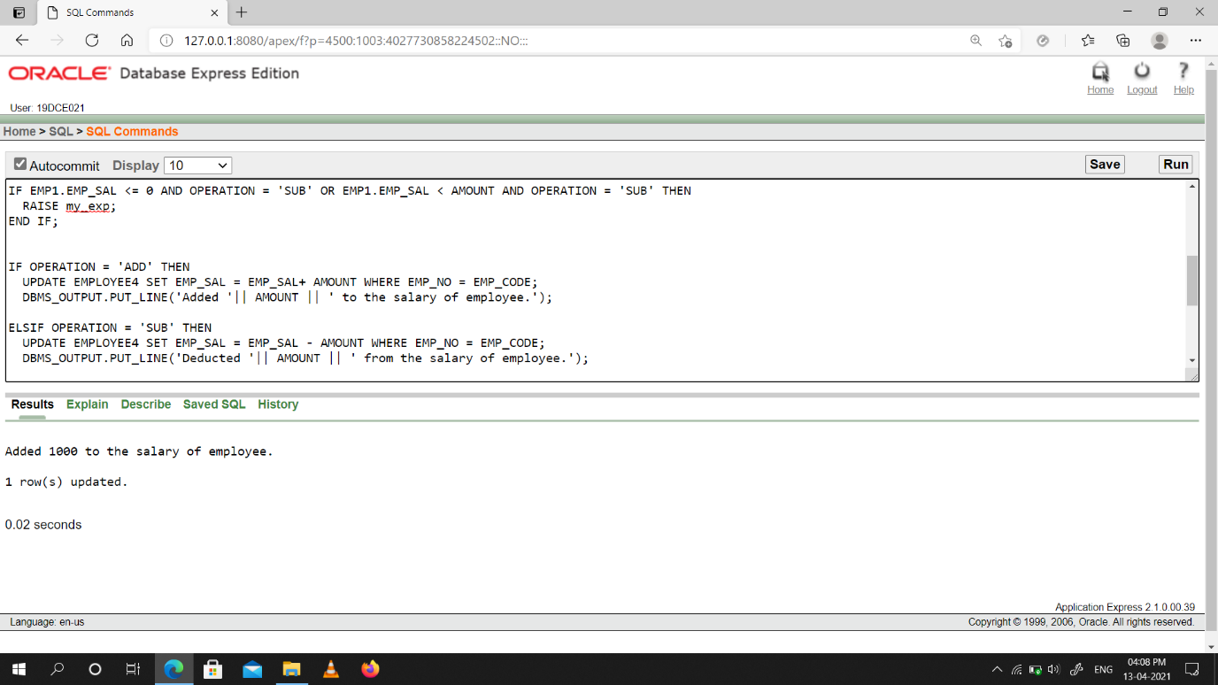

**Conclusion:** From This Practical I Learned how to handle exceptions in oracle.

**Practical -21**

**To perform the concept of package**

**Code:**

STEP 1: CREATE A PACKAGE DECLARATION.

CREATE OR REPLACE PACKAGE getEmployeeData AS

-- public

FUNCTION getRow(Emp_id number) return EMPLOYEE4%ROWTYPE;

END getEmployeeData;

STEP 2: CREATE A PACKAGE BODY.

CREATE OR REPLACE PACKAGE BODY getEmployeeData AS

FUNCTION getRow(Emp_id number) return EMPLOYEE4%ROWTYPE AS

-- THIS VARIABLE WILL BE PRIVATE.

EMPX EMPLOYEE4%ROWTYPE;

BEGIN

SELECT * INTO EMPX FROM EMPLOYEE4 WHERE EMP_NO = Emp_id;

RETURN EMPX;

END getRow;

END getEmployeeData;

STEP 3: Use the Package In a PL/SQL Block.

DECLARE

EMPX EMPLOYEE4%ROWTYPE;

BEGIN

EMPX:= getEmployeeData.getRow(102);

DBMS_OUTPUT.PUT_LINE('EMP_SAL: '|| EMPX.EMP_SAL);

-- Similarly all rows and values can be printed.

END;

Snap-shot:

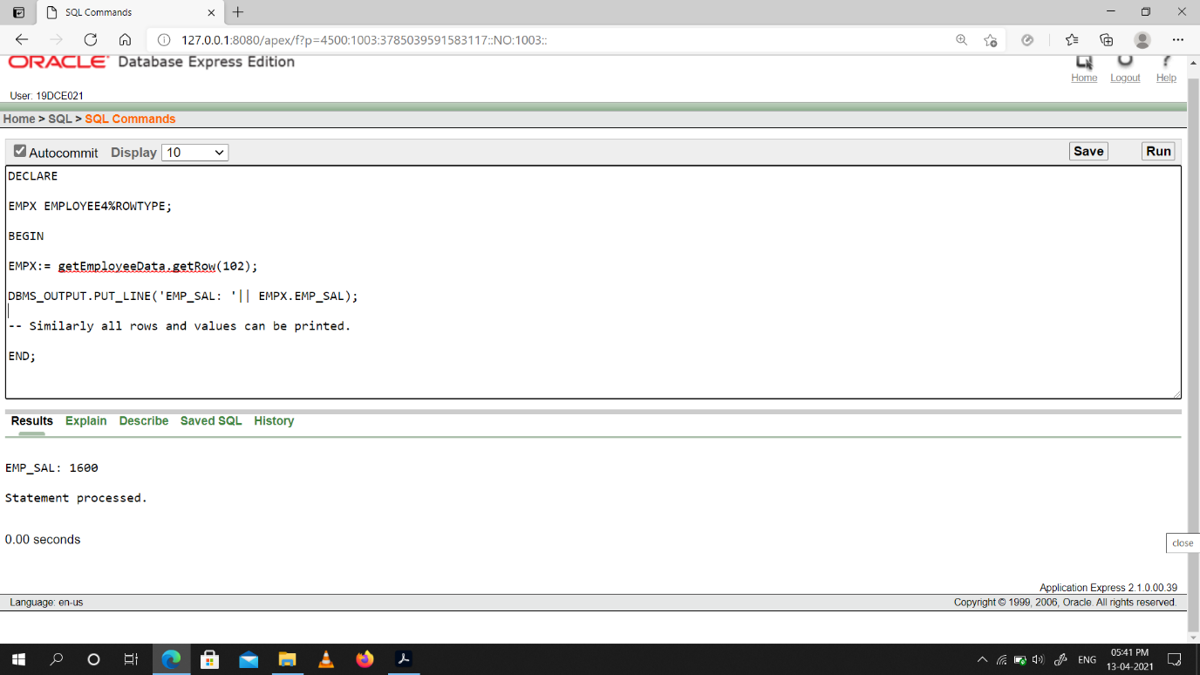

**Conclusion:** From This Practical I Learned how to create & use a package in oracle.